Survey Analysis of Usage of Mobile Platform by the Faculty of Technical Institutes for
Teaching and Learning

¹ Anjali Potnis ²C. S. Rajeshwari ³Ramesh B. Shivagunde

¹Assistant Professor, Electrical & Electronics Engineering
² Professor of Electrical & Electronics Engineering
³Professor of Management
National Institute of Technical Teachers Training and Research, Bhopal
anju.pot@gmail.com,csrajeshwari@gmail.com, rbshivagunde@gmail.com

Abstract
World over growth of mobile users has been phenomenal over the years and especially in Indian context where rate of increase of mobile users has been extraordinarily high. Mobile phones have changed the lifestyle of Indians in all spheres of day to day life. Usage of mobile platform as a teaching and learning tool is still not harnessed fully in India. Looking towards the potential of mobile platform and the present percentage of mobile users in general, the authors conducted a survey among the faculty of Engineering and Polytechnic Institutes of Western region of India regarding the use of mobile phone/platform for teaching and learning. Survey revealed that the teachers require awareness, motivation and technical support to use this platform extensively. Training of teachers and support for acceptance of this tool for improvement of efficiency and effectiveness of teaching and learning is the major finding of this research work. Based on the survey analysis, suggestions are proposed to make an action plan for sensitizing the teachers to adopt this tool for the academic and professional advancement.

Key Words: - Mobile Learning, Collaborative learning, e-learning, Mobile apps., Learning style

Introduction

The most prominent and useful characteristics of mobile platform is it’s anytime and anywhere accessibility that can be utilized for quality teaching and learning. Mobile teaching and learning platform provides flexibility not only to students, but also to teachers and both can utilize the available time and resources smartly to improve the effectiveness of teaching and learning activities. Mobile teaching and learning platform includes mobile phone, smart phones, iPod, Personal Digital Assistant (PDA), tablets, e- book reader and palm top computers. Mobile learning is one step advanced than e-learning as mobile phone is small and portable device which is very much easy to carry from one place to other and also less expensive compared to laptop and desktop computers. Mobile platform provides two dominant wireless mode of operation for data transfer or connecting to internet i.e. Mobile data/4G/3G and Wi-Fi. Mobile phones can also connect with each other through Wi-Fi, Bluetooth and Infrared technologies and can share the data and information.

Mobile platform provides equal opportunities to all type of learners i.e. fast and slow learner, in the class and away from the class, adult and young, male and female, rural and urban. The size of mobile is paramount reason that attracts people and they have the feeling that it is easy to handle or easy to use for learning and provides the required personal space. Compact hardware and the low cost are the biggest advantage of this platform. It is the most affordable tool for teacher and student in the present time. Figure:1, shows various learning styles included under Mobile Learning umbrella. Mobile apps are the key factor which differentiate this platform from e-learning. Large numbers of free mobile apps are available for the use of teachers and students.
Development of the teaching and learning content specifically for the mobile platform is an essential need for further adoption of this platform. This also opens up new area of research and development for teaching professionals. This research is specifically focused on the need and use of mobile for the teachers and teaching activities. This paper has four main sections; Introduction section describes the basic feature of mobile platform and brief information about it. Literature review section describes the views and findings of different researchers from the different part of globe on the topic in brief to understand the topic .This section further reinforces the further need and importance of this teaching tool in the
Situational Learning
Lifelong Learning
Collaborative learning
Contextual Learning
Peripheral Learning
Distance Learning
Responsive Learning
Mobile Learning
Self paced Learning
Inquisitive Learning

Figure 1: Mobile learning umbrella including various learning style

present time. Next section deals with the analysis of faculty responses and is the backbone of this research work. Primary data is collected by the authors through questionnaire survey and also personal interviews of some faculty members.
Based on the data analysis action plan is proposed to increase the utilization of mobile platform for teaching activities in the technical Institutes. Over all summary of this research is included in the conclusion section.

Literature Survey
Use of mobile platform in the classroom will be successful only when the faculty is trained and acquires knowledge of available content on the net which can be used effectively for the teaching and learning activities. It is a skill and attitude to determine the effectiveness of technology integration into the curriculum [1].

Mobile learning is a very good example of collaborative learning. It provides appropriate platform to allow reflection- in- action and to capture the spontaneity of the learning moments [2]. It also provides rapid access to the other’s view and balances the isolationist tendencies of the professionals. This research paper also explains the benefits, obstacles and issues of mobile mode
by [3] which was completed in the four phases: m-learning affordances, m-professional development, m-learning strategies and m-learning principals.
Mobile devices were used in this project not only as low level communication or recording device but as cognitive tool. Innovative pedagogical techniques developed by the

teachers and implemented and tested for the different courses. This project report also attracts one important attention that specific and cohesive National policy must be framed to help to use m-learning for the education. A detail paper submitted to UNESCO for Working Paper Series on Mobile Learning (WPS-ML), focus on Mobile learning for teachers [4]. This paper series contains two major sections, includes topics like mobile learning initiatives and their policy implications and how mobile technologies can support faculty and improve the effectiveness of teaching practices. Views on sustainability, scalability and funding to support mobile learning movement has also discussed in this paper.

The report published by the leading mobile communication company in the world “Ericsson” [5] in 2012, have predicted that the number of mobile user will reach beyond 4 billion by 2018.The growth of mobile user especially amongst the younger population is maximum in the last decade.

The effect of integrating mobile device with teaching and learning on students’ learning performance: A meta- analysis and research synthesis [6] have described the implications of use of mobile devices for teaching and learning activities.

It also expresses that more elaborate instructional design development are needed to thoroughly exploit the educational benefits possible by utilizing the mobile devices. The authors believe that the three implications proposed below will be helpful for facilitating and

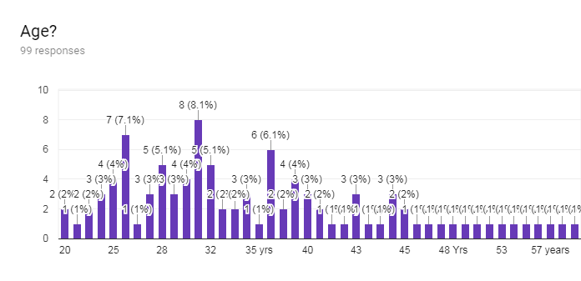

Figure 2: Age Distribution of faculty

to achieve these goals, leveraging the pedagogical effects of mobile devices through elaborate designs of learning/teaching scenarios, Enhancing the quality of the experimental design for mobile intervention and Empowering educational practitioners through the orchestration of mobile devices, software, and pedagogical design.
Literature survey also highlights the caution mentioned by some of the researchers that the usage of mobile may prove to be distraction for the students. Concerns regarding the security issues are to be considered while deploying this technology extensively while the contrary view is that there is not much of security issue ( except with the regular software security issues).

Analysis of Faculty Responses
Teachers play key role in the effective implementation of new teaching and learning technique. Adoption of mobile learning platform would systematically spread through teachers only. Therefore it is imperative to find out the present status of teachers regarding their knowledge of mobile learning domain, motivation, preparedness to adopt it, challenges and reservations for not adopting it. The demographic and other factors like age, gender, work place, level of teaching program and teaching experience that influence the rate of adoption of this technique are also required to be explored. To learn the effect of above mentioned parameters a survey was conducted amongst the faculty of technical Institutes of Western region of India.
A questionnaire has been designed which contains five sections. First section has general questions like: Name, Age, Gender, Institute, Teaching experience, level of teaching i.e. Diploma, Under Graduate (UG), Post graduate (PG) of faculty .
In second section information is collected about the usage, whether the faculty is using the mobile for teaching or not. If the answer is yes then the third section collects information about which teaching activity they use mobile platform, name of courses and list of mobile apps commonly used, how frequently the mobile is used by the individual faculty and also how the students are responding to it. Section four is designed to collect information from the faculty who are not using the mobile platform for teaching activities ,this section has questions like is there any specific reason behind not adopting this digital platform, what are the limitations, issues and challenges faculty is facing to adopt the mobile platform. Final section is common for all and collects information about the inputs and suggestions about the usage of the mobile platform in teaching and learning process and why we should adopt this platform. Faculty members of Diploma and Engineering Institutes of Western region of India which include states of Madhya Pradesh, Chhattisgarh, Gujarat and Maharashtra have participated in this survey.
Total of 100 faculty members have participated in this survey between 10th to 25th December 2017. Google forms a free service from Google was used for this work , The survey questionnaire was created and edited and the link generated and was distributed to the faculty members and the responses were received online.
The distribution of the age of the faculty members is as per Figure 2. The average age of the respondents is between 25 to 40 years .This age group is adequately.

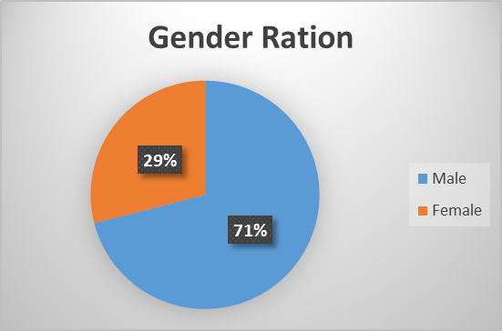

Figure 3: Gender Ration

exposed to the mobile technologies and keen to adopt it for teaching and learning activities In this survey 71% male and 29 % female faculty have submitted their responses as in Figure: 3.

As per the sample data of 100 faculty members presently 53% faculty is using the mobile platform where as 47% faculty is not using the mobile platform for teaching and learning purposes as per Figure 4.

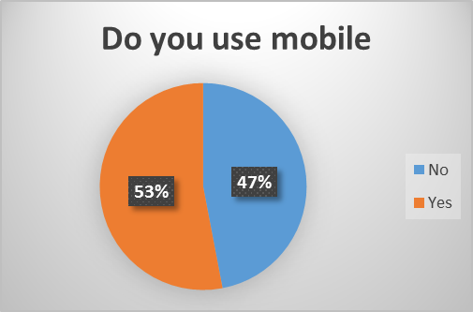

Figure 4: Mobile Adaptation Ration

53% of faculty members have responded that they are using mobile platform and their responses are summarized as follows:
- Frequency of usage: The usage is done by the faculty members in variety of ways like they use frequently, regularly, some time, very few times, occasionally, once or twice a week, once in a semester, few times, only during the free time.

- Purpose of usage: Faculty uses it for the practical session, distribution of assignment, notes, old question papers, regular notices, timetable, presentation preparation, survey on technical topics.

- Resources/Apps used: Response to this was: Whats app group, Wikipedia, Skype, You tube, blog, video
lecture, Google search, Google classroom, my lectures, kahoot.com, Piazza.
- How students are responding: In most of the cases student response to this tool is: very good, excellent, interactive, time saving, preferred options to adopt it.
- Responses for the which type of courses /activity/lesson do you use the mobile platform: A very exhaustive list of courses have been received and summarized such as courses which are common to all branches, courses that require demonstration, language practice and vocabulary building, learning grammar, manufacturing and processing courses, courses which require more imagination like fundamental of electrical and electronics engineering, electrical machines, antenna and wave propagation, initial introduction of new topic, simulation of many processes like chemical reactions and titrations, digital modulation, microprocessor and microcontroller functioning and programming, antenna pattern radiation, VLSI designing, hacking, VB and other computer language ,learning transfer function of any system, circuit simulation, automobile simulation etc.

Approximately 47% faculty is still not using this platform as teaching tool and this can be inferred that faculty is either not prepared or is not aware about the use of mobile technology for the teaching and learning activities. Most common answers received for not to use the mobile are very interesting and gives insights to identify the challenges and barriers for adoption of this technology. Faculty has given these specific reasons:
- Poor quality and weak English language communication of students.
- Connectivity is another big issue.
- No special apps developed by the Institutes Boards, Universities.
- Lack of resources, awareness, training and technology support by the Institute.
- Some said that this idea has not yet clicked while some mentioned that the small screen of mobile device is not comfortable for reading.
For the common questions of section five of the survey questionnaire, the responses are summarized as follows:
- Need for training to use it in better way was responded as: Definitely if available, yes sure, systematic training always uplifts the level of understanding and so the use of technology, motivation and technical support from the Institute is must.
- Responses to questions like the adverse effect of the tool are as follows: Maximum faculty (more than 60%) think that there is no adverse effect on the learner by the use of this tool. This is very encouraging data in favors of use of this tool for teaching and learning activities. Very few responded that it may cause eye sight problem, health issues, over use of it kills the creativity, mind diverted to different issues.

- To adopt this tool what modification and support you require, for this question the summary is as follows: training of teacher and students, specific apps related to the program and courses development, modification in curriculum, some

compulsory activities based on mobile, MIS development by the University/Institute and all the stake holder

activities that can be carried out efficiently through mobile platform are summarized as follows:

should be made compulsory to use it, local language interface will increase the percentage of its use, internet penetration, more interactive and user friendly applications are required.
- To the question as to why Indian Institutes should adopt it or not? Majority has responded in favor of adopting it and the main primary reason being the resources sharing and against the adoption the reason being usage of the mobile should be restricted for necessary activity only.

Proposed Action Plan
There are different factors affecting the adoption of mobile for faculty and students. New and effective pedagogical techniques will evolve using the distinct features of mobile platform like self paced learning, customized interface, context sensitivity, and instant feedback. In this paper the authors’ have focused their questionnaire on the teachers only and tried to get insights
as to what is the response of the faculty towards the use mobile as teaching and learning tool.
The proposed action plan has three phases as shown in
Figure 5, each phase can be spread over to six months to one year. The first phase involves organizing awareness camps and training the teachers through faculty development programme and workshop in the systematic manner to prepare and motivate them to use this tool for the teaching and learning activities. Some of the major
- Information like attendance of individual students, time table, class rescheduling and extra class, test and exam schedule, syllabus, program structure and scheme, extra-curricular activities. These schedules can be shared instantly to all the students individually on their mobile.
- Distribution of notes, old question papers, e-books, prerequisite reading material, useful links for video, podcast and other reading material that will increase the comfort level of student and save teacher’s class room time which can be utilized for other educational activities.
- Introduction of digital assessment partially for the formative and summative assessments that will speed up the assessment work with the high degree of reliability and students will get the fast and transparent feedback.

Phase two will involve the monitoring of progress and feedback from the faculty. The personal experiences and
best practices will be shared on the common platform. Information about the effectiveness, experiences and
difficulties faced by the faculty will be collected to take further improvement action. In the last phase the faculty will be encouraged for the content development specific for the mobile applications.

Phase-I
Major Activities

Awareness Camps
Faculty Development Training program
Workshop for hands on experience

Phase-II
Major Activities

Monitoring of progress
Feedback suggestions
Experiences sharing

Phase-III
Major Activities

Feedback and suggestions for the effective implementation
Training for the content development specific to the mobile platform

Figure 5: Phases of proposed action plan

- Conclusion

Role of digital technologies is becoming decisive factor in the professional education field in our country. Teacher plays very important role in the implementation of innovative teaching and learning techniques and therefore it is essential to empower teacher with the digital technology and new pedagogical techniques based on mobile learning (m-learning). This is an utmost priority to improve the quality of technical education in the country. Training and workshops are to be organized on regular basis for the faculty to update their knowledge and one should get the hands on practice to use this technology to improve the effectiveness in the classroom. Mindset of both teacher and student has to shift to adopt this teaching and learning tool and prepare them for the future generation technologies.
The survey response is encouraging and indicates that with the more access to mobile, change in the curriculum, technical support and Internet penetration there will be effective integration of mobile learning platform for teaching and learning activities. It is also inferred by the authors that developing more apps in the local language will help the students of remote and rural area. Simulation tools for explaining the abstract concepts, quiz and tutorials for practices, discussion and blogs for the exchange of ideas and views, virtual class room environment for the remote area students and teachers to interact with subject experts, distribution of administrative information like notices, exam schedule, attendance of individual students on mobile, virtual lab for the rural, remotely located and small
Institutes will definitely improve the quality of technical education in India. Strong National education policy to adopt mobile for teaching and learning for higher education and skill development is still waiting to be framed. The survey for this research was focused on the faculty, the same study from the student’s perspective will also help to find the local constraints and working out solutions for adopting this tool for the teaching and learning of technical courses. Mobile platform can transform the learning style and work as catalyst to meet the skills required to survive in the 21st century.

- References

- Bitner, Noel and Bitner, Joe., “Integrating Technology into the Classroom: Eight keys to success,” Journal of Technology and Teacher Education, volume-10(1), pp. 95-100, Southeastern Louisiana University Hammond, LA70402, USA, 2002.
- Peter Aubusson, Sandy Schuck & Kevin Burden, “Mobile learning for teacher professional learning: benefits, obstacles and issues,” ALT-J, vol.17:3, pp.233-247, DOI: 0.1080/09687760903247641, 2009.
- Herrington, J., Mantei, J., Herrington, A, Olney I. and Ferry, B. “New technologies, new pedagogies: Mobile technologies and new ways of teaching and learning. In Hellow! Where are you in the landscape of educational technology?” Proceedings of ascilite Melbourne 2008, http://www.ascilite.org.au /conferences/ melbourne08 /procs/ herrington-j.pdf, 2008.
- West, Mark., Vosloo, Steven, “Mobile Learning for Teacher,” United Nations Educational, Scientific and Cultural Organization,7, place de Fontenoy, 75352 Paris 07 SP, France, ISSN 2227-5029, 2012.
- Ericsson, “Ericsson Mobility Report,” http://www.ericsson.com/res/docs/2012/ericssonmobility-report November-2012.pdf, 2012.
- Sung,Yao-Ting., Chang,Kuo-En., Liu, Tzu-Chien, “The effects of integrating mobile devices with teaching and learning on students' learning performance: A meta-analysis and research synthesis,” ,Journal of Computers & Education, pp. 252-275, Elsevier, 2015.

