Pulse Width Modulation based Solar Charge Controller
Aldrin Claytus Vaz, C. Gurudas Nayak*, Dayananda Nayak, Navya Thirumaleshwar Hegde
Department of Instrumentation & Control Engineering, Manipal Institute of Technology, Manipal University, Manipal.
aldrin.claytus@gmail.com, cg.nayak@manipal.edu, daya.nayak@manipal.edu, hegde1211navya@gmail.com
Abstract - Solar Home Systems has the potential to offer many benefits to the user and to the society as a whole. The ease of usage along with using clean energy makes it a viable choice. A part of Solar Home System is a Solar Charge Controller. The main aim in developing this design is to make the product at an affordable price, without compromising on the reliability of the product. The proposed solar charge controller works with a Pulse Width Modulation (PWM) controlled DC-DC converter for battery charging. The design is implemented using an inexpensive PIC microcontroller. The charging of the battery is controlled by the PWM pulses generated by the PIC microcontroller depending on various input variables. The designed Solar Charge Controller is tested to check whether it’s matching all the proposed technical specifications. The product is also designed to support 120W of DC load.
Keywords – DC-DC converter, Solar Charge Controller, PWM.
*Author for Correspondence: E-mail: cg.nayak@manipal.edu

- INTRODUCTION
The Sun provides heat and light that Earth receives and therefore sustains every living being. Sustainable energy sources are becoming more and more popular and the energy from them can be best used where there is a scarcity of the energy. Solar energy can be converted to electricity by Solar Panels. Solar Home System (SHS) is a setup consisting of Solar panel, Charge Controller, Battery and Electrical loads. Flow of converted electricity from Photovoltaic (PV) is determined by Charge Controller. An efficient Charge Controller can be used to do the battery charging and discharging process faster and better. This Smart Charge Controller is designed with a view to charge the battery effectively and efficiently.
Considering the raising needs for electricity, solar energy can be used as backup for electricity generation to enhance the shortage of power which the grid is unable to provide. Moreover poverty corrupted rural areas faces the toughest criterions for crisis of electricity. Therefore, the aim is to make Solar Energy popular as one of the best renewable energy sources with a view to provide supplementary electricity. Huge amounts of energy can be trapped by solar panels using compound solar cells. When the solar batteries come into account, they get charged in a very short time period. The solar energy gets converted into electrical energy and is stored in the batteries. People whoever looking for savings and the future of the planet should indeed look into Solar energy.
A charge controller, shown in Fig 1, controls the amount at which electric current is drawn from or added to batteries. It prevents the overcharging of batteries which is one factor in reducing battery life. Also it prevents the deep discharging of the batteries, i.e. by controlled discharge. When the battery voltage exceeds a set high voltage level, charge controllers stop charging them, and when the battery voltage falls below that level, they re-enable charging of batteries. The two common methods for charging batteries are Pulse width modulation (PWM) and Maximum Power Point Tracker (MPPT), which are electronically sophisticated technologies that adjust the charging rates depending on the battery's level and charges the batteries closer to its maximum capacity.

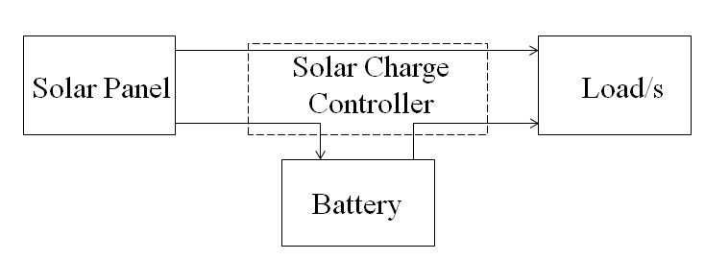

Figure 1: Block diagram of a Solar Home System
[1] presents a fuzzy based solar charge controller based on buck converter that controls the charging and discharging of pbatteries. Implementation is done using a breadboard and the controller is integrated with a pbattery and a solar cell. A 60V output voltage PV charge regulator designed for CdTe solar panel modules is presented in [2]. An MPP tracking technique is equipped with a stepdown inverter. In [3], a Cuk DC-DC converter is presented for transferring maximum power from the PV modules for battery charging. To extract maximum power from the PV modules, PWM control with MPPT algorithm is used. In [4], a solar charge controller based on Zero current soft switching buck converter with microcontroller is designed. The PWM pulses are generated using Atmega 16 microcontroller. A dynamic DC-DC Buck and Boost Converter based low cost charge controller is explained in [5]. An intelligent MPPT controller using microcontroller is presented in [6]. Chuang presented a high efficiency Buck converter in [7]. In [8], He et al., proposed a high efficiency battery charger. Pattnaik et al., proposed a synchronous buck converter in [9]. In [10], a new method of switching of charge controller by combination of electromechanical and solid state switching device has been incorporated to reduce the switching loss during charging cycle of a solar charge controller. [11] presents a high efficiency charge controller for a 1.2kW load controlled using a single-chip 32-bit microcontroller. In [12], a solar charge controller based on MPPT technique using Aurduino is presented. The proposed technique significantly reduces system power loss and increase the efficiency to 97.75%.

- PROPOSED SOLAR CHARGE CONTROLLER
Solar Panel
Panel
PV Voltage Sensing
PV Power Control MOSFETs
External Battery
Load Control MOSFETs
Load Current Sensing
Battery voltage & Current Sensing
Microcontroller
Load
LED Indications

Figure 2: Proposed Solar Charge Controller
The block diagram of the proposed Solar Charge Controller is shown in the Fig 2. The detailed design of each functional block is as follows:
2.1 SOLAR PANEL
The Solar Panel used here is of mono crystalline type of capacity 200Wp (max) with Open circuit Voltage 25V (max). The input from the Solar panels is controllably supplied to the Battery and Load using control MOSFETs, whose controlling action is carried down by the PWM signal generated by a microcontroller.
2.2 PV VOLTAGE SENSING CIRCUIT
This stage consists of input surge protection part, reverse leakage current protection (diode), reverse polarity protection along with the Voltage sensing circuit. The microcontroller measures the PV Voltage and generates the PWM signal depending on the sensing to control the PV side Power MOSFETs. The analog PV voltage is given to the analog channel pin of the microcontroller where it is internally stored as a digital value which is further used to generate the PWM signal.

2.3 BATTERY
The Battery used with the Charge Controller setup is Lead Acid Batteries (12V, 100Ah).
2.4 BATTERY VOLTAGE & CURRENT SENSING
The Battery voltage sensing stage consists of a voltage divider network, where the battery voltage is sensed and given to the microcontroller, in turn used to generate the PWM signal. The Battery current sensing stage consists of a simple sense resistor (low value resistor) which is used to measure the amount of current that is flowing into the battery. The voltage drop in the sense resistor (which is very low due to the low value resistor) is converted into electric current i.e. the amount of electric current flowing into the battery using V2I converter. This value is important to generate the PWM pulses to switch the PV power control MOSFETs.

2.5 LOAD CURRENT SENSING CIRCUIT
The load current sensing stage consists of a simple sense resistor (low value resistor) which is used to measure the current flowing into the load. The voltage drop in the sense resistor is converted into the amount of current flowing into the load. The load current is sensed by the microcontroller and the appropriate signals are given to the load side controlling Power MOSFETs. This value of current is used to give the overload condition in the LED when the load current increases beyond 10A. Also when the load side is shorted, the current is measured and load side MOSFET is turned off.

2.6 POWER MOSFETS
The power MOSFETs used in the proposed design is IRLB8748. These are N-channel power MOSFETs used for high frequency Buck Conversion applications. These are majorly used in Telecom & Industrial purpose. In the current design, these MOSFETs are used for the controlled input side charging & LVD control on the load side. The MOSFETs used are high current MOSFETs and a gate driver circuit is designed using transistors & other components.

2.7 MICROCONTROLLER
The microcontroller used for the design is PIC16F722A. PIC16F722A is an 8-bit microcontroller built around RISC (Reduced Instruction Set Code) architecture. The semiconductor division of General Instruments Inc. originally developed the PIC (Peripheral Interface Controller) line of microcontrollers. The microcontroller PIC16F722A was chosen depending on the availability of necessary GPIOs and analog channels necessary for the design requirements.

2.8 LED INDICATIONS
The LED indications are used to show the presence of Solar Charging, Battery status and fault conditions. The LEDs are current controlled devices. The presence of Solar Charging is shown in one LED, the Battery status is shown in a bicolour LED and fault conditions are shown in a LED. All the indications shown in the LEDs are the decisions taken by the microcontroller upon sensing the different Voltage levels in the PV and Battery.
2.9 POWER SUPPLY DESIGN
The simplest way of designing a power supply of low power is a transistor regulator. An emitter follower is considered where the base terminal of the regulating transistor is connected directly to the reference voltage. For a varying voltage of the power source and changes in load, a constant output voltage is obtained, provided that the input voltage is greater than output voltage by a sufficient large margin. Also, the power handling capacity of the transistor should not be exceeded than the threshold.

The proposed charge controller is designed for the technical specifications as given in table 1.

Table 1: Solar Charge Controller – Technical Specifications
S. No. | Parameters | Specifications
Solar Charge Controller – 10A
1 | Maximum PV voltage | 25V
2 | Maximum rated output current | 10A continuous load
3 | Maximum rated output power | 120W
4 | Rated Output Voltage | 12 V
5 | High voltage disconnect | $$14.3 ± 0.2 V$$
6 | Low voltage disconnect | $$11.6 ± 0.1 V$$
7 | Low voltage reconnect | $$12.6 ± 0.2 V$$
8 | Reverse Battery protection | Yes
9 | Reverse PV protection | Yes
10 | Over current from PV to battery protection | Yes
11 | Over current from PV to load protection | Yes
12 | Over current from battery to load protection | Yes
13 | Reverse current protection from battery to PV | Yes
14 | Short circuit protection on the load side | Yes
15 | Maximum No load current | <50mA
16 | Efficiency | >85%
Battery Specifications
17 | Type | Lead Acid
18 | Voltage | 12V
19 | Capacity | 100Ah
20 | Life cycle | 5000 cycles
Solar Panel Specifications
21 | Type of Solar Panel | Mono crystalline
22 | Maximum Rated Power | 200Wp
23 | Peak Power Voltage | 25V

- RESULTS & DISCUSSIONS
PWM CHARGING PULSES
The PWM signals for the PV side power MOSFETs control are given by the PIC16F722A microcontroller. The pin 13 of the PIC microcontroller (CCP module) will generate the PWM signals depending on the algorithm written. The PWM charging pulses for three different solar input voltages are shown in the Figure 3(a), 3(b), 3(c).
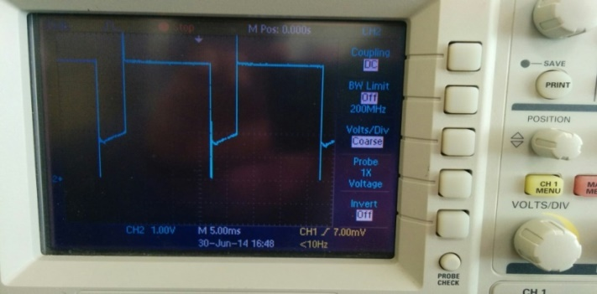
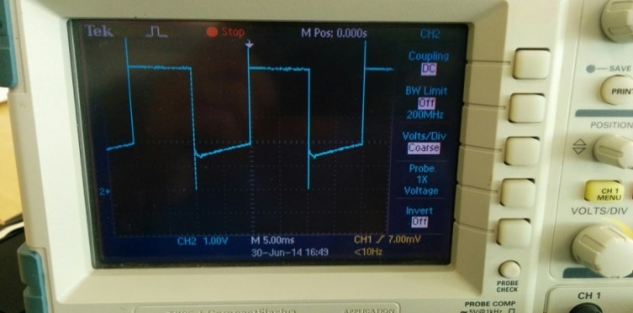
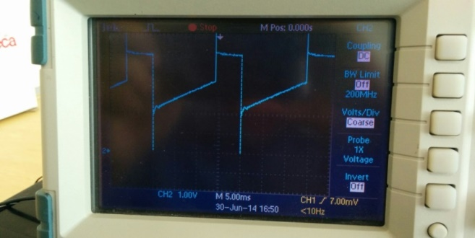
When the Solar input is 15V, the PWM pulses have a duty cycle of 75%. When then Solar input is 17V, the PWM pulses have a duty cycle of 50%. When then Solar input is 19V, the PWM pulses have a duty cycle of 25%.
Figure 3: PWM charging pulse when solar voltage is a) 15V b) 17V c) 19V
CRO OUTPUT WAVEFORMS
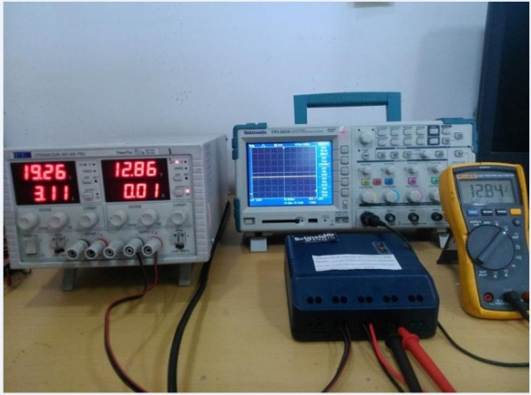
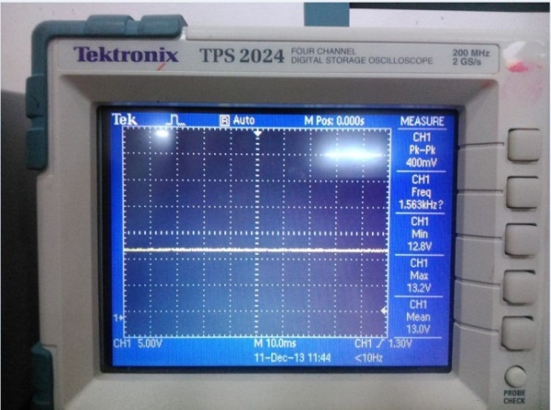
The output of the Solar Charge Controller is to supply a load of maximum 120W. The output Voltage waveform at the load terminals and at the mobile charging port is captured in CRO. Figure 4(a) and Figure 4(b) shows the No load output of the Solar Charge Controller. Figure 5(a) and Figure 5(b) shows the output voltage of the Solar Charge Controller when 5A load is connected.

(a) (b)
Figure 4: No load Output Voltage waveform

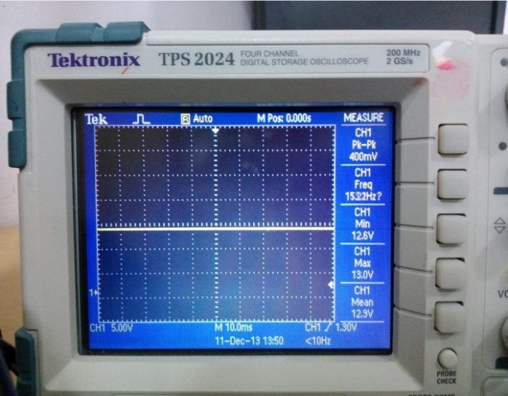
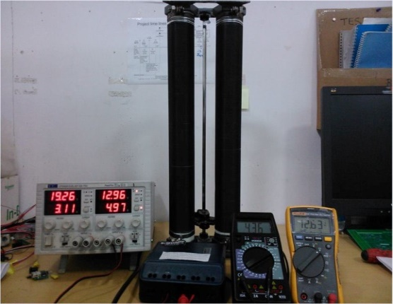

(a) (b)
Figure 5: Output Voltage waveform (5A load)

From the CRO waveforms, it is clear that the Solar Charge Controller is designed according to the technical specifications defined. The results obtained from the waveforms are satisfactorily matching with the expected values. The prototype is tested with 5A load and it was seen the output is achieved.
- CONCLUSION
The Solar Charge Controller is designed with a view that it serves well for the people who doesn’t have access to electricity and to make the product affordable to those people without losing its technical quality. Firstly, the general explanation of the Solar Charge Controller is given. Then the detailed Methodology of the Solar Charge Controller design is given. The complete functional testing is done on the designed Solar Charge Controller and the results are tabulated.
There are certain disadvantages in the design such as the PWM charging pulses are not fully square wave as there are some peaks in the pulses. Also, the mechanism doesn’t have auto detection of 12V/24V batteries. The designed Charge Controller works on the PWM control technique, thus there is no maximum power extracted during charging time. All these points can be considered as the specifications to do the next level of design. To the existing design, we can add the auto battery selection feature which can be an advantage in some cases. Also the design can have MPPT controlling scheme instead of PWM controlling scheme, which can harness maximum power from the PV module every time it tracks.
ACKNOWLEDGEMENTS

This research work has been funded by the Dr. TMA Pai Ph.D scholarship program by Manipal University, Manipal. The authors would like to thank the department of Instrumentation & Control Engineering, Manipal Institute of Technology, Manipal University, Manipal for allowing the research to be conducted in their laboratory and providing the required facilities.
REFERENCES
- Pritpal Singh, Jagadeesan Rajagopalan, Rodney Lafollette, Craig Fennie Jr. and David E. Reisner, “Fuzzy logic-based Solar charge controller for microbatteries”, Conference Record of the Twenty-Eighth IEEE Photovoltaic Specialists Conference, pp. 1726-1729, Sept, 2000.
- Wojciech Grzesiak, “MPPT Solar charge controller for high voltage thin film PV modules”, IEEE 4th World Conference on Photovoltaic Energy Conversion, pp. 2264-2267, May 2006.
- D.C. Riawan and C.V. Nayar, “Analysis and Design of a Solar Charge Controller Using Cuk Converter”, Australasian Universities Power Engineering Conference, Dec. 2007.
- A.S.Werulkar, P.S.Kulkarni, “Design of a Constant Current Solar Charge Controller with Microcontroller based Soft Switching Buck Converter for Solar Home Lighting System”, IEEE International Conference on Power Electronics, Drives and Energy Systems, Dec. 2012.
- X. Long, R. Liao and J. Zhou, “Low-cost charge collector of photovoltaic power conditioning system based dynamic DC/DC topology” IET Renewable Power Generation, pp. 167–174, Vol. 5, No. 2, Mar. 2011.
- Siwakoti, Y.Prasad, Bhupendra Bimal Chhetri, Brijesh Adhikary and Diwakar Bista, "Microcontroller Based Intelligent DC-DC Converter to Track Maximum Power Point for Solar Photovoltaic Module”, IEEE Conference on Innovative Technologies for an Efficient and Reliable Electricity Supply, pp. 94-101, Sept. 2010.
- Y.Chun Chuang, “High-Efficiency ZCS Buck Converter for Rechargeable Batteries”, IEEE Transaction of Industrial Electronics, pp. 2463-2472, Vol. 57, No. 7, July 2010.
- Y. Chuang and Y.Lung Ke, "A Novel High- Efficiency Battery Charger with a Buck Zero-Voltage-Switching Resonant Converter" IEEE Transaction on Energy Conversion, pp. 848-854, Vol.22, No. 4, Dec. 2007.
- S. Pattnaik, A. K. Panda, and K. Mahapatra "Efficiency Improvement of Synchronous Buck Converter by Passive Auxiliary Circuit" IEEE Transaction on Industrial Applications, pp. 2511-2517, Vol. 46, No. 6, Nov./Dec. 2010.
- Gour Chand Mazumder, Md. Shafiqul Islam, Md. Habibur Rahman, “Hybrid Switching low loss solar charge controller”, International Conference on Green Energy and Technology, pp.22-26, Sept. 2014.
- Mofakkharul Islam, Md. Abul Bashar Sarkar, “An Efficient Smart Solar Charge Controller for Standalone Energy Systems”, International Conference on Electrical Drives and Power Electronics, pp.246-251, Sept.2015.
- Md. Rokonuzzaman, Md Hossam-E-Haider, “Design and Implementation of Maximum Power Point Tracking Solar Charge Controller”, International Conference on Electrical Engineering and Information Communication Technology, Sept. 2016.

