**Survey and Study of Wild Boar Control Management on Oil Palm**

Muhammad Idrus, S. and Cik Mohd Rizuan, Z. A.

1Crop Protection Unit, FGV R&D Sdn. Bhd. 26400, Pusat Penyelidikan Pertanian Tun Razak, Pahang.

**ABSTRACT**

*Wild boar* (Sus scrofa) *is one of the mammalian pest that can cause significant damage to oil palm especially at the replanting stage. Their damage losses towards oil palm were RM 36.50 / ha / year with total volume from 1996 to 2003 reaching RM 4.3 million. Symptoms of wild boar damage on oil palm are consumption of palm meristem, dead palm and leaves defoliations. Wild boar damage had been significantly found between the replanting and immature stages of oil palm. The objectives of this study is to survey the plantation with wild boar incidence, conduct a preliminary trial on several wild boar deterrent and case study of using Blue LED blinker to control wild boar. Based on the surveyed, electric fence had the lowest average of wild boar damage, followed by zinc plate and chain-link fence. The cheapest methods were barbwire guard, followed by zinc plate guard, overage palm, chain-link fence and electric fence. The preliminary trial on several wild boar deterrent shown that all treatments (Kerimo, Naphthalene and White Light) were not significantly different with the Control Treatment. The result shown that the deterrent treatment were unable to reduce the wild boar incidence. In the case study of using Blue LED blinker, Plot C had no significant different with the Plot A and B after the installation of the Blue LED Blinker. The result showed that Blue LED Blinker can deterred wild boar infestation. Nevertheless, any control methods need to follow standard specification to operate efficiently.*

***Keywords*:** Wild boar, damage, control, oil palm

**INTRODUCTION**

Wild boar or feral pig (Sus scrofa) is one of the mammalian pest that can cause significant damage to agricultural, livestock and wildlife sectors (Reidy et al., 2008). For oil palm, the damage significantly affected the replanting stage and the nursery. Their damage losses towards oil palm were RM 36.50 / ha / year with total volume from 1996 to 2003 reaching RM 4.3 million (FASSB, 2010). Wild boar is an omnivore animal that is known to consume mainly on vegetables food and some animal materials (Schley & Roper, 2003). For other crops like maize and wheat, crop damage compensation from government for wild boar attack had turned out to be millions of euros every year in the Europeans countries (Klein et al., 2007). Wild boar had the ability to colonise new areas, extent their territories and thus increase conflicts with humans. Total numbers of wild boar hunted down had jumped from 2503 in 1998 to 8748 in 2008, indicating their population had been significantly increase throughout the years (Schlageter & Haag-Wackernagel, 2011).

Symptoms of wild boar damage on oil palm are consumption of palm meristem, dead palm and leaves defoliations (Plate 1). Wild boar damage had been significantly found between the replanting and immature stages of oil palm. For mature stage, wild boar prefers to forage on the loose fruitlets. Present, the method for managing wild boar is by using electric fences, large drains, collar guard on palm base, mulching plastic guards on palm base and repellents. Wild boar, *Sus scrofa* is a protected animal and under Wildlife Conservation Act, 2010 (Act No. 716). Under Section VI, No. 54 (1) & (2), PERHILITAN had suggested to control wild boar by using repellent, live caught and kill (Act, 2015).

The latest method for controlling wild boar are by using repellent, which were LED blinker and KERIMO, synthetic tiger urine. Blue LED blinker had been declared by PERHILITAN as one of the control methods to repel large mammals, especially wild boar and elephant. The usage of blue light maybe due to the facts that red LED solar blinker had been insufficient to protect crop from wild boar infestation (Schlageter & Haag-Wackernagel, 2011) and pig eyes had been studied to recognise bluish colour and green instead of reddish colour (dichromatic vision) (Eguchi et al., 1997). LED blinker was also used by the Penang Agriculture Department in the rice field area to control ricefield rat, *Rattus argentiventer*. The usage of LED blinker was able to reduce the presence of rats in the rice field by reducing the use of rat poison by 50% (the cost of rat poison is RM82.50) (Mohd Anim, H. 2015). On the other hand, predator odour had been ineffective to reduce wild boar infestation (Schlageter & Haag-Wackernagel, 2012). Although KERIMO had never been tested scientifically, this product had been talked about to deter wild boar successfully when placed at the farm. Based on all the info and problems suggested, the objectives of this study is to 1) survey the plantation with wild boar incidence, 2) conduct a preliminary trial using different olfactory deterrent to control wild boar and 3) conduct a trial on wild boar deterrent, Blue LED blinker.

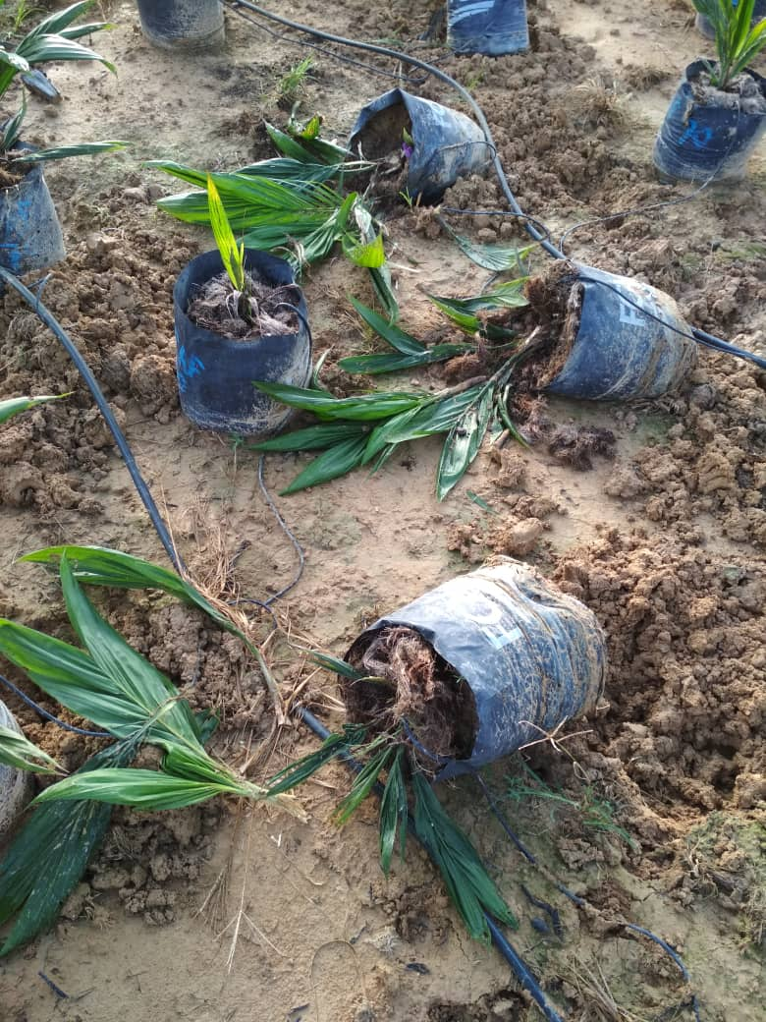 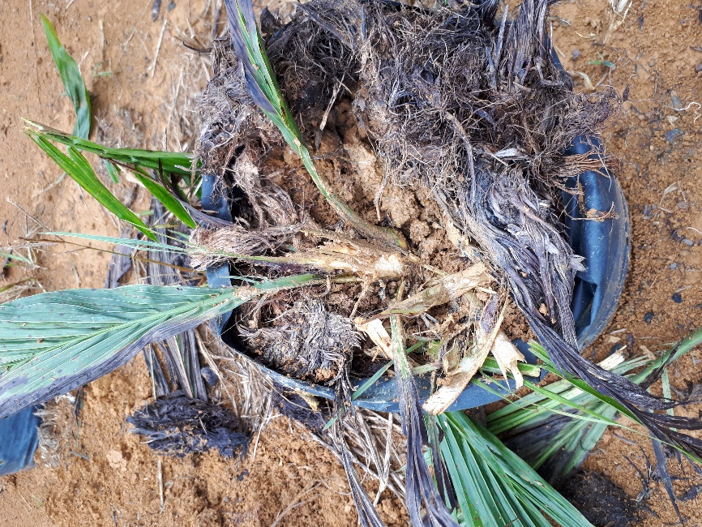

Plate 1: Symptoms of wild boar damage on oil palm seedlings in the nursery

**MATERIALS AND METHODS**

**Survey of Wild Boar Control Management at the Plantation**

Several survey had been carried out in several oil palm estates, specifically the FGV Plantation (FGVPM). Selection of farms to be visited were based on Agronomy Advisory's annual pest and disease (P&D) report. FGVPM had been chosen because they had compile P&D report to the Agronomist Department, FASSB on monthly basis. The report used in this study was from 2017 because our survey was conducted throughout the year 2018. The survey assessment were wild boar damage/ha/year, type and cost of wild boar control management.

**Preliminary Study of Using Different Olfactory Deterrent to Control Wild Boar**

The study plot was located in Ladang FASSB PPPTR, Jengka, Pahang, coordinate of 3°53'38.8"N 102°32'23.2"E. Palm trees from this plot were aged 11 years. This study site had been used because it is located near swampy area that sighted with wild boar incidence. This study was about evaluation of bait taken by wild boar on wallowing area that were treated with different olfactory deterrent. At first, there were 6 wallowing areas or plots that had showed active wild boar activities. All wallowing areas had been assessed for wild boar incidence (foot mark and wallowing activity) and bait taken. Each wallowing area had five replicates. Each replicate was placed with 2 tapioca with each bait weight around 250 g. Tapioca was used as the wild boar bait because from experience, tapioca is the only bait specifically eaten by wild boar. Other wild boar known baits like chicken head, jackfruit and salted fish were also consumed by other animals like monitor lizard, civet and rat. 250 g of bait was used because it is impossible for small mammals to carry the bait out from the treatment area. After two weeks, only four active wallowing area were chosen. The active wallowing area were subjected to four treatments, which were Kerimo, Naphthalene, White light and Control. The study assessment was done on weekly basis with a total of six post-treatment assessment.

For Kerimo and Naphthalene, each replicate was placed two feet from the ground and covered with a half-cut plastic bottle to protect the treatment from the rain and improved the longevity of the treatment life. The half-cut plastic bottle had been pierced with 20 – 30 holes to improve aeration. All replicates were applied at a distance of 30 feet between each other. For white light, one white light was placed in front of the wallowing area. Lastly for control treatment, only tapioca baits were placed here.

Kerimo was advertised as artificial tiger urine and had been said to deter mammals like wild boar, rat and civet. It is sold in liquid concentrated and gel form. The common usage of it is by soaking a cloth in the product mix with water, then the cloth is held under certain height and distance to deter the mammals. There was no scientific study on this product that proved the effectiveness yet. For this study, we were using the recommended formulation for Kerimo solution, 500 ml Kerimo for 10 L of water. 500 ml of Kerimo can cover 1 Ha of field with a total of 66 stations. Each Kerimo treatment consists of a handkerchief of 15 cm x 15 cm that soaked wet with the Kerimo solution. For Naphthalene treatment, it was composed of one naphthalene ball, 100g of shrimp paste, 100g of flour and 50ml of water. All items were mixed in a mortar, grinded and form a mixture ball. For White light treatment, a White LED PIR sensor (passive infrared sensor) light was used. This light had a radius of 120°, PIR activation range of 50 m, PIR trigger of 0.5 s and the light distance of 70 m.

**Case Study of Using Blue LED Blinker to Control Wild Boar**

The study plot was located around the oil palm nursery in Ladang FASSB PPPTR, Jengka, Pahang, coordinate of 3°53'38.8"N 102°32'23.2"E. Palm trees from this plot were aged between 3 – 6 months. This study used three plots, which were Plot A, B and C. Each plot has an area of 1600m2 planted with an average of 2700 palm seedlings. Each plot has nine replicates with 300 seedlings per replicate.

A proper scientific study cannot be done here because among these three plots, Plot C that located at the right side of the nursery had been recorded with the highest wild boar damage. We speculated that wild boar entered the plots through the right side of the nursery due to the swampy area that had become their shelter and foraging site. Because of the damage done by wild boar is based on the location of the plot, we can only do a case study here by treated the Plot C with Blue LED Blinker. Besides, the manufacturer label showed that the Blue LED Blinker light distance can be up to 500 metres. So, the Blue LED Blinker light range actually included Plot C, B and A. But the distance was based on the light ability to travel on a straight line, so some obstacles like the seedlings frond and uneven ground area will affect the light distance. Hypothetically, the blue light emitted from LED Blinker that installed surrounding the Plot C located beside the swampy area will prevent the wild boar from swampy area to enter the nursery thus reducing the damage done on the Plot A, B and C.

The Blue LED Blinker were installed and hung on PVC pole at a distance of 30m each with a height of 50cm from the ground. A total of six Blue LED blinkers were installed on the Plot C surrounding, whereas Plot A and B were untreated. Each Blue LED Blinker used two D2 size batteries and the batteries were replaced on every two weeks. The distance between each plot was around nine metres. Plate 2 shown the Blue LED Blinker specification and plot size for each treatment.

The assessment taken was the presence of wild boar (foot print) and damage symptoms on the oil palm seedlings. Each oil palm seedling that had been heavily damaged by the wild boar were recorded and culled out. Data assessment were conducted once a week and with a duration of three months. Pre-treatment were conducted for 2 weeks before the implementation of the treatment. Damage caused by other than wild boar, such as rat, disease and herbicide were excluded from the assessment.

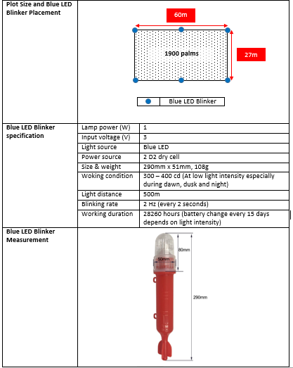

2700 palms

Plate 2: Blue LED Blinker specification and plot size for each treatment

**RESULTS & DISCUSSIONS**

**Survey of Wild Boar Control Management at the Plantation**

Table 1 showed the details of every plantation with wild boar incidence and damage.Electric fence on Plantation A and B had the lowest average of wild boar damage (4.77 Ha), followed by zinc plate (30.0 Ha) and chain-link fence (90.85 Ha).

**TABLE 1. DETAILS OF SELECTED PLANTATION WITH WILD BOAR DAMAGE AND CONTROL METHOD IN 2017.**

|  |  |  |
| --- | --- | --- |
| Plantation | Wild Boar Damage (Ha) | Control Method |
|
| A | 4.53 ha | * Electric fence |
| B | 5 Ha | * Electric fence |
| C | 30 Ha | * Zinc Plate |
| D | 0.38 Ha | * Chain-link fence |
| E | 6 Ha | * Chain-link fence |
| F | 81 Ha | * Chain-link fence with barbwire |
| G | 276 Ha | * Chain-link fence with razorblade wire |

From the survey, management from Plantation A and B said the wild boar damage caused when their electric fence encountered problems such as energizer sudden shutdown and electric wire snapped. Electric fence had been proven to deter wild boar and elephant from entering and destroying crops. This method was so costly therefore it will only implemented when encountered serious issue like elephant damage and human intrusion. Fence will be installed at the border of the plantation by focusing on the area with high damage done by elephant or wild boar. Installation of electric fence was followed PERHILITAN, which were the first wire was 76.2 cm from the ground, the second wire was 61cm from the ground. In addition, a third wire is installed at 100cm from the ground. An energizer box needed to be installed at every 3km of the fence, covering 1.5km from both left and right of the fence. The electric voltage needed to be a minimum of 7kV. The electric were channelled on every three seconds. On the other hand, two strand of polywire measured 20 cm and 45 cm from the ground with a minimum of 7kV had reduce wild boar daily infestation by 50% and deter 75% of them from the bait station (Reidy et al., 2008).

Plantation C was said to applying the zinc plate after the wild boar attack. The negligent act had caused the management to suffer from wild boar damage. Zinc plate that followed SOP and were properly installed can reduce wild boar damage. Supposedly, zinc plate was installed together with the young palm during planting process. 10 young palms from the border were compulsory to be installed with zinc plate in order to prevent pest damage. Zinc plate and barbwire guard is not only to control wild boar, but also from rat and porcupine damage. Zinc plate or barbwire were wrapped around the oil palm base to protect the meristem from pest. Some sticks or steel pegs were then used to fasten the guard onto the ground. This will prevent the pest from removing the guard and damage the palm meristem. Other materials such as mulching, polybag and special designed plastic were also used as the guard.

Installation of chain-link fence were usually accompanied with barbwire or razorblade wire to enhance the effectiveness. For chain-link fence, the height was around 1 metre. On top of that, three barbwire or razorblade wire will be installed at the top of the fence with a distance around 10 cm from each other. At the bottom of the fence, cemented concrete were installed to improved durability and prevent pest from digging the ground below the fence. One common problem by the plantation D, E, F and G were that all chain-link fence was only covered certain border of the plantation, which mean the chain-link was not fully linked to each other. A desperate wild boar will took the long route and still manage to enter the plantation compound from the border that got no chain-link fence (Reidy *et al.*, 2008; Morelle *et al*., 2015).

The result on Table 2 showed the types of control management on wild boar and their cost. There were six control methods that were commonly used by the plantation. The cost for each method was defined in a different ways, based on per palm and per metre. Because of that, a simulation cost of 136 palms per one hectare was established. One hectare comprised of 10,000 m2, which mean 100m x 100m. If one hectare of a square plot having 100m of diameter, we need 400m of fence to fully cover the one hectare of a square plot. From this, one hectare was equal to the 136 palms and 400m of fences. Based on the calculation, the result shown the cheapest methods were barbwire guard (RM77.52/ha), followed by zinc plate guard (RM292.40/ha), overage palm (DxP) (RM1604.00/ha), overage palm (Clone) (RM5276.80/ha), chain-link fence (RM7200.00/ha) and electric fence (RM7272.00/ha).

**TABLE 2. TYPES OF CONTROL MANAGEMENT ON WILD BOAR AND THEIR COST.**

|  |  |  |
| --- | --- | --- |
| Type of control | Cost | Simulation cost for 136 palms/ha |
| Barbwire guard | RM0.57/palm | RM77.52 |
| Zinc plate guard | RM2.15/palm | RM292.40 |
| Overage palm (DxP) | RM11.80/palm | RM1604.00 |
| Overage palm (Clone) | RM38.80/palm | RM5276.80 |
| Chain-link fence with barbwire/ razorblade wire | RM18.00/metre | RM7200.00 |
| Electric fence with barbwire/ razorblade wire | RM18.18/metre | RM7272.00 |

Overage palm (DxP and Clone) were used to replace the dead palm during immature stage of oil palm planting. This method was a bit difference from the normal planting because plantation were using the older oil palm seedlings instead of the normal age palm. The transportation and planting cost were slightly higher than normal planting because the older oil palm seedling was heavier and their fronds had grew longer which hinder the planting process. From our observation, this method was also good to reduce dead palm caused by rhinoceros beetle because older palm recover from rhinoceros beetle attack better than the younger one.

For other crops and country, the popular methods to control wild boar were hunting intensively, applying deterrent system, offer supplemental food to divert the wild boar from the crops, live trapping and usage of poison bait (Bengsen et al., 2016). Hunting had significantly reduce wild boar damage (Geisser & Reyer 2004), but their reproduction can increase by 200 % under favourable conditions (Schlageter & Haag-Wackernagel, 2012). Deterrent system by electric fence and live trapping were laborious and very expensive. It cost can be doubled because it need regular surveillance and maintenance to operate efficiently. Electric fence also exposed to other problems like stolen energizer, low voltage due to battery problem and loss of power when tree branch or stick fallen on the wire. Various deterrent system based on acoustic, gustatory and optic had been introduced in the market to control wild boar damage. Yet, no or little scientific study had been conducted to proof the effectiveness of these products. Poison bait from sodium flouracetate (1080) and sodium nitrite had been registered and used as vertebrate poison bait in New Zealand. Sodium nitrite poisoning symptom shown no major distress to pig (Cowled et al., 2008). Record shown that warfarin LD90 for wild boar is > 20 mg kg-1 but on average a wild boar consumed a total of 5.2 kg of 0.09% warfarin poison bait equivalent to a dose of 117 mg kg-1 (Saunders et al., 1990). Nevertheless, proactive action needed to be taken so that a sustainable, affordable and efficient ways to control wild boar damage can be established and saved management cost.

**Preliminary Study of Selected Control Management on Wild Boar**

The result on Table 3 showed that all treatments had no significant different when analysed with one way-ANOVA. The null hypothesis of all means are equal cannot be rejected. Nevertheless, from the result, Kerimo had the highest mean bait taken compared to naphthalene, white light and control. This situation is contradicted with what we expected as all the olfactory treatment need to have less mean bait taken compared to control. This was happened because of the different wild boar wallowing area had different population of wild boar. Some of the wallowing area had been abandoned by the wild boar due to the changes like weather, human intervention, competition and food source (Morelle et al., 2015.). After seven weeks of study, only one wallowing area was actively visited by wild boar.

Kerimo was advertised as artificial tiger urine and had been said to deter mammals like wild boar, rat and civet. This product was the same as scent fence called ‘‘Duftzaun®’’ and ‘‘Wildschwein-Stopp®’’, a chemical repellent imitating a mixture of several predator odours. Both products had considered as not effective in deterring wild boar incidence (Lutz, 1994; Schlageter, & Haag-Wackernagel, 2012). All olfactory deterrent were not effective maybe because of the wild boar had well-developed olfactory when compared to the visual (Reidy et al., 2008), which mean that they can differ the smell of the real predator compared to the artificial one.

**TABLE 3. RESULT OF THE WILD BOAR MEAN BAIT TAKEN ON DIFFERENT OLFACTORY TREATMENT.**

|  |  |
| --- | --- |
| Treatment | Mean bait taken ± s.e. |
| Kerimo | 0.66 ± 0.15 *n.s |
| Napthalene | 0.23 ± 0.10 *n.s |
| White light | 0.37 ± 0.13 *n.s |
| Control | 0.37 ± 0.12 *n.s |

Note: all treatments are not significantly different at P < 0.05 (by one way-ANOVA)

**Case Study of Using Blue LED Blinker to Control Wild Boar**

The result on Table 4 showed that Plot C had no difference in means with Plot A and B after the installation of the Blue LED Blinker starting from 1WAA till 6WAA. Before the treatment, Plot C had the highest wild boar damage (25.22 ± 6.7), compared to Plot A (7.67 ± 4.8) and B (13.78 ± 1.5). Pre-treatment had been done twice to confirm that the wild boar were continually infested the area. The result showed that Blue LED Blinker can deterred wild boar infestation.

**TABLE 4. RESULT OF THE NUMBER OF WILD BOAR DAMAGE ON BLUE LED BLINKER.**

|  |  |  |  |  |  |  |  |  |  |
| --- | --- | --- | --- | --- | --- | --- | --- | --- | --- |
| Plot | Mean number of wild boar damage (Week after application) | | | | | | | | Total palm damage (%) |
| **PRE1** | **PRE2** | **1WAA** | **2WAA** | **3WAA** | **4WAA** | **5WAA** | **6WAA** |
| A  (untreated) | 3.33 ± 1.2 a | 7.67 ± 4.8 a | 3.56 ± 1.3 a | 1.44 ± 1.2 a | 3.22 ± 2.8 a | 4.67 ± 1.0 a | 4.57 ± 2.4 a | 3.11 ± 2.0 a | 19.00 % |
| B  (untreated) | 19.33 ± 4.0 b | 13.78 ± 1.5 ab | 3.89 ± 1.5 a | 3.22 ± 1.2 a | 7.00 ± 1.5 a | 4.67 ± 1.4 a | 5.33 ± 1.0 a | 3.67 ± 1.1 a | 17.00 % |
| C  (Blue LED Blinker) | 22.22 ± 6.3 b | 25.22 ± 6.7 b | 4.00 ± 1.6 a | 4.11 ± 1.5 a | 8.33 ± 5.3 a | 6.11 ± 2.2 a | 7.44 ± 2.6 a | 6.33 ± 2.4 a | 24.63 % |

Note: Means in column with different letters are significantly different at P < 0.05 (by Tukey HSD).

ETL 5%

This study result was contradicted with the previous study that shown Red LED Blinker had deter the wild boar visit by only 8.1 % compared to the control plot, it is insufficient to protect the crops (Schlageter & Haag-Wackernagel, 2011). This is because pig, from order artiodactyla had only 7% of cone photoreceptor and sensitive to wavelength of 439 mm and 556 mm (Jacobs, 1993). Which mean they have a dichromatic vision, it can only detect mainly blueish colour, a part of greenish with yellowish colour and none of the red colour (Eguchi *et al.,* 1997). Wild boar had less red perception cone cells and more blue perception cone cells when compared to human. The differences is caused by the evolution to adapt in low light area such as forest (Eguchi *et al.,* 1997). In other study, weaners were preferred blue feeder box over yellow and red indicating their ability to distinguish blue colour over others (Klocek et al., 2016).

Plot C had the highest total palm damage with a total of 24.63 % compared to Plot A with 19.00 % palms and B with 17.00 % palms. Plot C was heavily damaged because it is located at the right side of the nursery. Observation showed the right side of the nursery was a swampy area with tall bushes, which is the favourable condition for shelter and foraging of wild boar. Zinc fence bordering the swampy area had shown scratches, holes and marks indicating active activity of wild boar passing through the area (Plate 3).

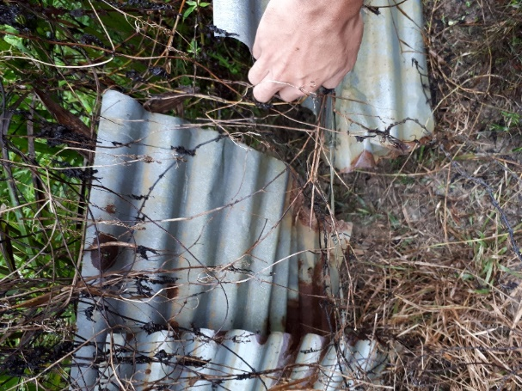 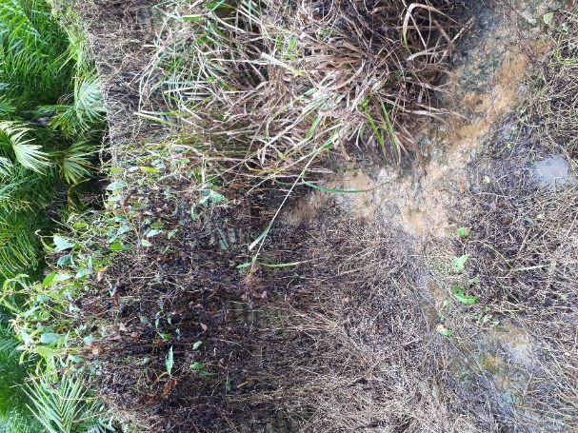

Plate 3: Broken zinc fence and trails done by wild boar

**CONCLUSION**

Plantation surveyed shown that electric fence on had the lowest average of wild boar damage. Despite that, electric fence is the most expensive control method for wild boar. All olfactory deterrent were having non-significant result in preventing wild boar incidence. Blue LED Blinker had shown significant result in reducing wild boar damage in oil palm nursery. Nevertheless, any control methods need to follow standard specification to operate efficiently.

**REFERENCES**

Act, W. C. 2015. Act 716. Percetakan Nasional Malaysia Berhad.

Bengsen, A. J., West, P., & Krull, C. R. 2016. Feral pigs in Australia and New Zealand: range, trend, management and impacts of an invasive species. Ecology, Evolution and Management of Wild Pigs and Peccaries. Implications for Conservation. Cambridge University Press, Cambridge, UK.

Cowled, B. D., Elsworth, P., & Lapidge, S. J. 2008. Additional toxins for feral pig (Sus scrofa) control: identifying and testing Achilles’ heels. Wildlife Research, 35(7), 651-662.

Eguchi, Y., Tanida, H., Tanaka, T., & Yoshimoto, T. 1997. Color discrimination in wild boars. Journal of Ethology, 15(1), 1-7.

Geisser, H., & Reyer, H. U. 2004. Efficacy of hunting, feeding, and fencing to reduce crop damage by wild boars. The Journal of Wildlife Management, 68(4), 939-946.

Jacobs, G. H. 1993. The distribution and nature of colour vision among the mammals. Biological Reviews, 68(3), 413-471.

Klein, F., Baubet, E., Toigo, C., Leduc, D., Saint-Andrieux, C., Said, S., Frechard, C., Vallance, M., 2007. La Gestion du sanglier. Des Pistes et des outils pour reduire les populations. Brochure Technique. OffNatl Chasse, Paris, Auffargis, Bar-le-Duc, France.

Klocek, C., Nowicki, J., Brudzisz, B., & Pabiańczyk, M. 2016. Colour preferences in pigs. Scient. Ann. Polish Soc. Anim. Prod, 12(4), 123-129.

Lutz, W. 1994. Ergebnisse der Anwendung eines sogenannten Duftzaunes zur Vermeidung von Wildverlusten durch den Strassenverkehr nach Gehege-und Freilandorientierungen. Zeitschrift für Jagdwissenschaft, 40(2), 91- 108.

Mohd Anim, H. 2015. Lampu Signal Nelayan Kawal Tikus? [Blog post]. Retrieved from <http://animhosnan.blogspot.com/2015/07/lampu-signal-nelayan-kawal-tikus.html>

Morelle, K., Podgórski, T., Prévot, C., Keuling, O., Lehaire, F., & Lejeune, P. 2015. Towards understanding wild boar Sus scrofa movement: a synthetic movement ecology approach. Mammal Review, 45(1), 15-29.

Reidy, M. M., Campbell, T. A., & Hewitt, D. G. 2008. Evaluation of electric fencing to inhibit feral pig movements. The Journal of Wildlife Management, 72(4), 1012-1018.

Saunders, G., Kay, B., & Parker, B. 1990. Evaluation of a warfarin poisoning programme for feral pigs (Sus scrofa). Wildlife Research, 17(5), 525-533.

Schlageter, A., & Haag-Wackernagel, D. 2011. Effectiveness of solar blinkers as a means of crop protection from wild boar damage. Crop protection, 30(9), 1216-1222.

Schlageter, A., & Haag-Wackernagel, D. 2012. Evaluation of an odor repellent for protecting crops from wild boar damage. Journal of pest science, 85(2), 209-215.

Schley, L., & Roper, T. J. 2003. Diet of wild boar Sus scrofa in Western Europe, with particular reference to consumption of agricultural crops. Mammal review, 33(1), 43-56.