Supplying and Controlling Water System Using IOT Techniques

G Chandra Mohan Reddy 1& M V Ramana Murthy2

MGIT, CBIT- Campus, Hyderabad-75, mail id- mv.rm50@gmail.com

**ABSTRACT**: Water is the most precious and valuable because it’s a basic need of all the human beings but, now a dayswater supply department are facing problem in real time operation this is because less amount of water in resources due to less rain fall. Water supply management system needs data regarding water storage present in Dam. Satisfying theincreasing demand for water supply has been major challenge for many countries around the world. . The system can measure the water level and give measurement report to the central office. This system use sensors to measure the water level of Dam and updates are provided to Corporation on daily basis. Supply of water to the particular area according to the water level in the dam, and it will be informing to the customer about water level and the time period of water supply using GSM message service. Internet of things is nothing but the network of physical objects embedded with electronics, sensors, software, and network connectivity.

**KEYWORDS**: Flow sensor, Turbidity sensor, GSM, Internet of Things (IOT), Water, Wireless

**INTRODUCTION :** In some water-related field such as pre-flood warning thousands of households collect periodic measurements system, irrigation system, electricity, powerhouse, and that are reported in real-time over a wireless network to a research, water level information is a very important issue. Usually, water level measurement was done manually, however this can be not effective due to some difficulties This system will update water level related notifications to like problem to reach the measurement site, human error, web servers using internet, which means that there is no etc. Some automatic water level measurement systems need to come directly to the measurement site. Water have been made using mechanical sensors such as resistive supply management will be done according to water level sensor, capacitive sensor, or magnetic sensor, but these present in Dam. sensors have to do direct contact with water that makes their life span shorter because of corrosion [1]. On the This system sends the data to the central office using web other hand, this system uses ultrasonic sensor that can server for database maintenance. The data base is secured measure the water level without direct contact with water, by providing a password protected access. By focusing on problems in traditional methods our system design and develop a low cost embedded system device for real time monitoring of water distribution system in Internet of things (IOT) platform. IOT is a world where billions of objects can sense, communicate and share information, all interconnected over public or private Internet Protocol (IP) networks. These interconnected objects have data regularly collected, analyzed and used to initiate action, providing a wealth of intelligence for planning, management and decision making.

**SYSTEM DESIGN**

In GSM Based Automated Irrigation Control using Rain gun Irrigation System.R.suresh , S.Gopinath , K.Govindaraju , T.Devika , N.SuthanthiraVanitha [1] mentioned about using automatic microcontroller based rain gun irrigation system in which the irrigation will take place only when there will be intense requirement of water that save a large quantity of water. These system brings a change to management of field resources where they developed a software stack called Android is used for mobile devices that include an operating system, middleware and key applications. The Android SDK provides the tools and APIs necessary to begin developing applications on the Android platform using the Java programming language. Mobile phones have almost become an integral part of us serving multiple needs of humans. This application makes use of the GPRS feature of mobile phone as a solution for irrigation control system. These system covered lower range of agriculture land and not economically affordable.

The System Supports excess Amount of water in the land and uses GSM to send message and an android app is been used they have used a methodology to overcome under irrigation, over irrigation that causes leaching and loss of nutrient content of soil they have also promised that Microcontroller used can increase System Life and lower the power Consumption. There system is just limited to the automation of irrigation system and lacks in extra ordinary features.

In GSM based Automatic Irrigation Control System for Efficient Use of Resources and Crop Planning by Using an Android Mobile Pavithra D. S, M. S .Srinath.[2] States features of their system.

* The system supports water management decision, used for monitoring the whole system with GSM(RS-232) module
* The system continuously monitors the water level (Water level Sensor) in the tank and provide accurate amount of water required to the plant or tree (crop).
* The system checks the temperature, and humidity of soil to retain the nutrient composition of the soil managed for proper growth of plant.
* Low cost and effective with less power consumption using sensors for remote monitoring and controlling devices which are controlled via SMS using a GSM using android mobile.

The setup of technical system describe in this paper is broad based and is relatively one of the efficient system that has developed windows application to monitor the field. Field is equipped with wireless communication sensors that avails better facilitated sensor communication and covers wider field area. Detailed description on site field sensors and Internet technology is described briefly. The statistical data provided is measured to be efficient and used for research work.

A wireless application of drip irrigation automation supported by soil moisture sensors [2] Irrigation by help of freshwater resources in agricultural areas has a crucial importance. Traditional instrumentation based on discrete and wired solutions, presents many difficulties on measuring and control systems especially over the large geographical areas.

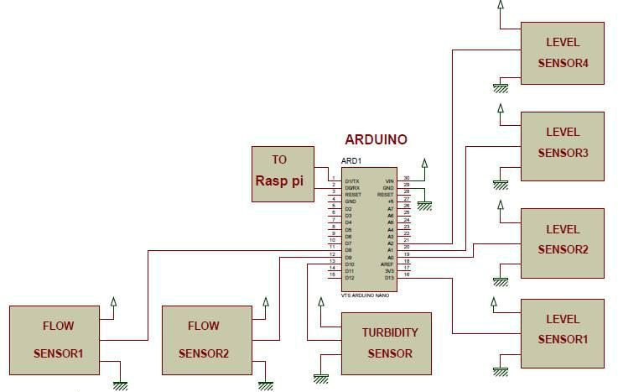

**Fig .1** Block schematic diagram of a system

Using we are going to collect a data from sensors here, level sensors are connected to analog i/p and flow sensors are connected to digital i/p pins are used. Water flow sensor consists of a plastic valve body with a water rotor it uses a pinwheel sensor to measure how much liquid has moved through, water flows through the rotor rolls, speed changes which outputs the corresponding pulse Signal. Flow rate measured in Liters/sec/min/hour. By counting the pulses from the output of the sensor, can easily track fluid movement. Flow rate in our project flow rate is calculated in ml/sec. Turbidity sensor measure the amount of suspended particles, or turbidity in the water. If the Soil level increases transmitted light decreases Turbidity sensors are used to check quality of water.

**ROPOSED WORK**

The two mobile are connected using GSM. The GSM and microcontroller are connected using MAX232. when moisture of the soil become low moisture sensor sense it and send signal to microcontroller, then the microcontroller gives the signal to mobile and it activate the buzzer. This buzzer indicates that valve needs to be opened by pressing the button in the called function signals are sent back to microcontroller.

**Algorithm**

It states the steps that the proposed system undergoes.

**Step 1:** Start the process.

**Step 2:** Initialize power is supplied to GSM

**Step 3:** Check the moisture level (less than or more than).

**Step 4:** If the level will be more than a fixed criteria, noneed to irrigation

**Step 5:** If Moisture level is less than a fixed criteria, startirrigation

**Step 6:** Initialization of pump and raingun

**Step 7:** After the process completed, It moves to originalstate.

**Step 8:** Stop the process.

Another methodology is broad based and is relatively one of the efficient system that has developed windows application to monitor the field. Field is equipped with wireless communication sensors that avails better facilitated sensor communication and covers wider field area. A conceptual system layout of distributed in-field WSN is illustrated. The system consists of five in-field sensing stations distributed across the field, an irrigation control station, and a base station. The in -field sensing stations monitor the field conditions of soil moisture, soil temperature, and air temperature, whereas a nearby weather station monitors micrometeorological information on the field, i.e., air temperature, relative humidity, precipitation, wind speed, wind direction, and solar radiation. All in -field sensory data are wirelessly transmitted to the base station. The base station processes the in-field sensory data through a user-friendly decision making program and sends control commands to the irrigation control station.

**CONCLUSION**

Using this system secure and continuous monitoring is possible No need to go on field for monitoring so manual work has reduced it makes system more efficient, reliable, low cost and accurate we can Data monitored from anywhere controlling is possible from a remote server it is Economical in development and This review is proposed to supports aggressive water management for the agricultural land. Microcontroller in the system promises about increase in systems life by reducing the power consumption resulting in lower power consumption. It is considered to be used at Cricket stadiums or Golf stadiums and also in public garden area for proper irrigation. Automated irrigation system has a huge demand and future scope too. It is time saving, led to removal of human error in adjusting available soil moisture levels and to maximize their net profits in accordance to factors like sales, quality and growth of their product.

**REFERENCES**

1. Shiraz Pasha B.R., Dr. B Yogesha, “Microcontroller Based Automated Irrigation System”, The International Journal Of Engineering And Science (IJES), Volume3, Issue 7, pp 06-09, June 2014.
2. S. R. Kumbhar, Arjun P. Ghatule, “Microcontroller based Controlled Irrigation System for Plantation”, Proceedings of the International MultiConference of Engineers and Computer Scientists 2013Volume II, March 2013.
3. Yunseop (James) Kim, Member, IEEE, Robert G. Evans, and William M. Iversen, “Remote Sensing and Control of an Irrigation System Using a Distributed Wireless Sensor Network”, IEEE July 2013.
4. Anjana S1, Sahana M N2, Ankith S3, K Natarajan4, K R Shobha5,” An IoT based WPAN enabled Experiment for Water Management , IEEE 2015.
5. S. Harishankar, R. Sathish Kumar, Sudharsan K.P, U. Vignesh and T.Viveknath, “Solar Powered Smart Irrigation System”, Advance in Electronic and Electric Engineering, Volume 4, Number 4 (2014), pp. 341-346