**Economic Implications of a Pathogen Infection of the Malaysian Oil Palm Plantations: A Partial Equilibrium Model Approach**

Oladokun Nafiu Olaniyi1 and Kenneth R. Szulczyk1

Faculty of Business1, Curtin University Malaysia,

nafiuo@curtin.edu.my

kenneth@curtin.edu.my

# Abstract

Oil palm is an important crop that contributes significantly to the economic and social development of Malaysia and contributes 39% of the global oil palm production. However, the effect of pathogens especially Basal Stem Rot (BSR) poses a significant threat to the oil palm. Lack of effective understanding of the economic implications of this dreaded disease has a considerable effect on its prevention. Motivated by this development, a partial equilibrium model that represents the Malaysian agriculture allows the measure of economic damage caused by a pathogen. The analysis indicates that even a slow-moving pathogen can harm the oil palm in terms of reduced social welfare, higher agricultural prices, and agricultural employment, and exacerbate deforestation. A one-time pathogen eradication fee helps recover the oil palm in terms of social welfare, agricultural prices, and employment but not to the base levels with the absence of a pathogen.

**Keywords:** Biosecurity; biological threat; oil palm; partial equilibrium model

# 1. Introduction

Oil palm is an important economic crop that contributes significantly to the global output of edible oil. The high demand for palm oil due to its economic importance has led to the continued expansion of oil palm plantation in Malaysia and Indonesia. In 2016, Malaysia accounted for 39% of world palm oil production and was the second largest exporter of palm oil (Economics & Industry Development Division, 2017). Malaysia earned an estimated RM78 billion in export revenue from oil palm in 2017 (Kushairi & Nambiappan, 2018). Furthermore, a total of 19.92 million tons of palm oil was produced from 5.74 million hectares of oil palm plantations in Malaysia in 2017 (Economics & Industry Development Division, 2017).

The contribution of oil palm to the economic growth of countries like Malaysia is vulnerable to pathogen infection. For example, Basal Stem Rot (BSR), the most prevalent disease in oil palm trees causes sizeable economic damages by reducing crop yields and killing the oil palm trees. When the infection first appeared in Malaysia, BSR affected the mature palm trees with ages exceeding 30 years but currently infects young palm trees of 1-2 years old (T. Azahar, Mustapha, Mazliham, & Boursier, 2011; Wong, Bong, & Idris, 2012). The BSR is caused by the fungus, Ganoderma boninense. According to Parthiban et al. (2016), Ganoderma disease has infected 151,208 hectares of Malaysian oil palms with an estimated loss of RM1.3 billion in 2009. One of the greatest obstacles in managing BSR is lack of effective understanding of the pathogen’s spread and its economic implications (T. M. Azahar, Boursier, & Seman, 2008).

The destructive nature of dreaded diseases affecting oil palm yields coupled with the need to provide enhanced understanding has attracted considerable attention from researchers who are striving to understand the nature, causes, and methods to mitigate diseases. BSR poses the greatest threat to oil palm production in South East Asia (Rees, Flood, Hasan, Potter, & Cooper, 2009). According to Parthiban et al. (2016), oil palm plantation owners should worry about incurring considerable financial losses when 10% of the oil palm stands become infected.

Two factors have contributed to the BSRs infection in oil palm plantations. For the first factor, studies have connected the widespread distribution of BRS in coastal areas in Malaysia (Govender, Wong, Maziah, & Idris, 2015; Parthiban et al., 2016). Conversion of previously coconuts stands to oil palm has attributed to the high infection rate in oil palm plantation. BSR could infect the oil palm tree via root contact of infected wood following lignin degradation (Govender et al., 2015). For the second factor, several studies have linked the relationship between BSR and palm tree density. For instance, T. Azahar et al. (2011) studied three different plantations with varying density and concluded that the spread of BSR was random across the three sampled plots. Contrary to this finding, Kamu, Chong, Seman, and Ho (2015) revealed the epidemic is not random and concluded that the spread of BSR occurs through root contact. Thus, the spreads of BSR is independent of the palm tree density.

Idris, Kushairi, Ismail, and Ariffin (2004), in addition, employed geographical information system (GIS) to examine the spatial patterns of BSR in oil palm plantation in Miri and Kuching, Sarawak. The study included oil palms ranging from 12 to 24 years to gain information about the temporal, spatial, and hotspots of the disease. The initial infection started from 0.12% to 0.27% at 12 years and grew from 9.74% to 18.63% at 24 years. Consequently, the disease spread started randomly (12-18 years after planting) and, after that, spread through root-to-root contact by affecting nearby palm trees.

Assis, Chong, Idris, and Ho (2016) investigated the economic losses from BSR using regressions on three commercial oil palm sites. The study revealed that the pathogen infection could quickly grow to as much as 43.32% yield loss. In a related study, Roslan and Idris (2012) equally assessed revenue loss due to BSR and determined that the disease may lead to yield losses between 0.04 and 4.34 tons per hectare on oil palm with ages between 10 and 22 years respectively. On the hand, Kalidas (2012) investigated the roots of the pathogen’s infection in oil palms and concluded pest migration carried the infection to new areas. The study determined that the yield loss of oil palms due to pests’ infection ranged between 20 and 30% after the attack had begun. Furthermore, Van de Lande (1993) explored the epidemiology of BSR in oil palms in Suriname and attributed the disease spread to the wind influence and replanting approaches. The study further indicated that a pathogen caused more than 50% yield loss. At last, Chong, Dayou, and Alexander (2017) assessed how to detect and control a pathogen in an oil palm plantation. The study revealed that infection and spread of pathogen are associated with in-contact roots with neighboring diseased oil palms and through airborne fungus spores.

Even though several studies estimated the economic impacts of pathogens, none of these studies comprehensively assessed and forecasted long-term economic implications of a pathogen on oil palm plantations. The present study, therefore, fills this research gap by exploring the economic implications of pathogens based on a partial equilibrium model. In contrast to previous studies as indicated in the literature review, the model estimates a variety of economic indicators and comprehensively forecasts the long-term effects of a pathogen’s spread on the oil palm plantations. The remaining sections of the paper are organized as follow: Section 2 discusses the methodology while results and discussion are presented in Section 3. Finally, Section 4 concludes the paper.

# 2. Methodology

## 2.1 A Partial Equilibrium Model of the Malaysian Agriculture

The study’s objective is to apply a partial equilibrium model to determine a pathogen’s spread across oil palm plantations. The study does not specify Basal Stem Rot (BSR) per se, but the approach applies to any pathogen or country’s agriculture. The model, the Malaysian Agriculture and Plantation Greenhouse Gas Equilibrium Model (MAPGEM), incorporates a pathogen’s spread rate, eradication costs, and forecasts equilibrium prices and quantities for Malaysia’s largest agricultural commodities. Table 1 presents the pathogen’s spread rate and four economic indicators: Social welfare, agricultural prices, agricultural employment, and deforestation.

MAPGEM includes land use changes via Equations (1) through (4). Equation (1) allows the conversion of cocoa, coconut, rainforest, and rubber plantations to oil palm via the convert (CN). Meanwhile, d(t) imposes a decreasing rate of land conversion. Land transfers (LT) places an upper limit on land conversion with plantation type (p), state (s), and time (t). Equation (2) represents the newly planted oil palms from land transfers. The model also replants old oil palms with new trees via replant trees (RT). Finally, landowners can pay a one-time fee to eradicate the pathogen and recover the land (RL). The RL utilizes an indicator function, φ(), to turn on land recovery. Equation (3) represent five-year oil palm trees inventory (TI). The indicator function loads the tree inventory in 2015, and the equation becomes dynamic for 2020 and later. Equation (4) comprises the 10-year oil palms and older. It retains the land from the previous period and adds five-year-old oil palms from the last period. It also deducts replanted trees (RT) and contaminated land (CL). In equation (5), it is assumed the oil palm trees’ age are uniformly distributed, and 1/30 of the land is cleared and replanted to maintain high fresh fruit bunch (FFB) yields, the fruits from the oil palm.

${CN}_{p,s,t}=d\left(t\right){LT}_{p,s} ∀ p,s,t$ (1)

$H_{oil palm 0y,s,t}=\sum_{p}{{CN}_{p,s,t}}+{RT}_{s,t}+{RL}_{s,t}∙∅\left({on}_{1}=1\right) ∀ s,t$ (2)

$H_{oil palm 5y,s,t}=H_{oil palm 0y,s,t-1}∙∅\left(t>1\right)+{TI}_{oil palm 5y,s}∙∅\left(t=1\right)∀ s,t$ (3)

$H_{oil palm 10y,s,t}=H_{oil palm 10y,s,t-1}∙∅\left(t>1\right)+H_{oil palm 5y,s,t-1}∙∅\left(t>1\right)$ (4)

${-RT}_{s,t}-{CL}_{s,t}+{TI}_{s,oil palm 10y,s}∙∅\left(t=1\right) ∀ s,t$

${RT}_{s,t}=\frac{1}{30}H_{oil palm 10y,s,t} ∀ s,t$ (5)

Equation (6) holds the contaminated land (CL) from the mature oil palms. Farmers can pay a one-time eradication fee to recovery land (RL) with the indicator function, φ()as an on-off switch. Meanwhile, Equation (7) ensures the recovered land can never exceed the amount of infected land.

$H_{infected,s,t}=H_{infected,s,t-1}∙∅\left(t>1\right)+{CL}_{s,t}-{RL}_{s,t}∙∅\left({on}_{1}=1\right) ∀ s,t$ (6)

${RL}_{s,t}∙∅\left({on}_{1}=1\right)-H_{infected,s,t}≤0 ∀ s,t$ (7)

Equations (8) – (11) handle the dynamic equations for cocoa, coconut, forest, and rubber. As oil palm land becomes contaminated, the landowners may convert (CN) more land from cocoa, coconut, forest, and rubber into oil palms. The land transfers would limit the amount landowners would pay to recover the contaminated land. However, a pathogen outbreak could hasten deforestation.

$H_{cocoa,s,t}=H_{cocoa,s,t-1}∙∅\left(t>1\right)+{TI}_{cocoa,s}∙∅\left(t=1\right)-{CN}_{cocoa,s,t-1}∙∅\left(t>1\right) ∀ s,t$ (8)

$H_{coconut,s,t}=H_{coconut,s,t-1}∙∅\left(t>1\right)+{TI}_{coconut,s}∙∅\left(t=1\right)-{CN}_{coconut,s,t-1}∙∅\left(t>1\right) ∀ s,t$ (9)

$H_{forest,s,t}=H_{forest,s,t-1}∙∅\left(t>1\right)+{TI}_{forest,s}∙∅\left(t=1\right)-{CN}_{forest,s,t-1}∙∅\left(t>1\right) ∀ s,t$ (10)

$H_{rubber,s,t}=H_{rubber,s,t-1}∙∅\left(t>1\right)+{TI}_{rubber,s}∙∅\left(t=1\right)+-{CN}_{rubber,s,t-1}∙∅\left(t>1\right) ∀ s,t$ (11)

The model allows the total contaminated land (TCL) to be transferred to the cropland (CL) in (12). The model starts with the available land (AL) for crops while farmers allocate cropland for banana, durian, kenaf, mango, papaya, pepper, pineapple, rambutan, and rice. Since oil palms greatly exceed all crops combined, this option is not explored in this paper.

$\sum_{c}{{CL}_{t,s,c}≤{AL}_{s}+{TCL}_{s,t}∅\left({on}_{3}=1\right) ∀ s,t}$ (12)

Once land becomes contaminated, oil palms die and yield zero fresh fruit bunches. Consequently, landowners would not employ labor and apply fertilizer to the contaminated land. Since oil palms are the largest grown commodity in Malaysia, a decrease in demand would lower the resource prices and affect all growing costs in the model. Equation (13) balances the resources employed in plantations and crops with hectares (H) representing the plantation type while cropland (CL) contains crops. The plantation resources (PR) and crop resources (CR) indicate resource usage for one hectare of land and include labor, nitrogen, phosphorous, and potash costs. Finally, resource usage (RU) indicates the available resources (r) for each state (s) and time (t).

$\sum_{p}{H_{p, s,t}∙{PR}_{p,s,r}}+\sum_{c}{{CL}_{c,s,t}∙{CR}_{c,s,r}}≤{RU}_{r,s,t} ∀ r,s,t$ (13)

Equation (14) shows the inverse supply functions for labor, nitrogen, phosphorous, and potash and appears in the objective function. P(RU) represents the inverse supply function with resource supply elasticity of d. Parameter e is calibrated for 2015.

$P_{r,s,t}\left({RU}_{r,s,t}\right)=e_{r,s}{RU}_{r,s,t}^{d_{r,s}}$ (14)

## 2.2 Modeling a Pathogen’s Spread in the Model

A two-stage procedure is applied to model a pathogen’s spatial movement and depends on two binary constraints. The base scenario, which omits the pathogen, estimates changes in the land use for palm oil between 2015 – 2065. The pathogen’s spread is estimated with the base scenario’s land use imposed as a constraint in the model. The model assumes that the pathogen’s spread across the land is independent of economic factors such as the wind carrying the fungus for BSR. The indicator function, pathogen spread (PS), in Equation (15) represents a pathogen’s strength. It is set to zero when the pathogen infects a low percentage of the land and does not spread to a neighboring state. The indicator function switches on whenever the contaminated land (CL) exceeds the threshold (δ), the proportion of contaminated land. The threshold is set at 0.85 indicating that the pathogen has the potential to spread to neighboring states if 85% of the land is contaminated. The Land Use (LU) in the model represent the forecasted land use for oil palm plantation between 2015 and 2065 for the base scenario.

${PS}_{s,t}=I_{\left\{{CL}_{s,t-1}/{LU}_{s,t-1}>δ\right\}}$ (15)

The first term of the indicator function (IS) in Equation (16) represents an infected state remains infected for the life of the model while the second term allows the infection to spread to neighboring states. In equation (16), the State Spatial (SS) consists of a matrix of zeros and ones whereby each state has a one for itself and a one for its neighbor while the remaining entries are zero. The SS is assumed to be symmetric by construction and is multiplied by the pathogen strength (PS) from (15).

${IS}_{s,t}={IS}_{s,t-1} or I_{\left\{\sum_{s1}{{SS}_{s,s1}∙{PS}_{s,t}>0}\right\}}$ (16)

The pathogen starts in Selangor which remains infected throughout the model. Equation (17) calculates the contaminated land (CL) for each state (s) at each time (t). The pathogen growth (g) is standardized and measured in hectares since each state differs in hectares of oil palm plantations. In addition, Equation (16) can be used to measure the pathogen’s duration in a state by counting the ones in each state’s row. The growth rate could then be adjusted by how long the pathogen has been present in the state. However, no studies at this time allow the inference of a growth rate’s adjustment.

${CL}_{s,t}=g∙{IS}_{s,t}$ (17)

The total uncontaminated land (TUL) and total contaminated land (TCL) for each state, s, and for a pathogen’s growth is obtained from Equations (18) and (19). The total uncontaminated land equals the past value plus the difference in land use (LU) and deducts contaminated land (CL) in each state, s, while total contaminated land (TCL) aggregates the contaminated land over time in each state. Finally, the program checks for negative land values in TUL and adjusts the CL, TUL, and TCL, accordingly. Then the variables, CL, TUL, and TCL, are imposed on oil palm land use in the model.

${TUL}_{s,t}={TUL}_{s,t-1}+{LU}_{s,t}-{LU}_{s,t-1}-{CL}_{s,t}$ (18)

${TCL}_{s,t}={TCL}_{s,t-1}+{CL}_{s,t}$ (19)

## 2.3 The Model’s Objective Function

MAPGEM is a partial equilibrium model while supply and demand in each market drive the dynamics of the model. Demand comes from domestic consumption and exports while supply originates from domestic production and imports. Equation (20) represents the inverse demand function for domestic consumption (C) with the inverse price represented by P(); subscripts i stand for commodity while t for time. Meanwhile, a growing population (POP) of Malaysia increases domestic consumption and raises the market price. Department of Economic and Social Affairs (2015) estimates the world and Malaysia’s population forecasts. Parameters b, and c are derived from the elasticities while the base year, 2015 calibrates a. The inverse demand function includes a tariff duty, and sales and services tax (SST). The tariff is set to zero for domestic consumption. The inverse demand function for exports resembles the domestic demand while a growing world population raises exports and export prices over time.

$P_{i,t}^{C}\left(C_{i,t}\right)=a_{i}C_{i,t}^{b_{i}}{POP}_{t}^{c_{i}}\left(1+duty\right)\left(1+SST\right)$ (20)

Equation (21) presents the inverse demand function for imports (I). Parameter b is derived from the supply elasticity while a is calibrated for the base year, 2015. Meanwhile, the import duty is fixed at 5%. For unknown elasticities, the price elasticity of demand is set to -0.75, and both supply and population elasticities to 0.75. Other elasticities come from the literature such as Kochaphum, Gheewala, and Vinitnantharat (2015), Sheng, Shamsudin, Mohamed, Abdullah, and Radam (2008), and Yusoff (1998).

$P_{i,t}^{I}\left(I_{i,t}\right)=a_{i}I_{i,t}^{b_{i}}\left(1+duty\right)\left(1+GST\right)$ (21)

MAPGEM is coded in the General Algebraic Modeling System (GAMS) and consists of 32 blocks of equations with about 26,000 variables. The strength of GAMS lies in its ability to represent and solve large-scale, mathematical optimization models in economics, management, and engineering. Furthermore, GAMS uses a variety of solvers to find solutions for linear, nonlinear, and mixed integer problems. For MAPGEM, the MINOS solver maximizes the discounted consumers’ plus producers’ surpluses in Equation (22) as the objective function (OF). The objective function incorporated the inverse resource supply from Section 2.1. Other terms include cultivating, growing, harvesting, processing costs, and the one-time pathogen eradication cost. Finally, the terminal conditions (TC) places a value on newly planted oil palms in the last period since newly planted oil palm trees yield zero harvests.

|  |  |
| --- | --- |
| $$OF={\left(1+\frac{δ}{100}\right)}^{-5t-5}\sum_{t}{\left[\sum_{i}{\left[\int_{0}^{C*}{P_{i,t}^{C}\left(C_{i,t}\right){dC}_{i,t}+\int_{0}^{E*}{P_{i,t}^{E}\left(E_{i,t}\right){dE}_{i,t}}-\int_{0}^{I*}{P_{i,t}^{I}\left(I_{i,t}\right){dI}_{i,t}}}\right]-\sum_{s}{\sum_{r}{\int_{0}^{RU*}{P_{r,s,t}^{RU}\left({RU}_{r,s,t}\right){dRU}_{r,s,t}}}}}+other terms\right]+{\left(1+\frac{δ}{100}\right)}^{-5T-5}TC}$$ | (22) |

Equation (23) balances the domestic consumption and exports with domestic production and import supply.

$C_{i,t}+E_{i,t}≤I_{i,t}+\sum_{s}{{DP}_{i,s,t}}$ (23)

MAPGEM contains two multi-input and output Leontief production functions. The production functions link the plantation and crop harvests with the processing of agricultural commodities. In addition, the production functions connect the demand for agricultural commodities to the growing and harvesting of the crops and plantations. Equation (24) represents the input production function for the plantations while (25) ascertains the domestic production (DP). The production function coefficients are in the matrices, manufacturing input (MI) and manufacturing output (MO). The production input (PI) assigns the harvests from plantations to a process. Plantations have six processes: Making cocoa, processing coconuts, crushing FFB, making biodiesel, collecting yellow grease, and making latex. Subscripts p, pp, s, and t stand for plantation trees, plantation products, state, and time. Oil palms require an alias, p1, to combine (COM) the FFB from five and mature oil palm trees into one stream. Finally, the plantation yield (PY) represents the plantation harvests while plantation trees are held in hectares (H).

$\sum_{process}{{MI}_{process,p}∙{PI}_{process,s,t}}≤\sum_{p1}{{COM}_{p,p1}∙{PY}_{p1,s}∙H_{p1,s,t}} ∀ process,s,t$ (24)

$\sum_{process}{{MO}_{process,p}∙{PI}_{process,s,t}}={DP}_{pp,s,t} ∀ pp, s,t$ (25)

## 2.4 The Simulation Scenarios and Data Sources

In this paper, two analyses are performed. The first analysis estimates the economic damage from a pathogen that freely spreads across the Malaysian oil palm plantations. Damages are measured in change in social welfare, agricultural price index, and employment. Furthermore, the potential deforestation is examined since plantations owners would clear rainforests to plant new oil palms on uncontaminated land. Four pathogen growth rates include 0, 75,000, 150,000, and 300,000 hectares per five years. The zero rate establishes the base scenario. In addition, the second analysis estimates the amount of land reclaimed if landowners pay a one-time eradication costs. The eradication costs include RM5,000, RM10,000, RM20,000, and RM30,000. Landowners would weigh the eradication cost to the cost of developing new oil palms from rainforests.

Prices, domestic consumption, exports, and imports in MAPGEM are calibrated within 5% for 2015 while MAPGEM forecasts prices and quantities for 2020 and later. Data sources for MAPGEM come many sources. The plantation tree inventory originates from the Economics & Industry Development Division (2015), Forestry Department Peninsular Malaysia (2015), Department of Statistics Malaysia (2016a), Department of Statistics Malaysia (2016b), Ministry of Plantation Industries and Commodities (2015a), and Ghani (2016)]. The crop information comes from Ministry of Agriculture and Agro-Based Industry (2015), Ministry of Plantation Industries and Commodities (2015b), Ministry of Plantation Industries and Commodities (2015c), and Statistics Unit (2015). Because of the sizeable number of references to construct MAPGEM, please refer to the ebook, The Construction of MAPGEM, at http://www.ken-szulczyk.com/mapgem.html.

# 3. Results and Discussion

## 3.1 Pathogen Outbreak

Table 1, Panel A presents four infection growth rate. The base scenario is the zero pathogen growth rate which starts with 4,702,600 hectares of mature oil palms in 2015 and grows to 6,769,400 hectares in 2065. Thereafter, the pathogen starts in Selangor and spreads across Malaysia. A geographical information system (GIS) software, GeoDa, plots the 75,000 hectares per five-year pathogen growth rate, which Figure 1, Panels A – D show. The white area indicates that the infection lies below 20% per land area while yellow, orange, red, and dark red show a spectrum of worsening infection. The infection starts in Selangor in 2015 and spreads across the states. The infection rate becomes severe in 2060 with the pathogen infecting most the mature oil palms.

Table 1, Panel shows the infection rates for 150,000 and 300,000 hectares per five years. The 150,000 spread rate devastates most of the oil palm tree by 2045 while the 300,000 infection rate hastens the devastation of the oil palm plantations. Indeed, a pathogen can quickly spread across Malaysia and supports Roslan and Idris (2012).

As shown in Table 1, Panel B, Malaysia agricultural is a large contributor to the economy. Starting in 2015, agriculture contributes RM274.0 billion with a potential to increase to RM308.3 billion by 2065. The economic damage from the pathogen accumulates over time with the largest impact in 2065. Consequently, the 75,000 infection rate can potentially reduce social welfare by about RM10.4 billion by 2065. In addition, the 300,000 infection rate could potentially reduce welfare by RM34.4 billion by 2065. Thus, a pathogen poses a severe threat to the agricultural sector and imposes hardship on the oil palm estates and generates losses to the Malaysian economy.

Panel C shows the price of the basket of agricultural commodities based on Fisher Price Index (FPI). The index is set at 100 at the base year 2015. As indicated in Table 1, Panel C, commodity prices are stable throughout the simulation year with the absence of the infection. The agricultural sector expands to meet domestic and export demand. With the infection rate of 75,000 per hectares per five years, prices of agricultural commodities increase to 107.3 in 2065. The price index increases for greater infection rates and attains 130.2 in 2065 for the 300,000 infection rate. Thus, worsening infection rates spur greater agricultural prices which would increase food costs for Malaysians.

Oil palm sectors employ the bulk of the agricultural workers. The effect of a spreading pathogen across oil palm plantations and its impact on agricultural employment is presented in Table 1, Panel D. At the spread rate of 75,000, the agricultural sector employs 1.06 million workers with the potential to induce a loss of 175,000 jobs by 2065. Higher infection rates will hasten the spread of the pathogen across the oil palms and generate further job losses. As the results indicate, a higher spread rate reduces agricultural employment. Leaving the infection rates unchecked can result in tremendous job losses in the agricultural sector.

Table 1, Panel E summarizes the potential deforestation of the rainforests. The base scenario indicates that deforestation increases at a decreasing rate. MAPGEM predicts the base scenario will lead to a loss of 1.3 million hectares of rainforests as plantation owners clear rainforests to plant oil palms. An infection rate of 75,000 leads to higher oil palm prices. Consequently, plantation owners clear more rainforests to help replace the contaminated land. Infection rates of 150,000 and 30,000, in turn, lead to higher rates of deforestation. The 300,000 infection rate leads to a loss of 3.5 million hectares of rainforests. Hence, a pathogen has the potential to devastate the oil palm industry and lead to greater deforestation as landowners clear forests to plant oil palms.

## 3.2 Recovering Infected Oil Palm Land

In this section, the analysis is conducted to allow landowners to pay a one-time eradication cost to recover contaminated land. Then the landowners use the land to grow oil palms for the remaining life of the model. Eradication cost includes the costs of labor, capital and fixed charges to eradicate the pathogen. The infection rate is set at 150,000 hectares per five years. The Malaysian government may aid in the eradication cost because of the inability of plantation owners to bear the financial burden of pathogen elimination.

The eradication cost of RM10,000 per hectare is presented in Figure 2, Panel A. The white area shows the less severely contaminated land with less than 20% infection rate. Those areas in orange, red and dark red represent a more severe contaminated land. The spread rate forms a distinctive pattern over the years as indicated in the map. Landowners recover fewer hectares in Western Malaysia where most of the deforestation occurs while landowners recover more land Eastern Malaysia, where the majority of the population lives. Thus, the results indicate most of the reclaimed land would be in Western Malaysia where land is more scarce while Eastern Malaysia would witness fewer hectares reclaimed.

Table 2, Panel A shows the amount of contaminated land reclaimed for four recovery costs. For a recovery cost of RM5,000 per hectare, plantation owners reclaim about 2.0 million hectares of contaminated land. The RM10,000 recovery cost only reclaims 1.6 million hectares as landowners recover fewer hectares for higher recovery costs. Finally, a recovery costs of RM30,000 allows only 11,625 hectares to be reclaimed. Thus, the landowners reclaim less land as the recovery cost increase, and landowners would just claim the more productive land.

Table 2 Panels B – D shows the economic indicators. As economic theory predicts, social welfare improves as landowners eradicate the pathogen and reclaim the contaminated oil palm land in Panel B. However, social welfare does not recover to the base level. Furthermore, the commodity price index in Panel C and agricultural employment in Panel D also improve but not to the original levels. Finally, the reclamation of contaminated land lessens deforestation as landowners replant oil palms on reclaimed land and clear fewer hectares of rainforests.

# 4. Conclusion

In this paper, the economic implications of a pathogen infection are investigated for the Malaysian oil palm plantations in MAGEM, a partial equilibrium model. The results indicate that even a low pathogen infection rate could expand rapidly and devastate the palm oil industry with significant economic losses in social welfare, higher agricultural prices, and considerable job losses. Furthermore, the rapid spread of a pathogen would hasten deforestation as higher agricultural prices index landowners to clear more forests to plant oil palms. In addition, the results suggest that a one-time eradication costs could help recover significant parcels of the productive land. Thus, the recovered land helps lower the Fisher Price Index, raises agricultural employment, and boosts agricultural welfare but not to the same levels as the base scenario with the pathogen’s absence. The landowners would balance the eradication costs with the decision to clear rainforests to plant new oil palms. Furthermore, the model’s implication provides important policy analysis to business people, researchers, and policymakers. Although no country is safe from biological threats, the model can estimate the level of economic damage and weigh the possible mitigation by recovering infected land.

For future research endeavors, the two binary constraints that estimate a pathogen’s infection should become endogenous in the model. If the constraints were endogenous, the model would allow the study of preventive and surveillance measures. Then the model could allow the comparison of the ex-ante and ex-post policies in biosecurity mitigation.

# Acknowledgement

The construction of MAPGEM was supported by the Ministry of Higher Education (MOHE) Malaysia [grants FRGS/1/2016/SS08/CURTIN/02/1 and FRGS/1/2017/SS08/CURTIN/02/1].

**References**

Assis, K., Chong, K., Idris, A., & Ho, C. (2016). Economic loss due to ganoderma disease in oil palm. *World Academy of Science, Engineering and Technology, International Journal of Social, Behavioral, Educational, Economic, Business and Industrial Engineering, 10*(2), 631-635.

Azahar, T., Mustapha, J. C., Mazliham, S., & Boursier, P. (2011). Temporal analysis of basal stem rot disease in oil palm plantations: An analysis on peat soil. *International Journal of Engineering and Technology, 11*(3), 96-101.

Azahar, T. M., Boursier, P., & Seman, I. A. (2008). Spatial analysis of basal stem rot disease using geographical information system. *Map Asia, 1820*.

Chong, K. P., Dayou, J., & Alexander, A. (2017). Pathogenic Nature of Ganoderma boninense and Basal Stem Rot Disease *Detection and Control of Ganoderma boninense in Oil Palm Crop* (pp. 5-12): Springer.

Department of Economic and Social Affairs. (2015). *World population prospects: the 2015 revision*. United Nations.

Department of Statistics Malaysia. (2016a). *Statistics Yearbook Sabah*. Department of Statistics Malaysia.

Department of Statistics Malaysia. (2016b). *Statistics Yearbook Sarawak*. Department of Statistics Malaysia.

Economics & Industry Development Division. (2015). *Oil Palm Planted Area 2015*. Retrieved from <http://bepi.mpob.gov.my/index.php/en/>.

Economics & Industry Development Division. (2017). *Overview of the Malaysian Oil Palm Industry*. Malaysian Palm Oil Board Retrieved from <http://bepi.mpob.gov.my/images/overview/Overview_of_Industry_2016.pdf>.

Forestry Department Peninsular Malaysia. (2015). *2015 Annual Report*. Ministry of Natural Resources and Enviroment Malaysia.

Ghani, E. A. (2016). *Number Of Smallholders & Smallholding Rubber Area, By State*.

Govender, N. T., Wong, M. Y., Maziah, M., & Idris, A. S. (2015). *Agrobacterium-mediated transformation of Ganoderma boninense to discern early stage pathogenesis of basal stem rot*. Paper presented at the Australasian Plan Pathology Society Conference, Fremantle, Western Australia.

Idris, A., Kushairi, A., Ismail, S., & Ariffin, D. (2004). Selection for partial resistance in oil palm progenies to Ganoderma basal stem rot. *Journal of Oil Palm Research, 16*(2), 12-18.

Kalidas, P. (2012). Pest problems of oil palm and management strategies for sustainability. *Agrotechnology S11, 1*(3).

Kamu, A., Chong, K. P., Seman, I. A., & Ho, C. M. (2015). Distribution of infected oil palms with Ganoderma basal stems root disease. *Journal of Scientific Research and Development, 2*(10), 49-55.

Kochaphum, C., Gheewala, S. H., & Vinitnantharat, S. (2015). Does palm biodiesel driven land use change worsen greenhouse gas emissions? An environmental and socio-economic assessment. *Energy for Sustainable Development, 29*, 100-111.

Kushairi, A., & Nambiappan, B. (2018). *Malaysia’s Palm Oil Supply & Demand for 2017 and Outlook for 2018.* Paper presented at the Conference: Palm Oil Internet Seminar (POINTERS), Kuala Lumpur.

Ministry of Agriculture and Agro-Based Industry. (2015). *Agrofood Statistics 2015*.

Ministry of Plantation Industries and Commodities. (2015a). *Cocoa Dataset*. Retrieved from: <http://www.kppk.gov.my/mpic/index.php/en/statistic-on-commodity/dataset/715->

Ministry of Plantation Industries and Commodities. (2015b). *Kenaf Dataset*. Retrieved from: <http://www.kppk.gov.my/mpic/index.php/en/statistic-on-commodity/dataset/721->

Ministry of Plantation Industries and Commodities. (2015c). *Pepper Dataset*. Retrieved from: <https://www.mpic.gov.my/mpic/index.php/en/statistic-on-commodity/dataset/717->

Parthiban, K., Vanitah, R., Jusoff, K., Nordiana, A. A., Anuar, A. R., Wahid, O., & Hamdan, A. B. (2016). GIS Mapping of Basal Stem Rot Disease in Relation to Soil Series Among Oil Palm Smallholders. *American Journal of Agricultural and Biological Sciences*.

Rees, R., Flood, J., Hasan, Y., Potter, U., & Cooper, R. M. (2009). Basal stem rot of oil palm (Elaeis guineensis); mode of root infection and lower stem invasion by Ganoderma boninense. *Plant Pathology, 58*(5), 982-989.

Roslan, A., & Idris, A. (2012). Economic impact of Ganoderma incidence on Malaysian oil palm plantation–a case study in Johor. *Oil Palm Industry Economic Journal, 12*(1), 24-30.

Sheng, T., Shamsudin, M., Mohamed, Z., Abdullah, A., & Radam, A. (2008). Complete demand systems of food in Malaysia. *Agricultural Economics, 54*(10), 467.

Statistics Unit. (2015). *Fruit Crop Statistics*.

Van de Lande, H. L. (1993). *Studies on the epidemiology of spear rot in oil palm (Elaeis guineensis Jacq.) in Suriname*: Van de Lande.

Wong, L., Bong, C.-F. J., & Idris, A. (2012). Ganoderma species associated with basal stem rot disease of oil palm. *American Journal of Applied Sciences, 9*(6), 879-885.

Yusoff, R. (1998). An Econometric Analysis of the Supply and Demand for Palm Oil in Sabah. *Jurnal Kinabalu, IV*, 136-159.

# Figures

Figure 1. An Infection Proliferates, Panel A. Year 2015

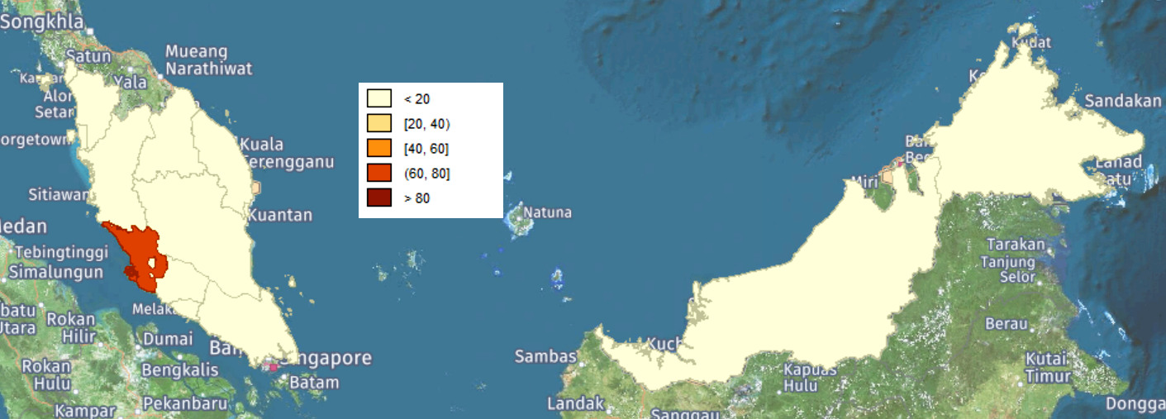

Panel B. Year 2030

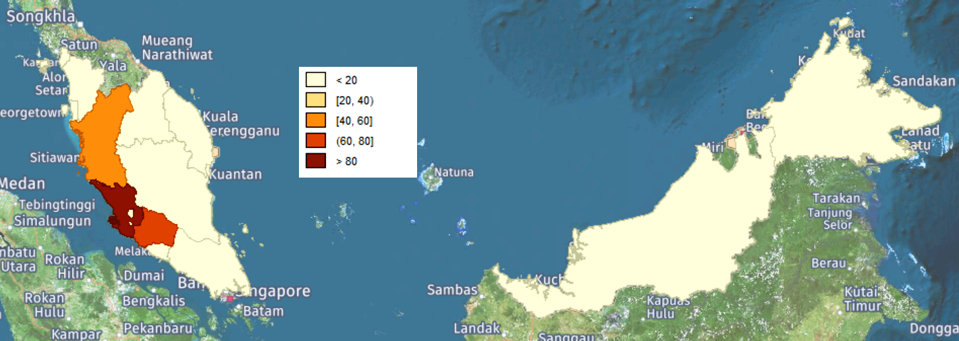

Panel C. Year 2045

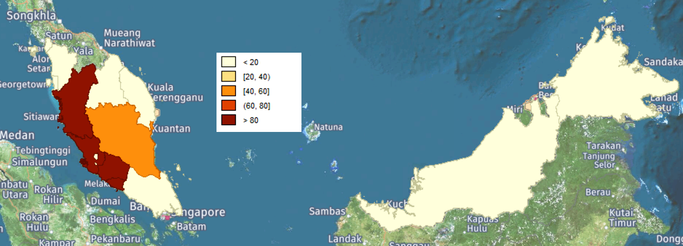

Panel D. Year 2060

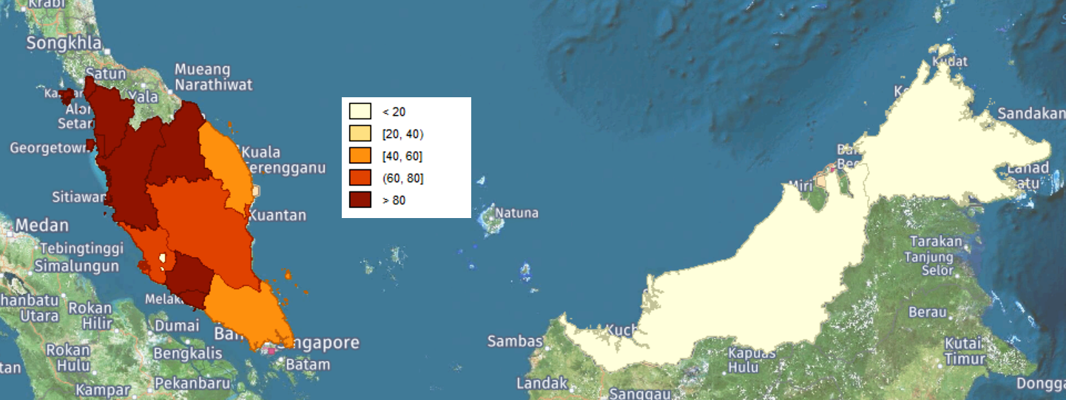

Figure 2. Recover Infected Land, Panel A. Year 2015

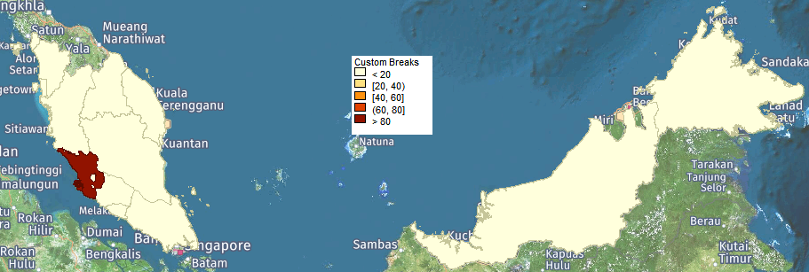

Panel B. Year 2030

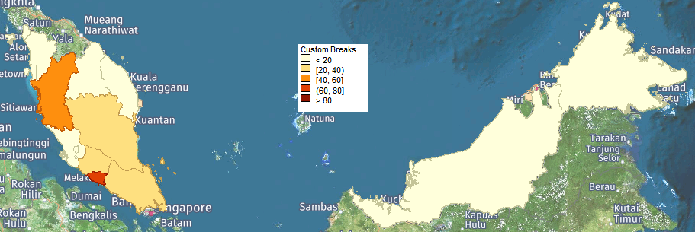

Panel C. Year 2045

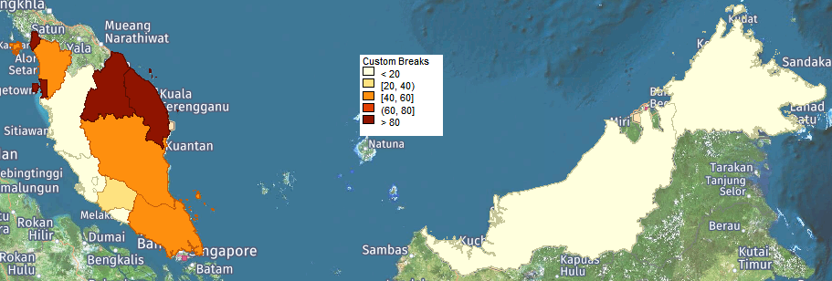

Panel D. Year 2060

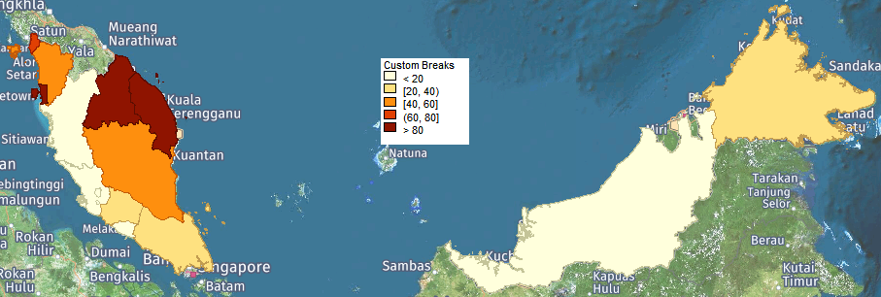

# Tables

Table 1. A Pathogen Proliferates

|  |  |  |  |  |  |  |  |  |  |  |  |
| --- | --- | --- | --- | --- | --- | --- | --- | --- | --- | --- | --- |
| Panel A. Mature Oil Palms (thousand hectares) | | | | | |  |  |  |  |  |  |
| Spread Rate | 2015 | 2020 | 2025 | 2030 | 2035 | 2040 | 2045 | 2050 | 2055 | 2060 | 2065 |
| 0 | 4,702.6 | 5,309.2 | 6,031.2 | 6,211.4 | 6,373.0 | 6,508.6 | 6,622.1 | 6,717.4 | 6,762.5 | 6,768.0 | 6,769.4 |
| 75,000 | 4,630.1 | 5,186.8 | 5,695.5 | 6,084.8 | 6,181.8 | 6,060.3 | 5,974.9 | 5,720.3 | 5,558.4 | 5,411.7 | 5,218.6 |
| 150,000 | 4,584.3 | 4,759.3 | 4,990.3 | 5,229.7 | 5,211.6 | 5,221.2 | 5,377.3 | 5,176.1 | 4,988.4 | 4,774.4 | 4,549.9 |
| 300,000 | 4,584.3 | 4,452.2 | 4,500.8 | 4,464.5 | 4,693.2 | 4,558.6 | 4,361.1 | 4,102.9 | 3,796.3 | 3,448.9 | 3,066.1 |
|  |  |  |  |  |  |  |  |  |  |  |  |
| Panel B. Social Welfare (million RM) | | | | | |  |  |  |  |  |  |
| Spread Rate | 2015 | 2020 | 2025 | 2030 | 2035 | 2040 | 2045 | 2050 | 2055 | 2060 | 2065 |
| 0 | 273,989 | 286,506 | 291,511 | 294,113 | 296,541 | 298,790 | 301,197 | 303,465 | 305,219 | 306,749 | 308,253 |
| 75,000 | 273,458 | 282,179 | 288,052 | 292,070 | 294,006 | 294,904 | 295,870 | 296,137 | 297,153 | 297,781 | 297,897 |
| 150,000 | 273,028 | 279,446 | 281,546 | 283,702 | 284,935 | 287,739 | 289,549 | 290,245 | 290,808 | 291,296 | 291,178 |
| 300,000 | 272,955 | 277,061 | 277,734 | 278,348 | 280,987 | 281,835 | 281,971 | 281,287 | 279,700 | 278,032 | 273,817 |
|  |  |  |  |  |  |  |  |  |  |  |  |
| Panel C. Agricultural Prices | | | | | |  |  |  |  |  |  |
| Spread Rate | 2015 | 2020 | 2025 | 2030 | 2035 | 2040 | 2045 | 2050 | 2055 | 2060 | 2065 |
| 0 | 100.0 | 101.5 | 99.6 | 99.1 | 98.7 | 98.1 | 97.8 | 97.8 | 97.7 | 97.6 | 97.6 |
| 75,000 | 100.0 | 101.8 | 100.1 | 99.7 | 100.2 | 101.3 | 102.2 | 103.9 | 104.9 | 105.9 | 107.3 |
| 150,000 | 100.0 | 104.5 | 104.7 | 104.5 | 105.1 | 105.7 | 106.1 | 107.9 | 109.5 | 111.3 | 113.0 |
| 300,000 | 100.0 | 106.9 | 108.6 | 109.8 | 109.0 | 111.0 | 113.6 | 116.6 | 120.3 | 124.3 | 130.2 |
|  |  |  |  |  |  |  |  |  |  |  |  |
| Panel D. Agricultural Employment (workers) | | | | | |  |  |  |  |  |  |
| Spread Rate | 2015 | 2020 | 2025 | 2030 | 2035 | 2040 | 2045 | 2050 | 2055 | 2060 | 2065 |
| 0 | 1,063,314 | 1,068,619 | 1,072,188 | 1,075,575 | 1,078,156 | 1,082,392 | 1,080,993 | 1,077,209 | 1,075,633 | 1,074,985 | 1,073,056 |
| 75,000 | 1,056,225 | 1,098,037 | 1,089,684 | 1,069,730 | 1,051,742 | 1,025,911 | 1,006,077 | 971,345 | 943,801 | 921,344 | 897,583 |
| 150,000 | 1,052,467 | 1,056,276 | 1,039,573 | 1,030,184 | 1,001,999 | 961,291 | 940,744 | 909,546 | 882,808 | 852,331 | 823,682 |
| 300,000 | 1,053,410 | 1,025,496 | 986,962 | 950,972 | 945,309 | 908,378 | 868,323 | 826,015 | 781,170 | 725,293 | 664,977 |
|  |  |  |  |  |  |  |  |  |  |  |  |
| Panel E. Deforestation (hectares) | | | | | |  |  |  |  |  |  |
| Spread Rate | 2015 | 2020 | 2025 | 2030 | 2035 | 2040 | 2045 | 2050 | 2055 | 2060 | 2065 |
| 0 | 688,178 | 162,801 | 136,833 | 115,062 | 96,223 | 80,711 | 39,370 | 3,376 | 0 | 0 | 0 |
| 75,000 | 688,178 | 578,686 | 256,472 | 117,166 | 97,992 | 82,198 | 69,120 | 57,227 | 17,821 | 5,298 | 0 |
| 150,000 | 697,266 | 586,329 | 493,042 | 414,597 | 348,101 | 93,187 | 72,334 | 58,123 | 48,875 | 14,973 | 0 |
| 300,000 | 697,266 | 586,329 | 493,042 | 414,597 | 348,101 | 292,514 | 245,974 | 206,839 | 173,930 | 40,976 | 0 |

Source: MAPGEM solves for the equilibrium market prices and quantities given the pathogen spread rates. The pathogen starts in Selangor and strikes the mature oil palm trees.

Table 2. Recovered Contaminated Land

|  |  |  |  |  |  |  |  |  |  |  |  |
| --- | --- | --- | --- | --- | --- | --- | --- | --- | --- | --- | --- |
| Panel A. Recovered Land (hectares) | | | | |  |  |  |  |  |  |  |
| Eradication Cost | 2015 | 2020 | 2025 | 2030 | 2035 | 2040 | 2045 | 2050 | 2055 | 2060 | 2065 |
| 5,000 | 61,122 | 255,561 | 394,654 | 397,032 | 399,898 | 358,322 | 173,100 | 849 | 0 | 0 | 0 |
| 10,000 | 61,122 | 255,561 | 394,654 | 370,339 | 383,027 | 144,021 | 0 | 0 | 0 | 0 | 0 |
| 20,000 | 61121.61 | 194,423 | 223,393 | 74,254 | 0 | 0 | 0 | 0 | 0 | 0 | 0 |
| 30,000 | 0 | 0 | 11,625 | 0 | 0 | 0 | 0 | 0 | 0 | 0 | 0 |
|  |  |  |  |  |  |  |  |  |  |  |  |
| Panel B. Social Welfare (million RM) | | | | | |  |  |  |  |  |  |
| Eradication Cost | 2015 | 2020 | 2025 | 2030 | 2035 | 2040 | 2045 | 2050 | 2055 | 2060 | 2065 |
| 5,000 | 272,376 | 276,512 | 280,007 | 284,532 | 287,128 | 290,075 | 295,410 | 300,111 | 302,134 | 302,717 | 302,765 |
| 10,000 | 272,071 | 275,234 | 277,191 | 282,744 | 285,665 | 292,152 | 297,539 | 299,005 | 299,851 | 300,725 | 300,868 |
| 20,000 | 271,460 | 274,326 | 276,268 | 283,981 | 290,572 | 292,081 | 293,009 | 293,713 | 294,321 | 294,941 | 294,965 |
| 30,000 | 273,028 | 279,446 | 281,122 | 283,746 | 285,039 | 287,903 | 289,660 | 290,327 | 290,893 | 291,384 | 291,269 |
|  |  |  |  |  |  |  |  |  |  |  |  |
| Panel C. Fisher Price Index | | | | |  |  |  |  |  |  |  |
| Eradication Cost | 2015 | 2020 | 2025 | 2030 | 2035 | 2040 | 2045 | 2050 | 2055 | 2060 | 2065 |
| 5,000 | 100.0 | 104.3 | 103.3 | 101.8 | 101.4 | 100.9 | 99.7 | 99.9 | 100.8 | 102.2 | 103.8 |
| 10,000 | 100.0 | 104.3 | 103.3 | 101.6 | 101.1 | 100.7 | 100.2 | 101.4 | 102.9 | 104.1 | 105.7 |
| 20,000 | 100.0 | 104.3 | 103.6 | 102.1 | 101.8 | 103.0 | 104.1 | 105.7 | 107.2 | 108.9 | 110.3 |
| 30,000 | 100.0 | 104.5 | 104.7 | 104.4 | 105.0 | 105.6 | 106.0 | 107.8 | 109.4 | 111.2 | 113.0 |
|  |  |  |  |  |  |  |  |  |  |  |  |
| Panel D. Agricultural Employment (workers) | | | | | |  |  |  |  |  |  |
| Eradication Cost | 2015 | 2020 | 2025 | 2030 | 2035 | 2040 | 2045 | 2050 | 2055 | 2060 | 2065 |
| 5,000 | 1,057,592 | 1,085,567 | 1,080,750 | 1,081,285 | 1,070,477 | 1,064,713 | 1,061,525 | 1,031,464 | 999,601 | 969,541 | 938,748 |
| 10,000 | 1,057,592 | 1,085,567 | 1,089,936 | 1,089,271 | 1,074,520 | 1,047,621 | 1,027,426 | 997,763 | 970,193 | 940,417 | 909,283 |
| 20,000 | 1,057,592 | 1,079,796 | 1,084,025 | 1,079,751 | 1,028,860 | 987,002 | 965,330 | 935,882 | 909,349 | 878,837 | 850,693 |
| 30,000 | 1,052,467 | 1,056,276 | 1,040,719 | 1,031,178 | 1,003,225 | 961,848 | 941,302 | 910,107 | 883,381 | 852,835 | 824,228 |
|  |  |  |  |  |  |  |  |  |  |  |  |
| Panel E. Deforestation (hectares) | | | | | |  |  |  |  |  |  |
| Eradication Cost | 2015 | 2020 | 2025 | 2030 | 2035 | 2040 | 2045 | 2050 | 2055 | 2060 | 2065 |
| 5,000 | 688,178 | 578,686 | 202,795 | 117,166 | 97,992 | 82,198 | 69,120 | 58,123 | 7,845 | 0 | 0 |
| 10,000 | 688,178 | 578,686 | 302,219 | 117,166 | 97,992 | 82,198 | 69,120 | 58,123 | 48,729 | 0 | 0 |
| 20,000 | 688,178 | 578,686 | 486,615 | 391,019 | 102,537 | 86,020 | 69,120 | 58,123 | 48,875 | 13,353 | 0 |
| 30,000 | 697,266 | 586,329 | 493,042 | 414,597 | 348,101 | 86,020 | 72,334 | 58,123 | 48,875 | 14,973 | 0 |

Source: MAPGEM solves for the equilibrium prices and quantities for the one-time payment of eradication cost in the table. The biological agent spreads at 150,000 hectares per five years and starts in Selangor.