Salient Object Detection using
the Edge Background and Median Filter

Jejin Ryu, and Hongki Min*
JINIT Co., Ltd., Incheon, South Korea
*Department of Information and Telecommunication Eng., Incheon National University
Incheon, South Korea

Abstract

In this paper, we propose salient object detection method based on the edge background and median filter for salient object detection. We assume edge pixels are background in input image and photographers tend to frame the salient object near the center of the image. We obtain a saliency value through the method of comparing color information of background pixels which derived from each edge with whole pixel in image. It generates background prior feature maps based on obtained saliency. And we generate saliency map through weighted near the center of background prior feature maps. We compare precision and recall of the proposed method with previous 5th salient object detection methods to test usefulness. The experimental results show that proposed method improves in performance than compared previous saliency object detection methods.

Keywords: Salient Object Detection, Edge Background, Background Prior Feature Mapmage, Median Filter

1. Introduction
Human beings specifically and selectively recognize and process prominent visual stimuli that feature differences in color, movement direction, and position by focusing on a given image. This capability have been studied by cognitive psychology, neuroscience, and computer vision community mainly because it helps find the objects or regions that efficiently represent a scene and utilize complex vision problems such as scene understanding. We called the salient object which is visually focused by humans [1]. Generally, human focused at a salient object when they get the image. Representative study is saliency map that contains information of the salient regions proposed by itti et al [2]. Since then, many studies try to predict with saliency map to detect salient object and understand visual attention of human. Bottom-up saliency uses intrinsic cues of image such as brightness, color, contrast, and texture. However, top-down saliency use extrinsic cues of image which made by learn about relationship of images similar [1-2].
2. Proposed Method
In this paper, we propose salient object detection method using the edge background[3] end median filter. Proposed method has saliency value of pixel wise, and it uses bottom-up method using intrinsic cues of image. We assume edge pixels are background in input image and used to solve the problem of attenuation of color values ​​in salient objects. Therefore we use background prior and median filter. Proposed method consists of preprocessing process, background prior feature map generation, median filtered map generation and saliency map generation. In preprocessing process, we cluster all pixels in input image by EDISON[2]. In background prior feature map generation process, we compute saliency through the method of comparing color information of background pixels obtained from each edge with all pixels in input image. We generate background prior feature maps : ${FM}_{l}$, ${FM}_{r}$, ${FM}_{t}$, ${FM}_{b}$. Each background prior feature maps generate by the four sides. Each background prior feature maps combine to background feature map ${FM}_{bg}$ by multiplication. In median filtered map generation process, we generate median filtered map by applying the median filter M using the ${FM}_{bg}$. And we integrate weighting media filtered map and background prior feature map as the saliency map. This process was shown in Fig 1.

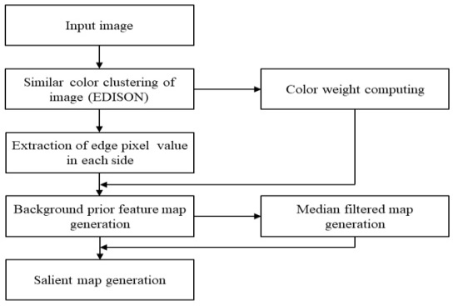
Fig. 1. Flowchart of proposed method

Eq 1 is a formula of the left background prior feature map ${FM}_{l}$. Also other side maps use same way as Eq 1.

${FM}_{l}\left(i,j\right)=\left\{\begin{aligned}I_{ij}×{\left(\frac{i}{n}\right)}^{2} if B_{i}(k)(1-w_{c})≤C_{ij}≤B_{i}(k)(1+w_{c}) \\ k=1,…, kl \\ 0 if I_{ij}=B_{i} \end{aligned} \right.$(1)

Where $I_{ij}$ is color value of position (i,j) in image, $B_{i}$ is pixels of left background, n is width of image and k is elements of $B_{i}$. $W_{c}$ is color weight for background pixels.
3. Result
We evaluate the proposed method on the ASD data set [4]. We utilize the Precision and Recall (PR) curve and F-Measure (𝐹𝛽) and Area Under ROC Curve (AUC) to evaluate the proposed method and other 5 previous methods : GC, CB, RC, SEG, FT. In PR curve, we set the threshold from 0 to 255 for the saliency maps. Eq 2. is a formula of the Precision and Recall by a binary mask M with ground-truth G. [4]. Fig 2 shows PR curve for proposed method and other methods.

$Precision=\frac{\left|M∩G\right|}{M}, Recall=\frac{\left|M∩G\right|}{G}$ (2)

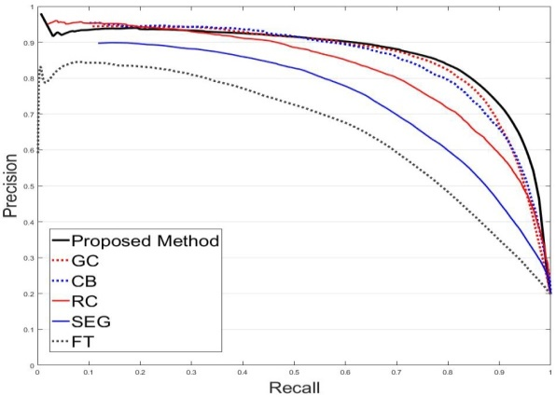
Fig. 2. PR curve of proposed method and other methods

References
- L. Itti, C. Koch, and E. Niebur, “A model of saliency-based visual attention for rapid scene analysis,” IEEE Trans. Pattern Anal. Mach. Intell., vol.20, no.11, pp. 1254–1259, 1998
- D. Comaniciu and P. Meer, “Mean shift: A robust approach toward feature space analysis”, IEEE Trans. Pattern Anal. Mach. Intell., vol. 24, pp. 603-619, 2002.
- J. J. Ryu and H. K. Min, “Saliency Map Generation Based on the Meanshift Clustering and the Pseudo Background,” Journal of Korean Institute of Information Technology, vol. 14, no. 11, pp. 119-125, 2016.
- R. Achanta, S. Hemami, F. Estrada, and S. Süsstrunk, “Frequencytuned salient region detection,” in Proc. IEEE Conf. CVPR pp. 1597–1604, 2009.

