**Automated Gland Segmentation Leading to Cancer Detection for Colorectal Biopsy Images**

Syed Fawad Hussain Naqvi, Salahuddin Ayubi, Ammara Nasim, Zeeshan Zafar

*Department of Electrical Engineering, Bahria University Islamabad, Pakistan*

*Email:* [*fawadnaqvi46@gmail.com*](mailto:fawadnaqvi46@gmail.com)*,* [*salahuddinayubi1@yahoo.com*](mailto:salahuddinayubi1@yahoo.com)*,* [*ammaranasim90@bui.edu.pk*](mailto:ammara.nasim@bui.edu.pk)*,* [*zeeshanzafar19@yahoo.com*](mailto:zeeshanzafar19@yahoo.com)

***Abstract-Glandular formation and morphology along with the architectural appearance of glands exhibit significant importance in the detection and prognosis of inflammatory bowel disease and colorectal cancer. The extracted glandular information from segmentation of histopathology images facilitate the Pathologists to grade the aggressiveness of tumor. Manual segmentation and classification of glands is often time consuming due to large datasets from a single patient. We are presenting an algorithm that can automate the segmentation as well as classification of H and E (hematoxylin and eosin) stained colorectal cancer histopathology images. In comparison to research being conducted on cancers like prostate and breast, the literature for colorectal cancer segmentation is scarce. Inter as well as intra-gland variability and cellular heterogeneity has made this a strenuous problem. The proposed approach includes intensity-based information, morphological operations along with the Deep Convolutional Neural network (CNN) to evaluate the malignancy of tumor. This method is presented to outpace the traditional algorithms. We used transfer learning technique to train AlexNet for classification. The dataset is taken from MCCAI GLAS challenge which contains tota 165 images in which 80 are benign and 85 are malignant. Our algorithm is successful in classification of malignancy with an accuracy of 9.40%.***

***Key words_ colorectal cancer, malignant, benign, glands, segmentation, Convolutional Neural Networks(CNN).***

1. INTRODUCTION

Colorectal cancer grows in colon or rectum which are part of large intestine. It is deliberated to be one of the most fatal disease worldwide (Torre et al., 2015). In the beginning of most cases, it starts with polyps and with the passage of time it spreads to other parts of body which makes it cancerous. Automated analysis has got much importance since the last few years, as it is very helpful in cancer grading. The sample of tissues are taken and then they are examined microscopically. Slides are prepared from it and H&E (Hematoxylin and Eosin) stained. These slides are digitized for the use in CAD (Computer Aided Diagnosis) using whole slide scanners. The variation between the images obtained is very large and it even increases on going toward highly malignant ones. These differences are based on contour, intensity or special dimensions. Hence, we need a solution which will be suitable for all the types of images.

Some of the techniques used earlier include, segmentation by globally optimized clustering in [1]. Size of graph of the image in [2] is reduced along with the complexity of affinity matrix. This simplicity aided in normalized cuts algorithm in [3]. [4] Learning glands done by weekly supervised method, [5] the representation based on sparse dictionary, [6] Model fitting and pixel level clustering are the mostly used approaches.

The segmentation and classification in [7] is done by labeling glands using features and PPMM (Probabilistic Pairwise Markov Model). Textural feature alone [8] or the combination of cytological and the textural features [9] are used for the detection of cancer regions by the classification of image pixels and patches. [10] presented a method based on region growing in which seed is initialized in the large empty space and is expanded till it reaches the boundary of epithelial nuclei. This is helpful for benign glands but failed to produce fruitful results in case of malignant. For the clustering of nucleus, stroma and lumen [11] used textural features. After that they removed the region containing stroma and lumen, while separated the region of nucleus.

DL (Deep Learning) has been widely used for detection of objects for the past few years. DL is composed of multiple convolutional layers and improves iteratively over learned representations of underlying data for the attainment of class detachability. Tissue classification [12], mitosis detection [13, 14, 15], [16] immunohistochemical staining and many more have proved the potential of DL for being unifying approach in variety of tasks in DP (Digital Pathology). Adequate data is used for training to obviate the need of manual classification by generalizing the system to unperceived situations.

Neural architectures were first proposed in [17], for the recognition of handwritten characters achieving the accuracy of 99.2% on MNIST dataset [18]. This was considered as the origin of modern CNN (Convolutional Neural Networks. Researchers got their inspiration from the mammal’s way of visually perceiving the world, by utilizing layered architecture of neurons in encephalon.

We altered some of the layers of pre-trained CNN for image classification which can get better efficiency in case of small dataset.

1. METHODOLOGY

The histology images obtained from dataset is passed through the three main steps: The images (in RGB) are preprocessed to reduce unwanted information in the images as far as possible. Next step is application of intensity-based segmentation followed by morphological operations. Convolutional Neural Networks (CNN) are utilized for categorization of images into benign and malignant. CNN is trained on annotated images available in the data sets, Using the trained model segmented images are tested for malignancy of tissues. Figure (1) shows the block diagram of proposed algorithm.

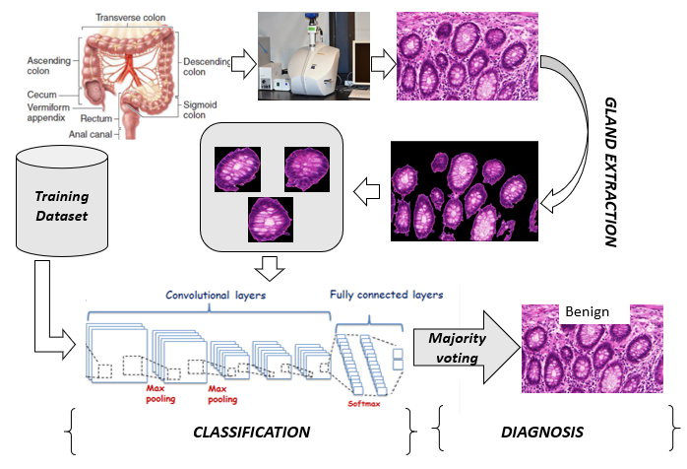

Figure 1 Proposed Approach

1. *Image Acquisition*

Images used for this research are taken from the dataset of **MICCAI GLAS 2015** challenge on gland segmentation of histology images [6]. The images are obtained from digitization of hematoxylin and eosin stained slides of Whole Slide Scanner with pixel resolution of 522×775×3.

1. *Preprocessing*

Initially we separated Red, Green and Blue channels of the original RGB image. For the purpose of contrast enhancement, each RGB channel is passed through the process of histogram equalization. (figure 2)

The discrete approximation of transformation function for histogram equalization is given below.

$s_{k}=T\left(r_{k}\right)=\left(L-1\right)\sum_{j=0}^{k}{p_{r}}\left(r_{j}\right)$ (1)

$s_{k}= \frac{(L-1)}{MN} \sum_{j=0}^{k}{n_{j}} k=0,1,2, . . . , L-1$ (2)

Where MN = Total number of pixels

$n_{j}$ = Pixels with intensity value $r_{j}$

L = Possible intensity levels

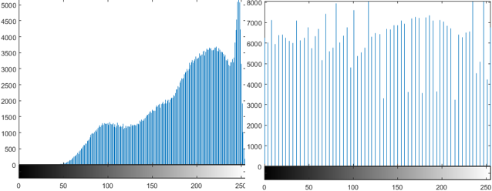

Figure 2: Histogram Equalization

1. *Image Segmentation*

we applied Otsu algorithm [20] to individual Red, Green and Blue channels (figure 3(a-c) for image binarization furthermore intersection of all the three binarized images is taken to scrutinize the information (figure 3d).

$I_{original}=\left(I_{r(gray)}+ I_{g(gray)}+I_{b(gray)}\right)$ (3)

$I_{binary}=I_{r(binary)}⋂ I_{g(binary)}⋂ I_{b(binary)}$ (4)

The images obtained after binarization, contain many small nuclei ($I_{nuclei}$) which are undesirable in our case, these components must be removed as much as possible to get the glands detached.

After the intersection of all the three Red, Green and blue components the resultant image contains lot of noise. We used morphological techniques to get the glands separated from other unwanted components. These techniques utilize the spatial and contour-predicated characteristics of objects present in the binary image. At first, we determined the objects connectivity and also computed the area occupied by each of these components. The extracted values labeled the objects based on their spatial dimensions. The pixels which corresponds to certain glands have proportionately greater connectivity than those of the nuclei, are stored discretely in variable ($I_{gland+nuclei}$). Then we extracted the nuclei components ($I_{nuclei}$) leaving the glandular objects. As depicted in equation 5 ,we have taken Exclusive Disjunction logical operation between both the ($I_{gland+nuclei}$) and ($I_{nuclei}$) to abstract nuclei left unremoved in ($I_{gland+nuclei}$) figure 3(c).

$I_{glands}=I_{glands+nuclei}⊕I_{nuclei}$ (5)

This process seems to be efficient for the benign tissues with the darker glandular boundaries but some of the benign tissues contain very dizzy and light glands, due to which their contrast and preprocessing was not fruitful enough to segment the glands. So, we familiarized another technique on the basis of morphological properties of those glands. Most of their glands include virtually white lumen. We have utilized region growing algorithm starting from the brightest pixels towards the boundary quite similar to method used in [10], The only difference arises in generation of seed. This step is usually not required for malignant glands where the boundaries of objects are more gathered towards lower histogram bins.

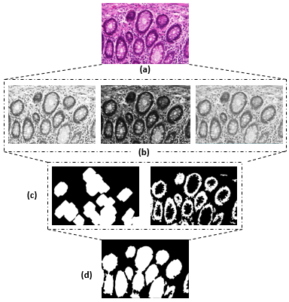

Figure 3 Input image is labeled as (a) and the Red, Green and Blue images as (b). The resultant of Otsu [19] and morphological processing is labeled as (c), while final segmentation is labelled as (d).

1. *Classification*

Computer Vision and DP has been revolutionized by the involvement of DL. Building a new model from scratch and training it is far lengthy processes then using an existing network. It can give even higher value of accuracy if the model which is taken is related to the model of interest, but after training of CNN on dataset, the size turns out to be much bigger in this case as it is pre-trained on very large dataset. This method is known as Transfer learning(TL).

The AlexNet model (available in MATLAB) which is used in our methodology is consisted of total 25 different layers of which 5 are convolutional layers, 3 are fully connected layers. Pooling and activation layers are in-between these layers.

TABLE 1 ALEXNET LAYERS DESCRIPTION [19]

|  |  |  |
| --- | --- | --- |
| **Sr** | **Name** | **Features** |
| 1 | Data | 227x227x3 images with normalization |
| 2 | Conv1 | 96 11x11x3 convolutions with stride [4 4] and padding [0 0] |
| 3 | Relu1 | ReLU |
| 4 | Norm1 | Cross Chanel Normalization with 5 channels per element |
| 5 | Pool1 | 3x3 max pooling with stride [2 2] and padding [0 0] |
| 6 | Conv2 | 256 5x5x48 convolutions with stride [1 1] and padding [2 2] |
| 7 | Relu2 | ReLU |
| 8 | Normi2 | Cross Chanel Normalization with 5 channels per element |
| 9 | Pool2 | 3x3 with stride [2 2] and padding [0 0] |
| 10 | Conv3 | 384 3x3x256 convolutions with stride [1 1] and padding [1 1] |
| 11 | Relu3 | ReLU |
| 12 | Conv4 | 384 3x3x192 convolutions with stride [1 1] and padding [1 1] |
| 13 | Relu4 | ReLU |
| 14 | Conv5 | 256 3x3x192 convolutions with stride [1 1] and padding [1 1] |
| 15 | Relu5 | ReLU |
| 16 | Pool5 | 3x3 max pooling with stride [2 2] and padding [0 0] |
| 17 | Fo6 | 4096 fully connected layer |
| 18 | Relu6 | ReLU |
| 19 | Drop6 | 50% dropout |
| 20 | Fc7 | 4096 fully connected layer |
| 21 | Relu7 | ReLU |
| 22 | Drop7 | 50% dropout |
| 23 | Fc8 | 2 Fully Connected Layers |
| 24 | Prob | Softmax |
| 25 | output | Benign or Malignant |

This pre-trained model is modified slightly to make it suitable for classification of histopathology images of tissues. As it is previously trained to classify 1000 different types of images, so we reformed one of the fully connected layer of AlexNet, which is consisted of 1000 neurons for those classes and altered it to the required number of neutrons. As we have solely two different types of classes (i.e. Benign and Malignant) so we substituted it with the network consisted of 2 different classes. We have also replaced the output layer which has learned the classification of AlexNet for 1000 different classes with an empty layer that can learn the classification of our dataset. AlexNet is trained to ground truth images for which we need a bigger dataset. To increase the dataset, we extracted all glands and nuclei elements identified in native images of both the classes and stored then separately. Those separated objects are then varied by alteration of angle, contrast and illumination of pixels to increase the training data. The data includes more than thousand images for each class. The input images size is restricted by AlexNet so the data is converted to 227×227×3, on which it is to be trained.

1. RESULTS

The dataset we used, contain native 165 images out of which 80 are benign and 85 malignant. Each image contains 5 to 20 glands. The data required for training of CNN is further generated by separating glands using the available annotations provided by MICCAI Glas[6] and through intensity, orientation and morphological variations of the native glands. Almost 10,000 glands are fed to CNN for training purposes.

we have used the segmented gland images resized to 227×227×3 for further classification. Each of the gland is assigned a class by CNN. An image is referred as benign or malignant on the basis of majority voting criterion.

figure 4 demonstrate segmentation results of benign (a) as well as malignant glands(b). These results illustrate a computationally efficient algorithm in comparison to conventional algorithms utilizing cumbersome techniques e.g. SLIC and DBSCAN [21]. Proposed system segments both benign and malignant structures quite accurately. The Classification of malignancy of image is accurate by 90.4%.

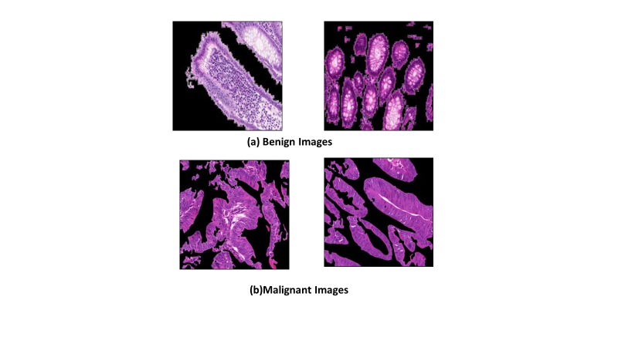

Figure 2 :Classification results (a) Image Classified as benign (b) Image Classified as malignant

1. CONCLUSION

A fully automated malignancy detection system is which successfully classify tumor tissues into malignant and benign at an accuracy of 90.4%. The algorithm is based on intensity-based segmentation and CNN which is trained on more than 10,000 ground truth images. This system can further be extended towards TNM grading of colorectal cancer.

ACKNOWLEDGMENT

We are thankful to MICCAI glas 2015 contest for providing us with the relevant data [6]

REFERENCES

1. *Shi J., Malik J., “Normalized cuts and image segmentation,”* *IEEE Trans. Pattern Anal. Mach. Intell., vol. 22, no. 8, pp. 888–905, 2000.*
2. *Tao W., Jin H., Zhang Y., “Color image segmentation based on mean shift and normalized cuts.,” IEEE Trans. Syst. Man. Cybern. B.Cybern., vol. 37, no. 5, pp. 1382–9, 2007.*
3. *Xu J., Madabhushi A., Janowczyk A., Chandran S., “A weighted mean shift, normalized cuts initialized color gradient based geodesic active contour model: applications to histopathology image segmentation,” Proc. SPIE, vol. 7623, no. April 2016, p. 76230Y–76230Y–12, 2010.*
4. *Xu, Y. Zhang, J., Chang E. I.-C., Lai M., Tu Z., “Context-constrained multiple instance learning for histopathology image segmentation.,”Int. Conf. Med. Image Comput. Comput. Interv. MICCAI, vol. 15, no. Pt 3, pp. 623–30, Jan. 2012.*
5. *Gao Y., Liu W., Arjun S., Zhu L., Ratner V., Kurc T., Saltz J., Tannenbaum A., “Multi-scale learning based segmentation of glands in digital colorectal pathology images,” Proc. SPIE, vol. 9791. p. 97910M–97910M–6, 2016.*
6. *Sirinukunwattana K., Pluim, J. P. W., Chen H., Qi X., Heng P.-A., Guo Y. Wang B., L. Y., Matuszewski B. J., Bruni E., Sanchez U., BöhmA., Ronneberger O.,. Ben Cheikh B, Racoceanu D., Kainz P., Pfeiffer M., Urschler M., Snead D. R. J., Rajpoot N. M., “Gland Segmentation in Colon Histology Images: The GlaS Challenge Contest,” pp. 1–24, 2016.*
7. *Monaco, J., Tomaszewski, J., Feldman, M., Hagemann, I., Moradi, et al.: High-throughput detection of prostate cancer in histological sections using probabilistic pairwise markov models. Medical Image Analysis 14, 617–629 (2010)*
8. *Doyle, S., Feldman, M., Tomaszewski, J., Madabhushi, A.: A boosted Bayesian multi-resolution classifier for prostate cancer detection from digitized needle biopsies. IEEE Trans. Biomed. Eng. 59, 1205–1218 (2012)*
9. *Nguyen, K., Jain, A., Sabata, B.: Prostate cancer detection: Fusion of cytological and textural features. Journal of Pathology Informatics 2, 2–3 (2011)*
10. *H-S Wu, R Xu, N Harpaz, D Burstein, and J Gil. Segmentation of intestinal gland images with iterative region growing. Journal of Microscopy, 220(3):190{204, 2005a.*
11. *Farjam, Reza, Et Al. "An Image Analysis Approach For Automatic Malignancy Determination Of Prostate Pathological Images." Cytometry Part B: Clinical Cytometry 72.4 (2007): 227-240.*
12. *. Cruz-Roa A, Basavanhally A, González F, Gilmore H, Feldman M, Ganesan S, et al. Automatic detection of invasive ductal carcinoma in whole slide images with convolutional neural networks. SPIE Medical Imaging. 2014;9041:904103-904103-15.*
13. *Veta M, van Diest PJ, Willems SM, Wang H, Madabhushi A, Cruz-Roa A, et al. Assessment of algorithms for mitosis detection in breast cancer histopathology images. Med Image Anal. 2015;20:237–48.*
14. *Roux L, Racoceanu D, Loménie N, Kulikova M, Irshad H, Klossa J, et al. Mitosis detection in breast cancer histological images An ICPR 2012 contest. J Pathol Inform. 2013;4:8.*
15. *Ciresan DC, Giusti A, Gambardella LM, Schmidhuber J. Mitosis detection in breast cancer histology images with deep neural networks. Med Image Comput Comput Assist Interv. 2013;16(Pt 2):411–8.*
16. *Chen T, Chefd’hotel C. Deep learning based automatic immune cell detection for immunohistochemistry images. In: Wu G, Zhang D, Zhou L, editors. Machine Learning in Medical Imaging. (Lecture Notes in Computer Science) Vol. 8689. Springer International Publishing; 2014. pp. 17–24.*
17. *LeCun, Yann, et al. “Gradient-based learning applied to document recognition.” Proceedings of the IEEE 86.11 (1998): 2278-2324.*
18. [*The MNIST database of handwritten digits*](http://yann.lecun.com/exdb/mnist/) *Hubel, David H., and Torsten N. Wiesel. “Receptive fields and functional architecture of monkey striate cortex.” The Journal of physiology 195.1 (1968): 215-243.*
19. *“Alexnet toolbox at Mathworks” [ONLINE] Available at: https://www.mathworks.com/help/nnet/ref/alexnet.html. [Accessed 13 April 2018].*
20. *Otsu, N., "A Threshold Selection Method from Gray-Level Histograms,"*IEEE Transactions on Systems, Man, and Cybernetics*, Vol. 9, No. 1, 1979, pp. 62-66.*
21. *Ammara N, Taimur H, M. Usman A, Bilal H. et.al., Automated identification of colorectal glands morphology from benign images” Int'l Conf. IP, Comp. Vision, and Pattern Recognition IPCV'17 (2017)*