**A behavioral study of cylindrical object impacted by bullet using FEA**

Tanadon Saisueb and Pattaraweerin Woraratsoontorn

Department of Industrial Physics and Medical Instrumentation, Faculty of Applied Science,

King Mongkut’s University of Technology North Bangkok, Bangkok, Thailand

**ABSTRACT**

At present, the rich variety of crimes news appear on the different types of mass media. The weapons that offender common use to make trouble as a pocketknife and a firearm. Although, the pocketknife is inexpensive and normally found, the firearm can be possessed easily in our country also. People are considerable who have occasion to survive from gunshot. The articles carried in the pocket of shirt may be a cause of survival. Especially, a metal pen is most favorite to take away. This research aims to study a deformation behavior of the cylindrical object impacted by 9 mm FMJ (Full Metal Jacket) bullet at various conditions. The finite element method (FEM) were applied to simulate the different conditions of shooting. From comparing, the finite element simulation results and shooting test results in the same case show that the cylindrical object and stainless steel pen give a behavioral result similar. Therefore, the simulation result can be used to support for forensic science. In addition, the result achieved can be analyzed that is possible that the pocket pen can helps to have a chance of survival after being shooting by a bullet.

Keywords : Bullet, Cylindrical object, Finite element method, **Forensic Science**

**1. INTRODUCTION**

Currently, firearms are used in most crimes. Because it is a powerful weapon, cause damage to life and property. The offender with the use of firearms is a serious offence and shocking case. Therefore, forensic evidence of bullets and gunshot wounds is very important. This is the information leading to the investigation of the offender. It can also control, and to prevent the crime will occur in society. Now, the advancement of technology has played a greater role in the lives of people. The concept of applying technology to forensic examinations on bullets reduces the time and cost of simulating real life situations. Moreover, the result of analysis can be used to confirm the forensic examination of the bullets.

The previous study, M.R. Ahmad et al. efforts to bring natural rubber to improve the structure of armor bullets to increase efficiency.Nonwoven fiberglass coated with natural rubber latex (NRL) specially prepared from Revertex (Malaysia) has 12 layers of overlays, increase absorbing up to 17% [1]. Mario Štiavnicky et al. also attempts to experiment using of various composite materials as armor in the Arm, with a lighter weight than other materials at a thickness of 50 mm. It was found that Kevlar fabric as the material can reduce the speed of the bullet better than ceramic plates [2]. In case of the ammunition, Roger Alimi, et al. tested in the laboratory to find compensation temperatures that affect the efficiency of 40 mm projectile propulsion by generating more than 1 MJ of power from a 1 GW power, it can increase the propulsion of the projectile by 20% for a 300-gr projectile [3]. In the behavioral studies of various shapes from bullets fired, the finite element method is often used. Because it can reproduce without the cost of real trial cost and it is accurately as the real experiment. Chuan Xua et al. compared the wounds of 17 pigs head firearm was hit by M43 bullet with the results of the finite element method results in the same direction [4]. In addition to modeling finite element method in animals, there are also human models as well. Jianyi Kang et al. studied the behavior of the organs in the chest while wearing light armor after being hit with a bullet 9 mm that result of simulation methods finite element made aware of the forces acting on the internal organs. As a result, the lungs are injured and may cause Epicardium hemorrhage [5-7]. Kui Li et al. investigated the behavior of various organs from being hit by a bullet, There is a study of the behavior of the brain injury caused by iron and wood sticks using finite element finite element method [8]. Finally, Jean-Sébastien Raul et al. analyzed the behavior of various shapes with finite element method is popular in forensic science because the result has accuracy and reliability [9-10].

From the above research, there are a lot of people who try to develop and improve the material to prevent the influence of bullets. But research on the effects of the shape of the material on the impact of ammunition has not been found. From the concept, in everyday life a lot of people put their pen and belongings in their pocket. It is possible that helps to have a chance of survival after being shooting by a bullet. So a cylinder object model substituting a stainless steel pen with the 9mm FMJ (Full Metal Jacket) bullet covered copper model has been created to inveatage the behavior of the object by firing it at various distances with finite element method.

**2. METHODOLOGY**

**2.1 3D Modeling**

The 3D Model of the metal pen and the 9mm FMJ bullet have created in this research.Actually, the structure of these objects are complex. In 3D modeling, only some of the parts of object that affect the simulation were selected to create. In the case of the stainless steel pen, assume that the pen and gel refill are very close together without the volume of ink inside the pen. Since cylindrical objects are symmetrical throughout, a specific length has been used for modeling. This model is similar to a commercial stainless steel rod with a diameter of 7.525 mm, an external diameter of 9.525 mm and a length of 40 mm as shown in Figure 1. In this study, the 9 mm FMJ bullets made from copper has been used. In order to reduce time in processing using FEA, bullet without shell case after fired has been created. It has a diameter of 4.515 mm, a length of 10.54 mm and a length from the tip of bullet to the base of bullet 8.54 mm, this section is symmetrically curved as shown in Figure 2. Then, the type of element to fit has been identified properly for reality of simulation result.

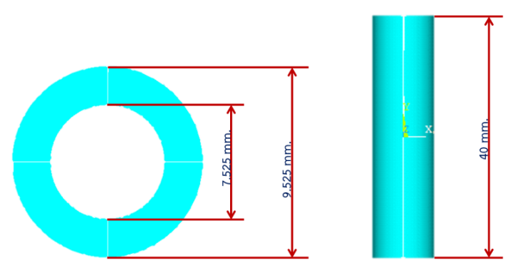

**Figure 1** Dimension of a 3D cylindrical object model

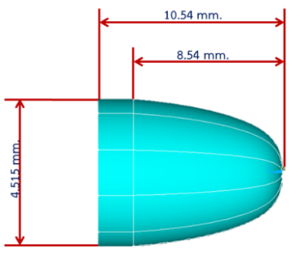

**Figure 2**  Dimension of a 9 mm FMJ bullet model

**2.2 Material Properties**

**Table 1** Material properties of 304 Stainless steel [11]

|  |  |
| --- | --- |
| **Mechanical Properties** | **Metric** |
| Young's modulus |  |
| Poisson's ratio |  |
| Mass density |  |
| Yield stress |  |
| Tangent modulus |  |

**Table 2** Material properties of Copper [12]

|  |  |
| --- | --- |
| **Mechanical Properties** | **Metric** |
| Young's modulus |  |
| Poisson's ratio |  |
| Mass density |  |
| Yield stress |  |
| Tangent modulus |  |

The material properties of 304 stainless steel for the cylindrical object and copper for the bullet have been defined as shown in table 1 and table 2, respectively.

In addition, the velocity of the bullet has been defined according to data from Marshall and Sanow's experiments, 9 mm bullets were tested to study the permanent cavity volumes and temporary stretch cavity volume from ballistic gelatin. They has used 9 mm FMJ Winchester bullet weighing 7.5 g, velocity 352 m/s, expansion 9.1 mm, penetration 620 mm, permanent cavity volumes 41 mL and temporary stretch cavity volume 174 mL. [13]

**2.3 Boundary Conditions and Simulation**

In this study, the firing a bullet into a cylindrical object has been simulated. Therefore, the characteristics of the bullet impacted to the cylindrical object designed to investigate the behavior of the cylindrical object were divided to four cases at various positions of object as following.

2.3.1 The bullet hit the center of the cylindrical object as shown in Figure 3

. 2.3.2 The bullet hit the 3/4 of the diameter of the cylindrical object as shown in Figure 4

2.3.3 The bullet hit the edge of the circumference of the cylindrical object, as shown in Figure 5.

2.3.4 The bullet hit the edge of the circumference of the cylindrical object and an additional speed of the pen moving towards the bullet, as shown in Figure 6.

In cases 1-3, the cylindrical object was fixed in the same plane as the direction of the bullet because assume that pen is attached to the chest. In case 4, the cylindrical object can be moved towards the bullet, assume that the human body remove to avoid the bullet while shock.

.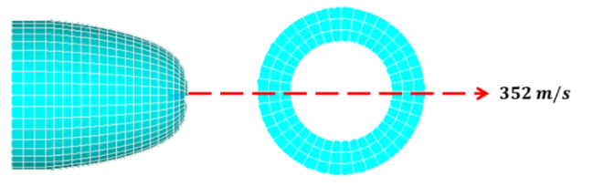

**Figure 3** Case 1 : The bullet impacts the center of the cylindrical object.

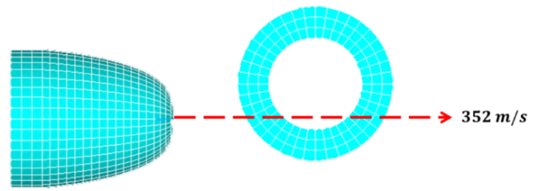

**Figure 4** Case 2 : The bullet impacts the 3/4 of the diameter of the cylindrical object.

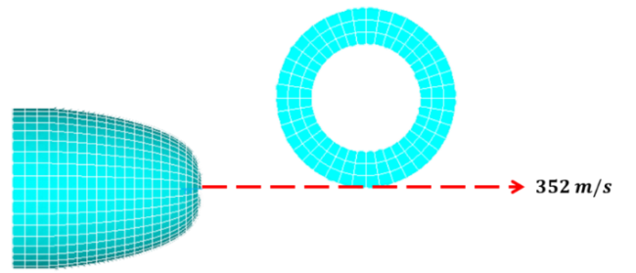

**Figure 5** Case 3 : The bullet impacts the edge of the circumference of the cylindrical object.

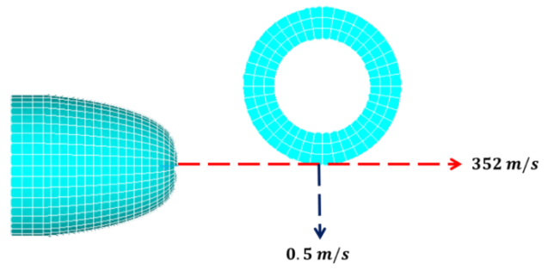

**Figure 6** Case 4 : The bullet impacts the edge of the circumference of the cylindrical object that can move towards the bullet.

**2.4 Validation**

The simulation results have been compared with the result from the shooting testing by shooter at bullet shooting range which can confirm the accuracy of the simulation results. The cylindrical object and bullet of the same size as the 3D model of both objects were used. Figures 7 and 8 show the length of 9 mm FMJ bullet covered copper and the diameter of the cylindrical object, respectively.

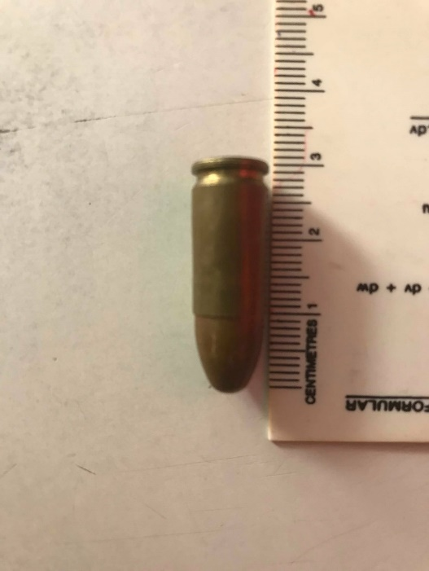

**Figure 7**  Length of 9 mm FMJ bullet covered copper.

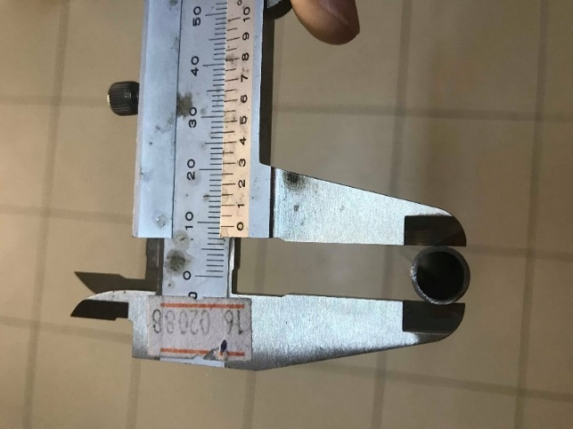

**Figure 8** Diameter of cylindrical object.

The shooting test for validation to confirm the behavior of the cylindrical object from obtained simulation were designed carefully. Due to the testing of firing a bullet into a cylindrical object, there is a limitation on the testing equipment. Furthermore, the gun is a serious weapon. These causes have a significant effect on the safety of shooter and observer. Therefore, only the first three cases can be tested for the actual shooting. In case 4, although the testing was actually, it has changed from cylindrical objects to actual stainless steel pen under same condition in case 3 has been used. The shooting distances were 5,10,15 and 20 meters. The actual test can be summarized as following:

2.4.1 The bullet hit the center of the cylindrical object.

2.4.2 The bullet hit the 3/4 of the diameter of the cylindrical object.

2.4.3 The bullet hit the edge of the circumference of the cylindrical object.

2.4.4 The bullet hit the edge of the circumference of the stainless steel pen.

**3. RESULTS**

The test results of the actual shooting of the bullet into the cylindrical object have four cases to validate the behavior of the cylindrical object achieved from the FEM simulation results. The results of both the simulation and the actual test showed the bullet trajectory, deformation of bullets and cylindrical objects with the four different cases as shown in Table 3. From the results revealed that, the case 1-3 have the same test conditions and the same results when the simulation results were compared with actual shooting. For example, case 1 of both tests, when the bullet impacted the center of the cylindrical object, the cylindrical object was bent to an angle of about 100 degrees, the bullet was deformed, the cylindrical object was fractured. Figure 9 shows the finite element simulation result comparing with the shooting test from the bullet impacted the cylindrical object (case1).

**Table 3**  The simulation results comparing with the Shooting test results.

|  |  |  |  |  |
| --- | --- | --- | --- | --- |
| **Test conditions** | **Changed bullet trajectory** | **Deformation of bullets** | **Deformation of cylindrical objects** | **Fracture of cylindrical objects** |
| **- FEM Simulation**  The bullet hits the center of the cylindrical object. |  |  |  |  |
| The bullet hits the 3/4 of the diameter of the cylindrical object. |  |  |  |  |
| The bullet hit the edge of the circumference of the cylindrical object. |  |  |  |  |
| The bullet hit the edge of the circumference of the cylindrical object and an additional  speed of the pen moving towards the bullet. |  |  |  |  |
| **- Shooting test (cylindrical object)**  The bullet hits the center of the cylindrical object |  |  |  |  |
| The bullet hits the 3/4 of the diameter of the cylindrical object. |  |  |  |  |
| The bullet hit the edge of the circumference of the cylindrical object. |  |  |  |  |
| **- Shooting test (Stainless steel pen)**  The bullet hit the edge of the circumference of the stainless steel pen. |  |  |  |  |

Note : **=** Yes, ** =** No

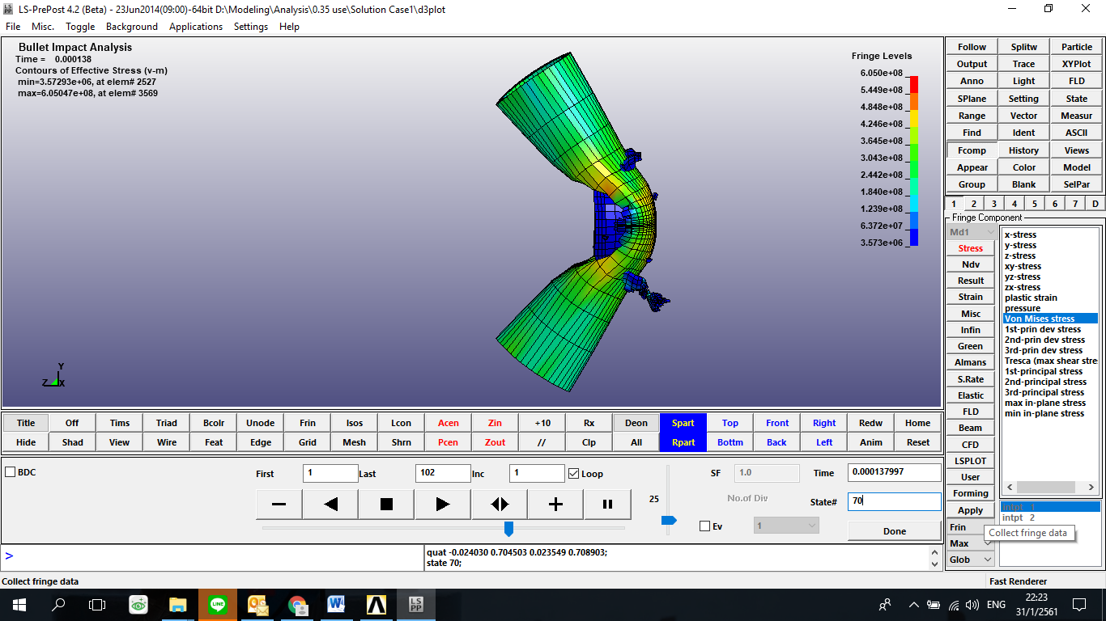 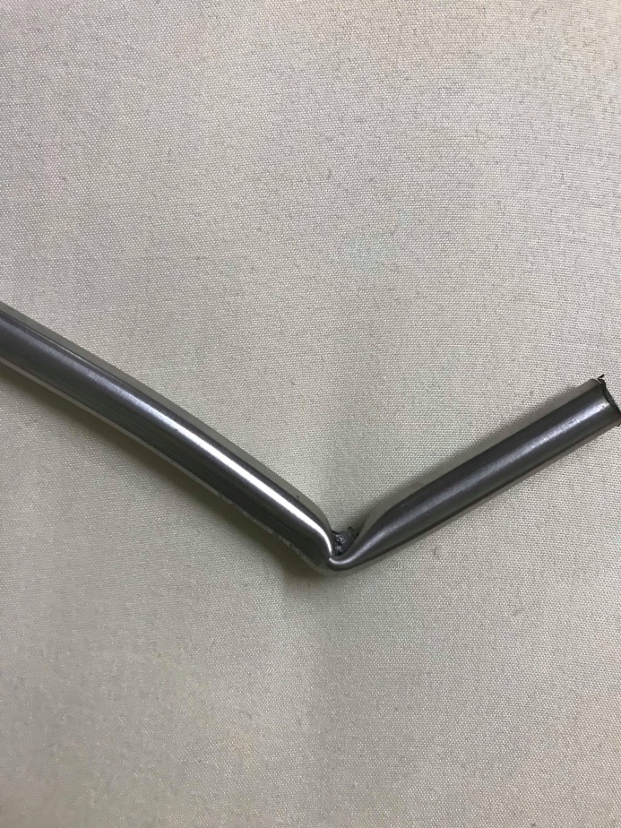

**Figure 9** FEM (left) and actual shooting (right) by the bullet hits the center of the cylindrical object.

The other test results confirms that the cylindrical object and the stainless steel pen have same results, when comparing both test results. In case of bullet impacted the edge of the circumference of the cylindrical object and the stainless steel pen, the cylindrical object was partially deformed, the bullet shifted away from the cylindrical object then push the cylindrical object out in the opposite direction. Similarly, the stainless steel pen occurred deformation as shown in Figure 10.

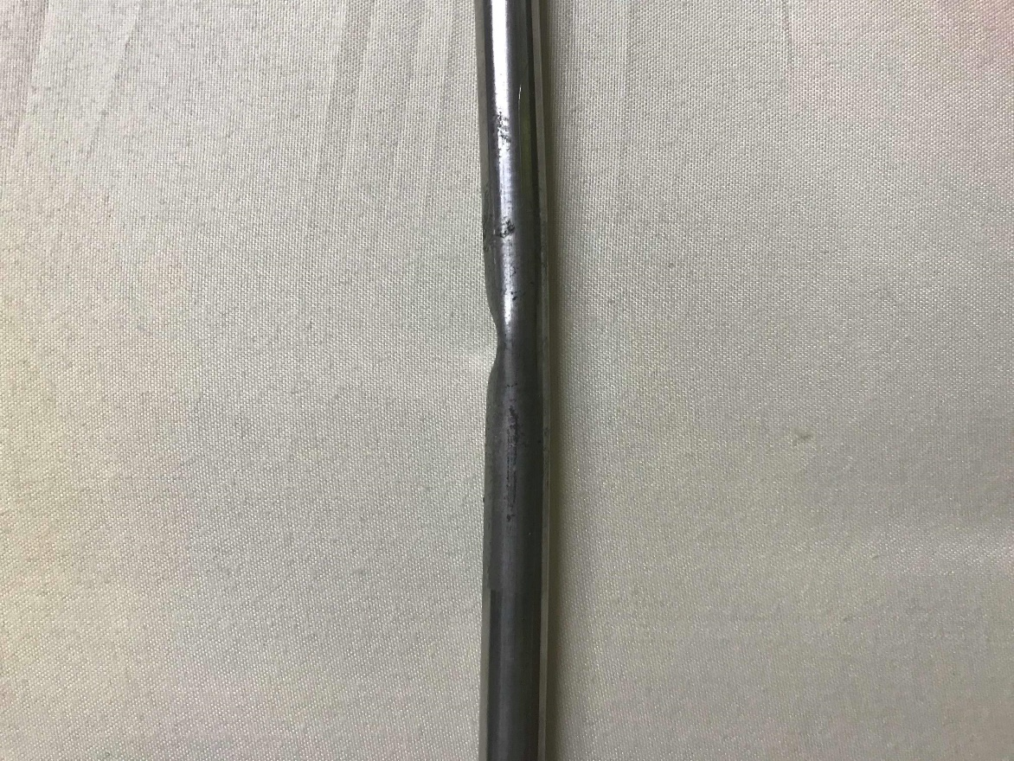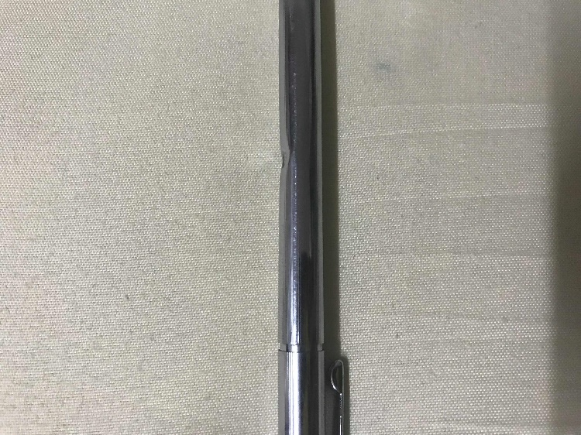

**Figure 10** The deformation of cylindrical object hit by the bullet at the edge of the circumference (left) and the stainless steel pen hit by the bullet at the edge of the circumference (right).

**4. CONCLUSION**

The simulation results of a bullet impacted into the cylindrical object that yielded a close approximation to the shooting test on a cylindrical object. That shows that the finite element method plays a very important role in analyzing the behavior of the object from being fired by the bullet at various distances. Especially, it is able to lead be information for support the forensic evidence. Moreover, FEM in this analysis reduces the time and costs that will occur in actual shooting. From the rational, in everyday life many people frequently put their metal pen in their pocket of shirt which may be cause to have a chance of survival after being shooting by a bullet. The finite element simulation results of the firing of the bullet into the cylindrical object and the shooting test results in the same case show that it is possible that the pocket pen is able to helps to have a chance of survival after being shooting by a bullet. That is probable because the stainless steel pen support partially the energy from the bullet and bullet are deflected likely.This may cause the bullet that cannot penetrate the heart directly follow the path of the original shot.

**References:**

[1] M.R. Ahmad, N. Hassim, W.Y.W. Ahmad, A. Samsuri, M.H.M. Yahya. “Utilising Natural Rubber Latex in Improving Ballistic Impact Performance of Unidirectional Fabric Systems”, IEEE International Conference on Business Engineering and Industria Applications (ISBEIA), pp. 458-461, 2012.

[2] Mario Štiavnicky, Norbert Adamec “Improved ballistic protection of vehicles using composites”, IEEE International Conference on Military Technologies (ICMT), 2015.

[3] Roger Alimi, Lior Bakshi, Eran Kot, Moris Sudai, “Temperature Compensation and Improved Ballistic Performance in a Solid-Propellant Electrothermal-Chemical (SPETC) 40-mm Gun”, IEEE Transactions on Magnetics. pp. 289-293, 2007.

[4] Chuan Xua, Yubin Chena, Bingcang Lia, Liangchao Zhanga, Jianmin Wanga, Jianyi Kanga, Zhiqiang Chena and Xiaoxia Lia, “Finite element analysis vs experimental study of head firearm wound in pig”, Technology and Health Care, pp. 60-69, 2015.

[5] Jianyi Kang, Jing Chen, Ping Dong, Hai Liu, Qikuan Zhang, “Numerical Simulation of Human Torso Dynamics under Non-penetrating Ballistic Impact on Soft Armor”, International Journal of Digital Content Technology and its Applications, pp. 843-850, 2012.

[6] Jack C. Roberts, Paul J. Biermann, James V.O’Connor, Emily E. Ward, Russell P. Cain, Bliss G. Carkhuff, and Andrew C. Merkle, “Modeling Nonpenetrating Ballistic Impact on a Human Torso.”, Johns Hopkins apl technical digest, volume 26, number 1, pp. 84-92, 2005.

[7] Hai Liu, Jing Chen, Jian-yi Kang, Xiao-xia Li, Ivan Azhari, “Finite element analysis of the dynamic response of the cardiovascular system to the blunt ballistic impact”, Computer modelling & new technologies, pp. 44-49, 2014.

[8] Kui Li, Jiawen Wang, Shengxiong Liu, Sen Su, Chenjian Feng, Xiaoxiang Fan, Zhiyong Yin, “Biomechanical behavior of brain injury caused by sticks using finite element model and Hybrid-III testing”, Chinese Journal of Traumatology (English Edition), pp. 65-73, 2015.

[9] Jean-Sébastien Raul, Caroline Deck, Rémy Willinger, Bertrand Ludes, “Finite-element models of the human head and their applications in forensic practice”, International Journal of Legal Medicine, pp. 359-366, 2008.

[10] A. Mota, W. S. Klug, M. Ortiz, A. Pandolfi, “Finite element simulation of firearm injury to the human cranium”, Computational Mechanics, pp. 115-121, 2003.

[11] Matweb (Material Property Data), “304 stainless steel properties” [serial online], 1996 [cited 2017 Aug. 17], Available from: http://www.matweb.com/search/DataSheet.aspx?MatGUID=abc4415b0f8b490387e3c922237098da&ckck=1

[12] Matweb (Material Property Data), “Copper properties”, [serial online], 1996 [cited 2017 Aug. 17], Available from : http://www.matweb.com/search/DataSheet.aspx?MatGUID=9aebe83845c04c1db5126fada6f76f7e

[13] Marshall and Sanow, “Handbook of Handguns”, [serial online], 2006 [cited 2017 Oct. 1] Available from: https://books.google.co.th/books?id=njAeBQAAQBAJ&pg=PA162&lpg=PA162&dq=Marshall+and+Sanow,+Street+Stoppers,+Appendix+A,+Paladin+2006&source=bl&ots=QPPJOBWirA&sig=Nt5GYaRJm6kXfWdEY2gwhMEOXYw&hl=th&sa=X&ved=0ahUKEwig4p6665XZAhWLKo8KHVt6AswQ6AEIJTAA#v=onepage&q=Marshall%20and%20Sanow%2C%20Street%20Stoppers%2C%20Appendix%20A%2C%20Paladin%202006&f=false