1. **Abdul Hameed Panhwar**

Associate Professor

Institute of English Language and Literature

University of Sindh, Jamshoro

1. **Muhammad Khan Sangi**

Professor

Institute of English Language & Literature University of Sindh, Jamshoro

1. **Saba Zaib**

PhD scholar

Institute of English Language & Literature University of Sindh, Jamshoro

**Teacher-student perceptions and experience of large ESL classes at the University of Sindh, Jamshoro Pakistan**

**Abstract**

*The issue of large ESL classes has been most researched problem in the context of developing countries. This paper investigates ESL teacher-student perceptions and experiences of large classes. The participants of the study were ESL teachers and students at the University of Sindh, Jamshoro Pakistan. The study used mixed methods design and the data were collected through teacher-student questionnaires and semi-structured interviews. Findings indicate that both the teachers and learners find large ESL classes difficult and ineffective for language learning. The problems such as insufficient participation of students, lack of communication between the teacher and student and students and students, adequate teacher feedback and class management issues were most recurrently mentioned by the participants. In order to reduce the intensity if these problems, group and pair work was suggested.*

1. **Introduction**

The study aims at finding out the real problems faced by English language teachers and learners in large compulsory English language classes at the University of Sindh, Jamshoro (UoSJP), and to see what strategies are suggested by the teachers and students to address these problems. Locastro (2001) claims that the majority of researchers have found that large heterogeneous English classes hinder teachers from helping learners progress in their language proficiency. Teaching and learning in large classes has been a very serious issue in the research studies carried out in developing countries such as Pakistan, where the large number of mixed-ability students cannot be accommodated easily due to the lack of funds and resources (Shamim, 1993; 2007).

1. **Literature Review**

Large class size learning and teaching is one of the distressing phenomena for teachers and learners all over the world, specifically in developing countries where class size reduction is not possible because of the scarce budget for education (Shamim, 1993). There is a consensus in the relevant literature that what is perceived as a ‘large class’ varies from context to context (e.g. Hayes 1997 and Harfitt 2012). Certainly actual class sizes vary enormously, for example, between different countries (Wößmann and West 2006) or different types of school (Shamim 1993). Shamim (1993) reports that, in the early 1990s, classes in government secondary schools in Pakistan sometimes had as many as 90 pupils, while classes in private secondary schools in Pakistan usually had less than 50. In so far as large means larger than normal or at the upper end of the size range I’ve experienced, then clearly perceptions of what constitutes a large class will vary. Shamim (1993, p. 140 and 142) looked in some detail at the factors that influence teachers’ and students’ perceptions of class size. On the basis of interviews with 20 teachers of English in Pakistani secondary schools, and 21 groups of their pupils (3-5 pupils in each group), she concluded that teachers’ perceptions of what constitutes a large class were mainly influenced by “their previous experience in classes of varying size, the average class size in the immediate educational context and the physical conditions in the classroom”, while learners’ perceptions were mainly influenced by “the physical conditions in the classroom, such as adequate work space”. But, despite the consensus that perceptions vary, what is less clear is whether there is also variation in the point at which class size becomes detrimental to learning and teaching.

Many studies of large classes have defined a large class as one with at least 40-50 students (e.g., Locastro 1989; Shamim 1993; Hayes 1997; Jun 2005; Zhenping 2009 and Harfitt 2012). Although some of these studies simply base the figure on previous literature (e.g., Zhenping, 2009) or the author’s subjective experience (e.g. Jun 2005), others have investigated the question empirically. These empirical studies have involved asking samples of teachers or learners at what size they perceive a class as being too large. For example, LoCastro (1989) used a questionnaire to investigate the perceptions of students of English Language at the University of Tsukuba and Keio, Japan. Amongst other things, the students were asked at what size they perceived a class as being so large that the size adversely affected their learning. Although there was some variation in the exact figure given, only 2% regarded classes with fewer than 21 students as excessively large, while 100% regarded classes with 51+ students as too large, with a negative impact on learning. Hayes (1997) interviewed secondary school teachers of English in Thailand, and found that the majority reported having experienced difficulty in teaching classes of 50 students or more, because of the class size. Similarly, Harfitt (2012) conducted semi-structured interviews with three experienced English language teachers in Hong Kong secondary schools and observed their teaching. He found that classes of 40 or more students created problems for the teachers and hindered the process of teaching and learning.

The most common problems of large classes identified by research studies that make the teaching-learning process difficult for both teachers and learners are: giving individual attention, making students participate, establishing student-teacher and student-student interaction, giving feedback, and management issues. One of the serious problems teachers face when teaching large classes is to give individual attention to students. Teachers experience problems in remembering students’ names, creating a good rapport with students, giving attention to all students during class time and knowing them individually, which results in a gap between teachers and students (Locastro, 1989; Shamim, 1993; Hayes, 1997; Waddington, Crowley & McCaffery, 2009). For example, Mgeni (2013) discovered through a questionnaire survey based on the 30 teachers of the University of Arusha, Tanzania that almost all the teachers perceived it very difficult in large classes to easily identify weak students and give individual attention to them. Due to the lack of individual attention in large classes the majority of students feel anonymous and uncomfortable. (Hayes, 1997).

Findings from a considerable number of studies indicate that large classes reduce student participation to a great degree. In large classes, the least of the class time involves any kind of student participation and teachers find it difficult to provide all students with equal chances to participate and practice, therefore there are less opportunities for each student to practice the language skills (Shamim, 1993; Cooper and Robinson, 2000 and Waddington, Crowley and McCaffery). Specifically, in the context of language learning, Mgeni (2013) by investigating teacher perception, found that the sampled teachers considered student class participation essential for effective language learning. However, the majority reported that large classes reduced student participation in the learning process to a disappointing degree. In addition, Cuseo (2007) observed in the studies on large classes that students felt highly dissatisfied in large classes regarding the gap in teacher-student and student-student interaction.

Large number of students usually overburdens teacher’s workload which results in little or no teacher feedback to students on their written and oral tasks. For example, Cuseo (2007) discovered that a large number of students in a class increased the workload of teachers in the form of assignments and exam scripts, therefore the frequency of feedback from the teacher to the students got reduced to the disappointing levels. Zhengping (2009) argues that due to the large size of classes and limited time, the assessment of oral English becomes an even greater problem because it tends to be done in the class. Getting feedback from teachers and giving feedback to a large number of students becomes very difficult in large classes and the lack of feedback affects students’ cognitive development (Shamim, 1993 and Herbert et al., 2001).

The problems of management and behaviour have always kept teachers and learners worried in large classes. The increased numbers of students in a class can create distractions and behaviour issues. Most of teachers complain of misbehaving attitude, gossiping, coming late or leaving early and incorrect and confused questions on the part of learners (Shamim, 1993 and Kerr, 2011). Similarly, the issue of discipline was considered as a major problem by the students in the study of Waddington, Crowley and McCaffery (2009). Locastro (1989) found that in large classes, teachers experienced difficulty in assessing and correcting a large number of essays and organising pair/group work. . Large classes make teachers desperate to discipline the students because noise appears to be a great disturbance, students are inattentive and are talking to themselves ultimately this type situation keeps any class out of control. Teachers of large classes identified that it was very difficult for them to set speaking, reading and writing activities and found it very hard to organise and manage communicative activities. From the evidence of the research studies about class management and pedagogical teaching activities in large classes, it may be concluded teachers felt it difficult to teach and manage large classes. Some studies have suggested the use interactive activities as a solution to the better class management in large classes. For example, Renaud, Tannenbaun & Stantial (2007) argued that constant use of interactive activities with lecture help manage and discipline class to a satisfactory level.

1. **Methodology**

This study used the mixed methods research. The mixed methods design assisted me to triangulate the quantitative and qualitative data to assess convergences and divergences. Mixed methods research, which combines qualitative and quantitative approaches in a one project, can produce broader results than the project using one method approach(Lieber, 2009) and can provide comprehensiveness and depth of understanding and authenticity (Johnson, Onwuegbuzie & Turner, 2007).

***Participants***

Thirty five copies of the student-participant questionnaire were distributed among the students of a combined English Compulsory class that was composed of the students of three different departments: Statistics, Mathematics and Psychology of the University of Sindh. Out of the thirty five copies of the questionnaire, the thirty three copies were returned. The age of these participants ranged from 19-21 years. Among these 33, 23 were male and 10 were female students.

Six teachers were given copies their questionnaire to complete and all the six returned them after completion. The questionnaire contained 18 main queries and 72 total items. Queries 01 to 04 covered personal details, 05 to 08 the University policy regarding large classes, 09 to 18 the facts and opinions of teachers about large class teaching and learning. To subdivide further the query 15 contained 12 items, 16 contained 19 items, 17 contained 23 items and the query 18 contained 12 items. The queries 14 and 18 were based on purely qualitative aspects of data.

All teacher-participants were male because no female teacher were given large groups of 100 and plus students. In response to teaching experience one teacher had experience of up to 1 year, three teachers had 1-5 year teaching experience, one had 11-15 year experience and one said to have more than 15 year teaching experience. Responding to educational qualifications, four teachers had master’s degree and 2 were doctorate.

The questionnaires aimed to investigate teachers’ and students’ perceptions of and experiences about teaching-learning processes in large compulsory English classes. The majority of the items in the questionnaires were designed to obtain quantitative data except three items which aimed to obtain qualitative data in the forms of the participants’ further comments and suggestions.

Three students and two teachers were interviewed to find out more about the teaching-learning process their large compulsory English classes from their subjective perspectives. The findings obtained from the participants’ interviews were triangulated with the results of the participants’ questionnaires. For interviews two teachers, both male and three students, one female and two male were randomly selected.

***Data Analysis***

The process of data analysis is of studying repeatedly between the crude texts of the collected data and the research aims to understand the ways the data may impact on the concerns under investigation (Auerbach and Silverstein, 2003 and luff, 2010). The data of the study have tried to answer the following three research questions through the mixed methods approach.

1. *How do learners and teachers perceive and experience the English Language learning and teaching in the large compulsory English classes at the UoSJ?*
2. *What methods are suggested by the teachers and students to address these problems?*

The latest SPSS packages were used to analyse the quantitative data. For the analysis of the qualitative data the constant comparison method for was used. The results of quantitative are presented through the graphical display using boxplots. They are very suitable to display the distribution of data, study proportion, and show evident outliers and can also be used for the comparison of parallel groups of information (Liu, 2008, p. 1). For qualitative data, the constant comparison method of data analysis was used as a process of data analysis in which all sets of data are compared to explore different and similar angles of the data. Thus, this method enabled me to identify variations in categories and themes of the data and helped classify them for core concept categories (O’Connor, Netting, and Thomas, 2008).

In the article, firstly, the quantitative data findings are presented separately for the clear understanding of the reader. Later, the same quantitative data findings are triangulated in the next section named ‘qualitative data findings and triangulation’.

1. **Quantitative Data Analysis**

***Class Sizes***

Student and teacher participants were asked three questions in their questionnaire: firstly, to report the “usual” size of their compulsory English classes; secondly, to give their views on “large” size when learning-teaching becomes difficult and less effective; and thirdly, to specify the “ideal” size which they think makes their learning easier and more interactive (See Table 1).

**Table 1: Experience and perceptions of class size**

|  |  |  |  |
| --- | --- | --- | --- |
|  | **Usual class size** | **Problematically large size** | **Ideal size** |
| Mean student response | 140 | 40 | 35 |
| Mean teacher response | 120 | 60 | 36 |

Table 1 shows that on average both the students and teachers normally experience larger classes than the size they perceive to be problematically large where learning English becomes difficult for them. The average ideal size reported is much smaller, which indicates that they seldom experience the classesof their ideal size.

* 1. **Findings: Quantitative Sections (Student-participants’ Questionnaire)**

***Student-Participants’ Perceptions about Learning in Large English Classes***

**Chart 1**

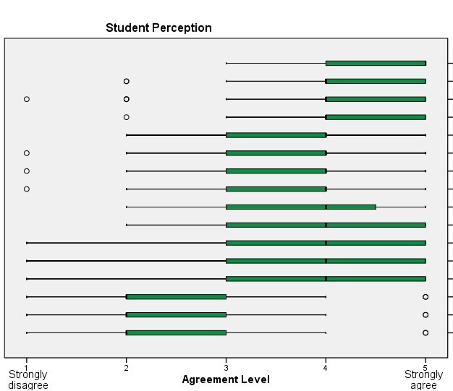

**teachers don't know students' names**

**atmosphere is teacher-centred**

**practical skills are neglected**

**chance to work in groups**

**promote lecture-based teaching**

**group work is effective way to learn**

**teachers have no time to feed back**

**students become passive**

opportunity to make many friends

one feels neglected

interactive activities are neglected

overcrowding makes feel anxious

suitable for learning productive skills

suitable for learning receptive skills

students become active

getting enough attention is easy

Student-participants’ Chart 1 shows 50% consensus with statements and 50% inconsistency. Only first eight statements show consistency in the student agreement them and remaining statements are neither consistent in students’ agreement nor disagreement with them. Among the eight statements of consistency, six statements (Statement 1, 2, 3, 5, 7 and 8) show the participants' negative attitude to large English classes and two statements (Statement 4 and 6) show students’ positive attitude concerning possible use of group work in large classes. However, they are not sure; they only perceive that group may effectively be used in large classes. On the whole, the students’ responses suggest that large English classes are ineffective in terms of learning English because teachers do not remember students’ names and students are neglected. Moreover, large classes promote teacher-centred teaching which reduces teacher feedback thus, students become just passive learners.

***Teacher-Participants' Perceptions about Teaching-Learning in Large Classes***

**Chart 2**

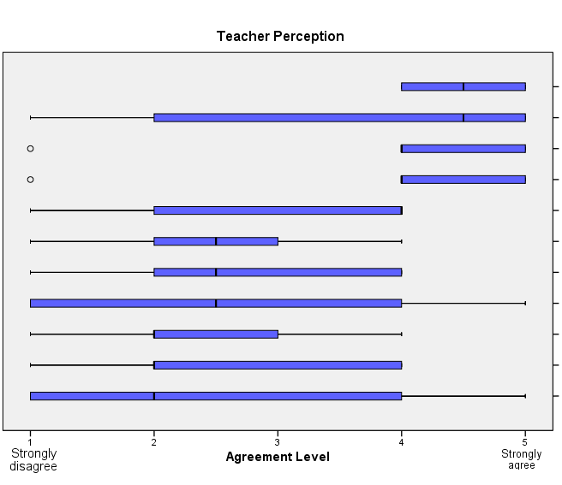

**weaker/shyer students don’t participate**

**promote lecture-based approach**

**teaching is not difficult but challenging**

**teaching should be student-centred**

chance to work in groups

suitable for receptive skills

student-centred learning is possible

assessment focuses on exam more

suitable for productive skills

teaching should be teacher-centred

teaching is easier than small ones

Regarding their perceptions about large English classes, the teacher-participant Chart 2, in comparison with the student-participants’ Chart 1, shows much lesser consensus. The strongest agreement is with the statements 1to 4. The first two statements corroborate the student results concerning negative aspects of the large English classes. For example, the weak and shy students are most of the time reluctant to participate in large English classes and large classes promote the lecture approach. On the other the hand, the statements 3 and 4 show positive attitude like students in which the teachers consider large classes challenging rather than difficult and, they wish that there should be student-centred learning in large English class which shows discrepancy between aspiration and a reality.

***Student-Participants’ Experiences about Learning in Large English Compulsory Classes***

**Chart 3**

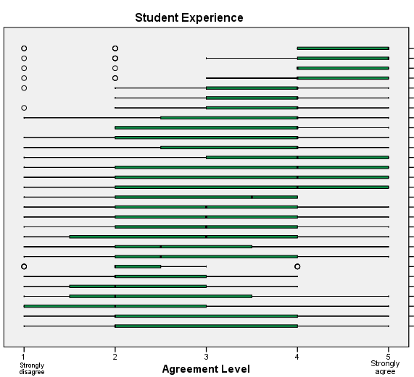

**difficult to get seat near the front**

**from the back I can't see the board clearly**

**brighter students given more attention**

**weaker students given less attention**

**teacher feeds back on oral tasks**

**we always work in groups**

**little opportunity to express myself**

teacher's gestures clearly seen from any seat

large size helps compare answers with others

classmates peer review

can understand the teacher

noisy atmosphere

more comfortable with smaller size

teacher doesn't remember my name

teacher-student interaction neglected

teacher gives feedback on written tasks

large size discourages from studying hard

feel shy to speak

classroom not well-furnished

class remains disciplined

teacher assesses and returns assignments

teacher remembers my name

more comfortable in larger size than present

feel sick in large crowd because of lack of air

classroom badly constructed

teacher uses A/V aids

enough space for teacher to move around class

class not well-ventilated

I am satisfied with the size of class

The student-participants’ chart of experiences of learning in large English classes show the least consensus with the statements and the most inconsistency. Out of thirty statements only seven statements are show consistency with agreement (Chart 3). Among these out of seven statements, five statements (Statement 1, 2, 3, 4 and 7) agree that the students’ experience of learning in large English classes was not satisfactory and two statements (Statement 5 and 6) agree that their experience of learning in large compulsory English classes was. However, the overall results of these statements suggest that the majority of the respondents were not satisfied with their large compulsory English classes because: they could not easily get the seat near the front; the brighter students were given more attention and the weaker ones less; and they had little opportunity to express themselves. However, the students also had positive experiences of learning in large compulsory English classes: the students indicated that they found their English teacher giving them feedback on their oral presentations, and they always worked in groups.

1. **Qualitative Data and Triangulation**
   1. **Qualitative Data Analysis**

The qualitative data includes 3 student and 2 teacher interviews, as well as 33 student and 6 teacher free-text queries of their questionnaires and class observation of one lesson. The qualitative data were analysed manually through the qualitative content data anlysis. The texts of the data are read and studied repeatedly in order to code words and phrases. Later, the coded words/phrases are further used under main categories, themes and sub-themes.

The class observation notes suggested that the dominant instructional method was teacher-centered lecture. Very little of the instructional activities met the diverse needs of learners which did not relate learning to the students’ real world or context. The other activities used were occasional individual explanation or presentations and no activities engaged students in various grouping designs, like group discussions. No special focus was given to group/pair work activities. The interview responses also corroborated the class observation notes. However, teachers reported that sometimes they sometimes used interactive activities and gave presentations to students, which were more often given by the more able students and the weaker students were once again neglected.

*Yes, exactly [my class is lecture based most of time]. Though I ask them every time to come, they don’t come forward to perform activities and they say sorry. […] It is too much difficult to do any activity in large classes (Interview with TE2 on 23.11.12).*

The quantitative findings of the data also support the qualitative in which both teachers and students indicated that their classes were teacher-centred (See Chart 1-4).

**5.1.1 Problems Faced by Teachers and students**

***Class Management******Issues***

The class observation showed that all the students were not listening to the teacher and many of them were busy in other activities such as writing other subjects’ assignments, playing games and using mobiles and chatting. Furthermore, class was not unbearably noisy, which is also corroborated in the quantitative findings (See Charts-1-4). However, the same is not reflected in the students’ and the teachers’ responses of interviews. They reported in the interview that their classes were noisy all the time and unmanageable due to the large size.

*can’t understand him because of the disturbance and noise. […] The main thing is number of students, because the large number of students disturbs the class, their coming and going, noise etc. (Interview with SS2 on 01.12.12)*

*[…] when I go to teach in a large class and it’s quite difficult rather most difficult for a teacher to teach a large class. […] the good teacher is that who gives equal time to every student but when there is a large class, we cannot give them time equally, we cannot check out their assignments therefore we don’t give them assignments/homework. And even if we assign them any presentations to them, we cannot listen to every student therefore it is difficult to give equal time to every student. (Interview with TE2 on 23.11.12)*

***Insufficient teacher-student Interaction and teacher Attention***

Both the student and teacher participants have agreed in the questionnaire responses that teacher-student interaction was neglected in the large compulsory English classes because of the large number of students in the class. This further led to the teachers’ insufficient attention given to students individually and left the teacher incapable of remembering the names of all students (See Charts 1-4). The responses clearly suggest that the weaker and shyer students are always neglected and only few the brighter students get the teacher’s attention and could interact with him. Moreover, the class observation notes and the interview responses of both the teachers and students confirm this phenomenon.

*Yes, exactly [my class is lecture based most of time]. Though I ask them every time to come, they don’t come forward to perform activities and they say sorry. […] It is too much difficult to do any activity in large classes (Interview with TE2 on 23.11.12).*

*[…] Yes, I get the full attention from the teacher because I am one of the brilliant students. […] they (weak and shy students) are being neglected totally and I feel guilty by seeing those students.* *(Interview with SS1 on 26.11.12).*

***Teacher Feedback and its effects on the students***

All the three student respondents wished that their teacher could give them feedback and they believed that the teacher feedback would improve their skills especially writing skills. Unfortunately, the teacher of their class could not give them feedback all the time because of a large number of students in the class.

*Yes returns (assignment with comments) it but not always sometimes.(Interview with SS2 on 01.12.12)*

*[…]We keep repeating the same mistakes because the teacher is not giving us corrective feedback. (Interview with SS1 on 26.11.12)*

Similarly, both the teachers found it difficult to check homework/classwork or assignments and give feedback to the students on them because of the large size and other compulsory and major classes.

*Just I check few paragraphs of few students then I ask them this will be like this simply because I can’t check every student’s paragraph then I ask them that these are the techniques of writing skill and this will be like this.(Interview with TE2 on 23.11.12)*

*It is difficult [to give feedback] because the teacher has so many other things to do, such as other classes.(Interview with TE1 on 22.11.12)*

Quantitative responses show some contradiction between students’ and teachers’ responses about the teacher feedback. Students indicated that their teacher had no time to give feedback (Chart 1 and 2). They believed and experienced that most of the students were neglected and only brighter students were given feedback attention and feedback. However, the teachers’ indicated that they at least could give feedback on oral tasks (Chart 4). On the other hand, the class observation supported students’ responses more and showed that the teacher could neither give oral, nor written feedback to students.

**5.1.2 Suggestions for Improvement**

***Group Work and Presentation***

Both the teachers and students most frequently suggested that the use of group work and presentation on a regular basis because develops their confidence and motivates them. For example a student suggested group work activities in the class if properly checked because then work would enhance their confidence and motivation. *The teacher has to consider every student, and give group work and check every group. In this way it will build our confidence and interest in study (Interview with SS2 on 01.12.12)*

Similarly, the teachers believed that group work enriches students’ ideas because in it many minds of students work together teachers in their free-text items of the questionnaire also suggested group work and presentation to make large classes effective. For example the teacher *(TE1)* emphatically suggested group activities:*‘… for example, if it is group of five it means there are five minds they are working it means that from one another they will learn many points’ (Interview with TE2 on 22.11.12).* The same suggestion is very much reflected in the quantitative data findings (See Chart 1 and 2), both the teachers and students believed that students still had a chance to work in groups and the teaching should be student centered. However, the insufficient use of group work and presentation is not always clear. When the teachers were asked about the frequency of group work , they reported it was not very often because of the large size of class and also a huge syllabus which they had to finish through lecture.

1. **Conclusion**

Although the largest number of the student and teacher participants reported that it was difficult to teach and learn in large English Compulsory classes, the major portion of the findings suggested the more use of interactive activities specifically group work activities could improve teaching and learning in large English classes to some extent.

The findings suggest that for the improvement of teaching and learning in large English classes the implementation of group work activities may be used. The student-participants, while responding to the quantitative items of their questionnaire, believed and might have experienced that group learning was possible and effective in large classes. Similarly the majority of the student-participants stressed group work activities in large English classes in both qualitative and quantitative findings. The teacher participants also believed that teaching should not be teacher-centred in large classes but rather it should be student-centred. Their responses suggested that group work could be practised effectively in large classes. Moreover, it may also be noticed from the interview findings that two out the three student-participants suggested group work activities emphatically. They further proposed that when group activities were properly checked and monitored by the teachers, they could give more effective results. From the two the teacher interviewees, one emphatically suggested group work activities for better results and the second one said they were good but many students did not involve in them.

Since previous studies reported in the literature have advocated the use of organised group work, and since both students and teachers in this study felt that group work would be beneficial to students’ learning, why is it not more widely used in this context? The next stage of this study will attempt to answer this question and through an action research process will develop a trial and evaluate the implementation of cooperative learning strategies which introduce group work to the syllabus in an organised and permanent way, and can flexibly be adapted to any specific context.

**References:**

Aslam, H. D., Nadeem, M. A., Hussain, M. and Khan, M., 2010. Comparison of Human Resources’ Impact on Teaching Grammar to Second Language Learners and Developing Teachers’ attitude towards Teaching of English Grammar at Secondary School Level. *Journal of Educational Research 13(1), 2010.*

Colemen, H., 2010. *Teaching and Learning in Pakistan : The Role of Language in Education*. British Council. Islamabad.

Cooper, J.L. and Robinson, P., 2002. The argument for making large classes seem small. *New Directions for Teaching and Learning, [e-journal],* 2000(81), pp. 5-16.

Cuseo, J., 2007. The Empirical Case against Large Class Size: Adverse Effects on the Teaching, Learning and Retention of First-Year Students. *The Journal of Faculty Development,* 21 (1), pp. 5–21.

Harfitt, G.J., 2012. An examination of teachers’ perceptions and practice when teaching large and reduced-size classes: Do teachers really teach them in the same way? *Teaching and Teacher Education, [e-journal]*, 28 (1), pp. 132-140.

Hayes, D., 1997. Helping teachers to cope with large classes. *ELT Journal, [e-journal]* 51(2), pp. 106-116.

Herbert, D., Chalmers, D., Hannam, R., Terry, D., and Lipp, O., 2001. Teaching Large Classes: An AUTC Project on the Evaluation and Dissemination of Best Practice in Australian Universities. Higher Education Research and Development Society of Australasia 24th Annual Conference. Newcastle, New South Wales, 8-11.

Johnson, R. B., Onwuegbuzie, A. J., & Turner, L. A. (2007). Toward a definition of mixed methods research. *Journal of Mixed Methods Research*, 1(2), pp. 112–133.

Kerr, A., 2011. *Teaching and Learning in Large Classes at Ontario Universities: An Exploratory Study*. Toronto: Higher Education Quality Council of Ontario

Lieber, E., 2009. Mixing qualitative and quantitative methods: Insights into design and analysis issues. *Journal of Ethnographic and Qualitative Research*, 3(4), pp. 218–227.

LoCastro, V., 1989. Large size classes: The situation in Japan. [pdf] Lancaster: Lancaster-Leeds Language Learning in Large Classes Research Project, Report 05

Locastro, V., 2001. Teaching English to large classes. *TESOL Quarterly*, 35(3), pp. 493-6.

Luff. P., 2010. *Ways of Seeing and Knowing Children: A Case Study of Early Years Practitioners’ Understandings and Uses of Child Observation during Their First Year of Employment.* PhD, Anglia Ruskin University, UK.

Mgeni, E.M., 2013. Teacher Perceptions on Effective Teaching Methods for Large Classes. *American International Journal of Contemporary Research*, 3(2), pp.114-118.

Renaud, S., Tannenbaum, E. and Stantial, P., 2007. Student-centred teaching in

large classes with limited resources. *English Teaching Forum Online*, 3, pp. 12-17.

Shamim, F., 1993. *Teacher-learner behaviour and classroom processes in large*

*ESL classes in Pakistan*. Ph.D, University of Leeds, UK

Waddington, S., Crowley, U. and McCaffery, C., 2009. What do they really think about large classes? *National University of Ireland, Maynooth.*

Wößmann, L., and West, M., 2006. Class-size Effects in School Systems around the World: Evidence from Between-grade Variation in TIMSS. *European Economic Review*, 50(3), pp. 695-736.

Zhengping, Z., 2009. Addressing Large Class Sizes: Learning Strategies for Improving Oral English of Students Majoring in English at Yunyang Teachers College: A Seminar Paper Research Presented to the Graduate Faculty University of Wisconsin-Platteville.