Detection and Classification of Short and Long Duration Disturbances in Power System

M.M. Zaid^{1*}, M.U. Malik², M.S. Bhatti³, H. Razzaq¹ and M. U. Aslam¹
¹Department of Electrical Engineering, University of Engineering and Technology, Lahore, Pakistan
²Department of Electrical Engineering, University of Engineering and Technology, Taxila, Pakistan
³Department of Mechanical Engineering, International Islamic University, Islamabad, Pakistan
muhammadzaidmalik@gmail.com; usama.maik32@yahoo.com; sibtain413@gmail.com; hamidrazzaq95@gmail.com; umair94aslam@gmail.com.
Abstract:
In this project, PQ analyzer is developed which depicts the detection and classification of short and long duration disturbances in power system. These disturbances comprising of sag, swell, interruption, undervoltage, and overvoltage. All these disturbances are analyzed by uninterruptedly monitoring of power system. This paper outlines the start time, end time, magnitude and waveform of disturbances. These detected disturbances are classified on the basis of their respective characteristics. The perceptions and classifications are accomplished by using Advanced Digital Signal Processor (ADSP-21369). The statistics of disturbance are stored precisely and accurately. The prototype is configured with the LabVIEW to receive and store all the data which is sent by the processor via UART interface (RS-232 protocol).
Keywords:
PQ event classifier, Power System, Detection and Classification of Disturbances, Power Quality Analyzer, Waveform Monitoring.

- Introduction
In recent years, electricity is analyzed by consumers as well as distributors on a large scale. Everyone is trying to improve power quality of the system. To do so everyone is trying to reduce the losses and disturbances in power system. Disturbances in power system affects the components used in it [1].
Electricity is scrutinized by consumers as well as distributors on a large scale. To do so the whole world is trying to diminish the losses and disturbances in power system. These losses and Disturbances in power system affect the components used in it.
Now a day we are using a large amount of electronic equipment in our daily life. These equipment affects the electrical systems and diminishes its quality [2]. Although the powerhouses which engender a large amount of electricity and the power sectors have worked a lot to improve its quality. Despite all this improvement and protection in power system, disturbances also befell in it. Due to this the turbulences which occurred in power systems cannot be taken too lightly and is given more importance.
In power system, different types of the load are present which affects the quality and parameters of the power system [3] and distort the waveform of current [4]. To monitor all these things the analyzer which is used are termed as power quality analyzer.
These analyzers are used to
- Detect electrical disturbances instantaneously;
- Classify, detect, and store the parameters of power system in external memory devices like SD Memory Cards etc.;
- Monitor online in real time domain [4];
- Detect waveform distortion and disturbances in power system [5].
- Work Goals
The aim of this project is to acquire a prototype comprising of PQ analyzer, which is used to perceive and categorize the long and short duration disturbances befell in power system. All the signal computations are performed through digital signal processor (DSP). In this project a redundant power supply is present. If the power interruption occurs due to the disturbances in power system then this redundant power supply is used to power the analyzer and prototype for continuously monitoring.
This is portable and it can be mounted on streets which are retrieved only by the personnel of electricity.
  - State of Art
Please According to IEEE 1159-1995 [5], the turbulences produced in power system is divided into different categories e.g. sags, swells, undervoltage, overvoltage, and interruptions etc [6]. The Table 1 shows the characteristics of disturbances in power system.
Table 1: Main characteristics of power quality (PQ) disturbances [7]
Category | Duration of  Disturbance | Magnitude of  Disturbance
Sag | 0.5 cycle (1 min) | 0.1 p.u. to 0.9 p.u.
Swell | 0.5 cycle (1 min) | 1.1 p.u. to 1.8 p.u.
Interruption | > 0.5 cycle | Less than 0.1 p.u.
Overvoltage | > 1 min | 0.8 p.u. to 0.9 p.u.
Undervoltage | > 1 min | 1.1 p.u. to 1.2 p.u.
Different techniques are performed for the perception of disturbances. Some used pattern recognition technique and time-frequency representation comprising of fast fourier transform [9] and wavelet transform [8] for the perception of disturbances [10]. Other uses the technique of root mean square (RMS) [13] which is employed by using digital filters [11] [12].
- System’s Architecture
The single-phase voltage 230 V/ 50 Hz is fed into the voltage transducer which is used to measure the single-phase voltage [14]. The output signal which is obtained from the voltage transducer is sent into the analog to digital converter (A/D) by passing through signal conditioning circuit. The resolution of A/D is 16 bits and its frequency is 25.6 kHz. Which portrays that it takes 25600 samples in one second for signal computation. The sampling clock of A/D (AD7980 of analog devices) is given through processor named ADSP-21369. This A/D is attached with the processor through synchronous serial ports (S-PORTS). Along with this advanced digital signal processor (ADSP) accomplishes all the signal computation for the detection of disturbances.
The processor which is using in this project is 32 bits and have a frequency of 332 MHz. This DSP has internal memory of 2 Mbit which is less for all the signal computations therefore, 128 Mbit of synchronous dynamic random-access memory (SDRAM) is used for volatile storage of all the variables of data for signal computation.
In this, the prototype is allied with LABVIEW through which detection and classification of disturbances ensue by analyzing the real-time domain of power system.
In the analyzer, the separate Li-Ion battery is connected which is rechargeable. When the power turned off or during the disturbances of power system this battery is used as a backup supply and it is recharged when the voltage of power system becomes normal.
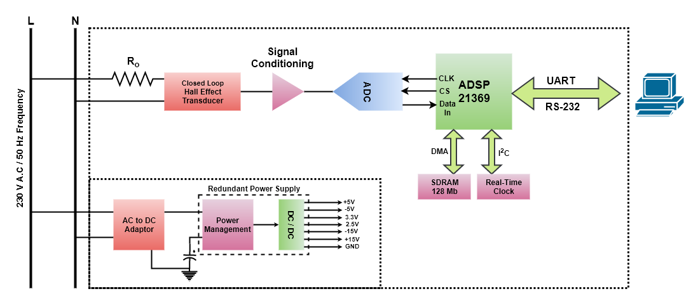
Fig. 1: Block diagram of PQ analyzer
  - Voltage Sensor
In this project, LEM LV 25-P is the voltage sensor which is used for the measurement of voltage. The schematic of this voltage transducer is shown in figure 2. In this 230V AC is given to the transducer and the current proportional to AC voltage is passed through the resistor R0. The voltage which is to be measured is taken across resistor RM. The values of R0 and RM is accustomed in such a way that they should operate properly during an abnormal condition of voltage so that they are adjusted according to the atypical voltage of 460V RMS because in this project overvoltage is also measured [15]. Although instead of this transducer step-down transformer can also use for voltage measurement [4] this transducer has a lot of good specifications e.g. good linearity, excellent accuracy, best isolation and broad bandwidth [16].
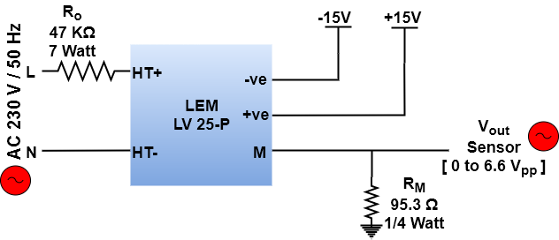
Fig. 2: Schematic of Voltage Sensor
  - Signal Conditioning Circuit
A/D has the range of 0 to 3.3 Volts but the signal taken by a voltage transducer is bipolar. To make this bipolar signal to unipolar conditioning circuit is used. The signal conditioning circuit, shown in figure 3 accepts the signal coming from voltage transducer and converts that bipolar signal to unipolar by giving offset such that signal is centered across 1.65 V and this signal is within 0 to 3.3 V [4]. The relation between input and the output of signal conditioning circuit is
V_{OUT} = 1.65 - 0.5 V_{I N} (1)
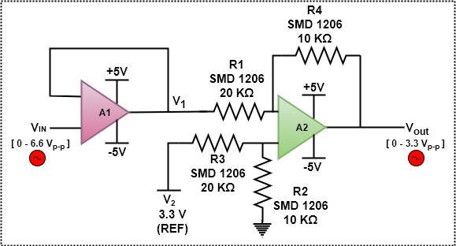
Fig. 3: Schematic of signal conditioning circuit
  - Analog to Digital Converter
Before the signal is sent to A/D the signal is passed through low pass filter which has cutoff frequency fc of 14 KHz. This filter is used to eradicate noise and to improve SNR. This filter works as an anti-aliasing filter. This filtered signal is sent to the IN+ terminal of A/D which has the range of 0 to 3.3 V. Along with A/D DSP is used which gives the clock to A/D by connecting Clock of DSP with SCK of A/D. Similarly, SDO of A/D relates to Data In of DSP. This interaction is achieved through SPI Communication. In this 3.3 V is applied to the VIO pin of A/D which is used for the digital interface, in the same way, 2.5 V is given to the VDD pin of A/D which is used for analog part. The reference pin (REF) of A/D is attached with 3.3 V.
The four precision clock generators (PCG) are present in a single DSP which controls the A/D by giving clock signals to it. In PCG a phase locked loop (PLL) is present which is used to engender a clock signal for the A/D and Serial PORTs (SPORTs). When analog signals are altering to digital one then PLL should not provide a clock to SPORTs or A/D. During sampling of signals, A/D is attached directly with the oscillator of frequency 24.576 MHz to avoid jitter which is caused because of the involvement of more than one frequencies.
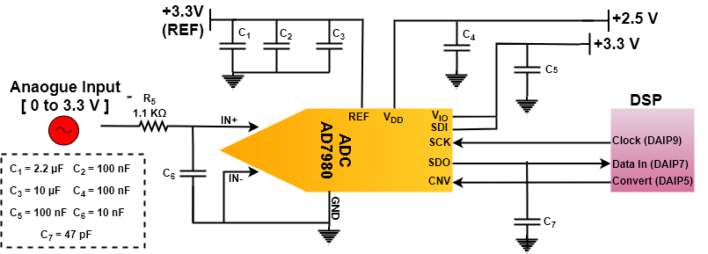
Fig. 4: Schematic of the A/D converter
  - External Memory
It is impossible to store all the samples of an analog signal into the memory of the processor. To store all these samples without any loss an external memory of SDRAM having capacity of 32 Mbit is used. This memory is composed of four banks having a capacity of 32 Mbit each which consists of 4096 rows and 256 columns [4]. When the internal buffer of the processor reaches its maximum capacity than the Direct Memory Access (DMA) transfer all the data to the address of the external memory.
While DMA transfers all the data to external memory the processor can be able to perform other signal computations [4]. Due to this process, all the calculations are done without any loss of a single sample which gives better accuracy.
  - Real Time Cock (RTC)
As this project is about detection and classification of disturbances so, if a disturbance occurs it is necessary to store and save characteristics of disturbances. For this purpose, the real-time clock of M41T81S of STMicroelectronics © is used. This clock has the capability to measure time in tens of milliseconds, seconds minutes, days, weeks, months, years and centuries. The communication between RTC and the processor is performed through the process of I2C protocol. The number has the format of binary coded decimal (BCD) in which first 8 bytes are used for external SDRAM as clock and calendar function and the remaining 12 bytes are used to read the values of timer registers.
3.3 V is given to power the RTC. If the power interruption occurs due to some abnormal condition than an external battery of model BR1225, 3V, and 48 mAh is used as a backup
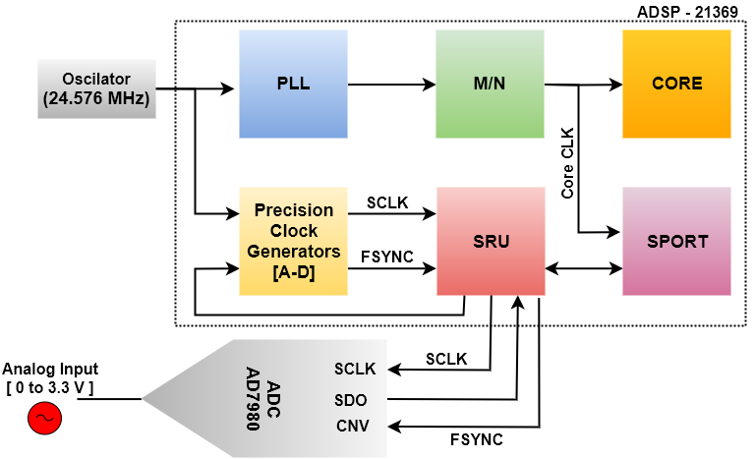
Fig. 5: Schematic of PCG with A/D
  - Redundant Power Supply
In this project, the power supply is designed which has the capacity to power all the parts of PQ Analyzer E.g. Voltage Sensor, External SDRAM, A/D, PCG etc. It is necessary to power up the project during the occurrence of disturbances like sags, swells etc. For this purpose, a backup power supply is also designed which is used to work during abnormal conditions of the power system. Figure 6 shows the block diagram of the redundant power supply. In this 90V to 264V AC is given to A/D which converts the voltage and current to 5 V DC and 2.4 A having power of 12 W. This voltage is given to the chip of Texas Instruments© named BQ24070. The output of this chip is used to charge the Li-Ion micro battery of 2200 mAh having 3.7 V and energy of 8.2 Wh. Along with this, it is used to make DC voltages of different voltage levels to power all the project.
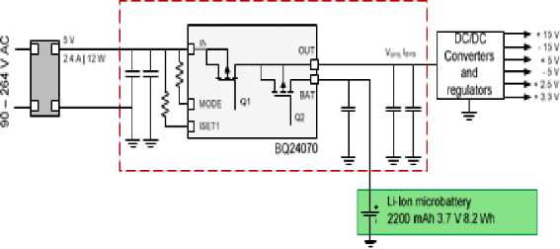
Fig. 6 Schematic of redundant power supply
- System’s Algorithm
The method of detection and classification presented in this paper was implemented in four stages, as seen in Figure 7. First stage is named as pre-processing, second stage is known as processing and the other two are last stages termed as detection and classification.
During the first stage, the processor sends the control signals to the A/D and acquires N = 65536 samples [ , ,…., ]. Meanwhile, the samples are transferred through DMA to the external memory after every 4096 samples [17]. Then the processor moved towards the second stage of processing. When the processor is busy in second stage, during this interval A/D continues to take samples of signal and send it to SDRAM for continuous monitoring for the detection of disturbances.
In the first stage of processing, normalization block is present which performs detection process by the selection of threshold levels. These levels don’t depend on the range of voltage sensor.
After first stage, the processor moves towards the second stage of processing. Where the normalized signal is sent to the RMS block. Then the processor moves towards the third stage of detection, where the detection of disturbances occurs. After this the processor moves towards the last stage of classification where classification of different types of disturbances are assorted.
  - Detection of Disturbances
The RMS of signal is calculated as
$V_{rms}$ = $\sqrt{\frac{\sum_{i=1}^{n}{{\left(X_{i}\right)}^{2}}}{n}}$ (2)
n = number of samples; $X_{i}$ = Instant Samples
The RMS value is calculated of one cycle through sampling and this value is refreshed after every half cycle to prevent any loss of disturbance detection. The two values of threshold of RMS is set. One is the value above the nominal of RMS termed as RMS_THR+ and the other one is the value beneath the nominal of RMS termed as RMS_THR-. RMS which is calculated of the voltage signal is compared with these threshold values to detect disturbances in power system.
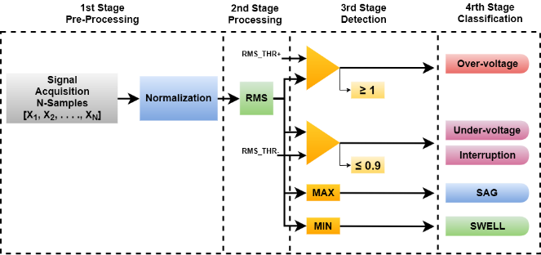
Fig. 7: Block diagram of different stages
  - Classification of Disturbances
In this classification of different types of disturbances occurred. If the voltage magnitude of the signal is greater than 1.1 p.u. then it is termed as swell and overvoltage. The time of swell is between 0.5 cycle to 1-minute while, the time of overvoltage is greater than 1 minute.
If the voltage magnitude of signal falls below 0.9 p.u. It is termed as sag and undervoltage. The time span of sag is between 0.5 cycle to 1-minute while, time span of undervoltage is greater than 1 minute.
If the voltage magnitude is less than 0.1 p.u. and it stays less than 0.1 p.u. for greater than 0.5 cycle then it is termed as interruptions. The classification of disturbances is shown in figure 8 [18].
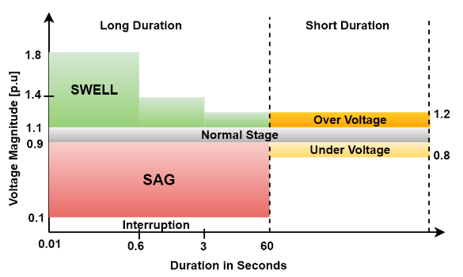
Fig. 8: Classification of disturbances
- Measurement Results
The prototype of the analyzer was connected and installed at University of Engineering and Technology, Lahore, Pakistan, where it is scrutinized through the local conditions of the power system. The upper limit which is RMS_THR+ was attuned to 1.1 p.u. and the lower threshold RMS_THR- was adjusted to 0.9 p.u.
Artificial disturbances are created to and implemented on the prototype to corroborate the algorithms instigated in this project.
Figure 9 and Figure 10 show an example of a detected interruption. This interruption has the duration of 0.29 seconds and has the minimum magnitude of 0.004 p.u. The disturbance commenced at 7h 29m 52.21s and finished at 7h 29h 52.50s, on March 21, 2017.
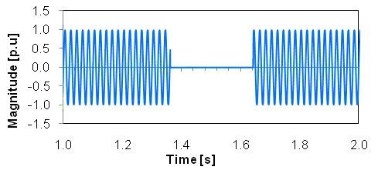
Fig. 9: Incidence of interruption in voltage signal
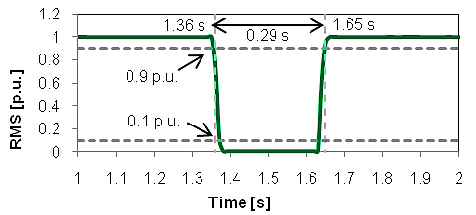
Fig. 10: Variation in RMS due to interruption
A swell was detected which is shown in Figure 11 and Figure 12. This swell has the duration of 0.08 seconds having maximum magnitude of 1.247 p.u. It began at 7h 41m 24.30s and finished at 7h 41h 24.38s on March 21, 2017. The RMS variation is shown in Figure 13.
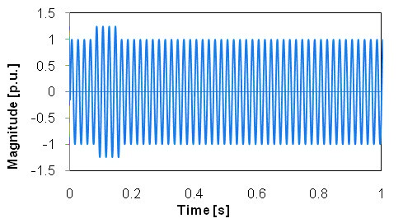
Fig. 11: Incidence of swell in voltage signal
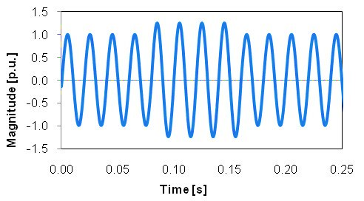
Fig. 12: Incidence of swell in voltage signal (detail)
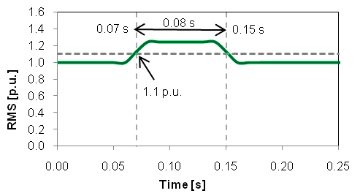
Fig. 13: Variation in RMS due to swell
Figure 14 shows the occurrence of sag while the figure 15 shows the RMS variation occurs in it. This sag has the duration of 0.075 seconds to 0.12 seconds having maximum magnitude of 0.665 p.u. It was simulated and detected on March 21, 2017.
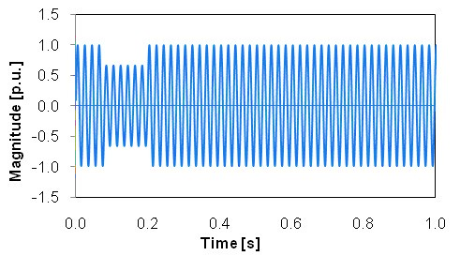
Fig. 14: Incidence of sag in voltage signal
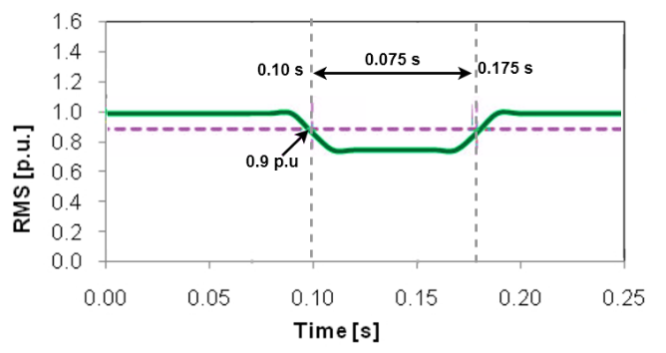
Fig. 15: Variation in RMS due to sag
- Conclusion
In this project, the results are obtained through artificial and natural disturbances. All the signal computations are performed through ADSP-21369. This analyzer is portable, robust, efficient and vigorous. The exact time of disturbances which are detected in power system is depicted without having any error. The disturbances are detected continuously in real time domain.
This project also has the capability of sending all the waveforms of disturbances to the PC via UART interface (RS-232 protocol). This analyzer is fast, easy to handle and can be installed anywhere. The sensitivity of analyzer is adjustable and can be done by adjusting the value of RMS_THR+ and RMS_THR-.
References
- P.Daponte, M.di Penta, and G. Mercurio, Transientmeter: A distuributed measurement system for power quality monitoring, Proceeding 9th International Conference Harmonics and Quality of Power, 2000, Vo. 3, 1017-1022.
- He H., Shen X., Starzyk J.A., Power quality disturbance analysis based on EDMRA method, Electrical Power and Energy System, Vol. 31, 2009, 258-268.
- R. Dugan, M. McGranaghan, and H. Wave Beaty, Electrical Power Systems Quality (N.Y.,McGraw-Hill, 1996).
- M. M. Zaid, M. Nauman, M. Rahim, and M. U. Malik, “DSP Based Energy Monitoring with Online DAQ System,” Open Access International Journal of Science & Engineering, vol. 2, issue 5, pp. 9–16.
- Entidade Reguladora dos Serviços Energéticos. ERSE. [Online]. http://www.erse.pt/
- S.Edwin Jose, and S.Titus, Detection and classification of Power Quality using Adaptive decomposition structure and neural network, European Journal of Scientific Research,Vol.89, No.3, October 2012, 477-489.
- "IEEE Std. 1159TM-2009 (revision of IEEE Std 1150-1995)," IEEE Recommended Practice for Monitoring Electric Power Quality, The Institute of Electrical and Electronics Engineers, Inc., New York, June 2009.
- Zwe-Lee Gaing, "Wavelet-based Neural Network for Power Quality Disturbance Recognition and Classification," IEEE Transactions on Power Delivery, vol. 19, issue 4, pp. 1560–1568, Oct. 2004.
- Min Wang, G. I. Rowe, and A. V. Mamishev, "Classification of Power Quality Events Using Optimal Time-Frequency Representations – Theory and Application," IEEE Transactions on Power Delivery, vol. 9, issue 3, pp. 1488-1503, Jul. 2004.
- M. Gaouda, S. H. Kanoun, M. M. A. Salama, and A. Y. Chikhani, "Pattern Recognition Applications for Power System Disturbance Classification," IEEE Transactions on Power Delivery, vol. 17, issue 3, pp. 677–683, Jul. 2002.
- Feng-Feng Zhu, Guo-Sheng Hu, and Jing Xie, "Classification of Power Quality Disturbances Using Wavelet and Fuzzy Support Vector Machines," Proceedings of 2005 International Conference on Machine Learning and Cybernetics, vol. 7, pp. 3981–3984, Aug 2005.
- Z. Chen and P. Urwin, "Power Quality Detection and Classification Using Digital Filters," 2001 IEEE Porto Power Tech Proceedings, vol. 1, no. 6, p. 6, Sept. 2001.
- E. Styvaktakis, M. H. J. Bollen, and I. Y. H. Gu, "Automatic Classification of Power System Events Using RMS Voltage Measurements," 2002 IEEE Power Engineering Society Summer Meeting, vol. 2, pp. 824–829, Jul. 2002.
- D. Saxena, K.S. verma and S.N. Singh, Power quality event classification: an overview and key issues, International Journal of Engineering, Science and Technology, Vol. 2, No.3, 2010, 186-199.
- Emmanoiuil Styvaktakis, Irene Y.H. Gu, Math H.J. Bollen, Voltage dip detection and power system transients, IEEE Transactions Power Engineering Society Summer Meeting, Vol. 1, 15-19 July 2001, 683-688.
- M.H.J. Bollen, Understanding Power Quality Problems-Voltage Sags and Interruptions (New York, IEEE Press, 2001).
- D. Castaldo, D. Gallo, C. Landi, and A. Testa, "A digital instrument for nonstationary disturbance analysis in power lines," IEEE Trans. on Instr. and Meas., vol. 53, nº 5, pp. 1353-1361, Oct. 2004.
- Santoso S., Lamoree J., Grady W.M., Powers E.J., and Bhatt S.C., A scalable PQ event identification system, IEEE Transactions on Power Delivery, Vol.15, 2000, 738-743.

